


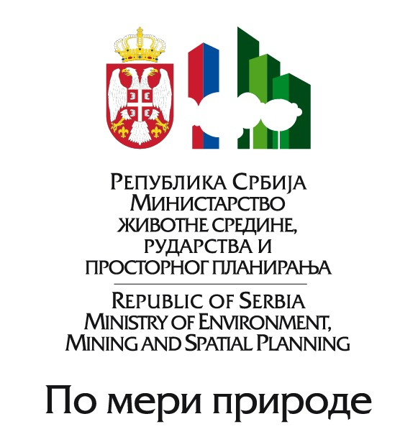

EXPERT WORKSHOP “SOUTH EAST EUROPEAN RESEARCH FRAMEWORK IN REGIONAL CLIMATE MODELING
FOR 2012-2017”
Belgrade, Serbia, April 11-13, 2011
Venue: International Congress Cultural & Business Center “Sava”, Milentija Popovica 9
PRELIMINARY AGENDA
DAY 1
11 April 2011 (Monday)
08:30-09:00 | Registration
09:00-09:30 | I Segment Opening / Welcome addresses –  Chair: Mr. Milan Dacić | Mr. Milan Dacić, Director RHMSS-SEVCCC, Host  Dr. Ghassem Asrar, WMO, Director WCRP  Dr. Philippe Dandin, Meteo-France, Director of Climatology, WMO RA VI RCC Node  Dr. Zaviša Janjić, NCEP, USA  Dr. Barbara Früh, Deutscher Wetterdienst (DWD), WMO RA VI RCC Node  Mr. Ivan Čačić, President WMO RA VI
09:30-10:30 | II Segment – Introductory notes –  Chair: Mr. Milan Dacić  (30 min per a presentation) | Mr. Ivan Čačić, President WMO RA VI  Dr. Ghassem Asrar, WCRP
10:30-10:40 | Group photo
10:40-11:00 | Coffee break
11:00-12:00 | II segment – Continued | Dr. Philippe Dandin, Meteo-France  Dr. Zaviša Janjić, NCEP
12:00-13:30 | Lunch
13:30-15:30 | III Segment – Themes –  Co-Chairs: Dr. Zaviša Janjić,  Dr. Borivoj Rajković  (20-30 min per a Topic) | Atmospheric model NMMB – (Dr. Zaviša Janjić)  Ocean model, Interconnections within the climate model – (Dr. Vladimir Djurdjević, Dr. Borivoj Rajković)  Lower Boundary Conditions: Land Surface Model, Ocean-Ice – Dr. Borivoj Rajković, Ms. Ana Vuković)
15:30-16:00 | Coffee break
16:00-18:00 | III Segment – Continued | Hydrology – (Mr. Goran Pejanović, Dr. Zoran Stevanović , Dr. Vesna Ristić-Vakanjac, Dr. Jasna Plavšić, Ms. Mirjam Vujadinović,)  Aerosols – (Dr. William Sprigg)  Downscaling – (Dr. Mathias Müller)
20:00-22:00 | Dinner in the Hotel Continental, Banquet hall “Le Club”
DAY 2
12 April 2011 (Tuesday)
09:00-10:00 | III Segment – Themes  Co-Chairs: Dr. Zaviša Janjić,  Dr. Borivoj Rajković | Data assimilation – (Dr. Tijana Janjic, Dr. Borivoj Rajković)  Computational aspects and visualization – (Dr. Robert Bishop, Dr. Aleksandar Belić)
10:00-10:30 | Coffee break
10:30-11:30 | IV Segment – Present experiences and plans  Chair: Dr. William Sprigg  (15 min per a presentation) | “Priorities and Plans: A Prospective From the Academic Research Community”, Dr. David Parsons  “NIMH-BAS Experiences”, Dr. Vesselin Alexandrov  “Present Experiences and Plans for Research” Chapman University, USA, Dr. Menas Kafatos, Dr. William Sprigg  “Coupled Regional Modeling System for Mediterranean Region”, Dr. Vladimir Djurdjević
11:30-12:00 | V Segment – End user aspects, Data exchange, Implementation –  Chair:  (15 min per a presentation) | Implementation in SEE (Mr. Milan Dacić)  Mineral Compositions of Dust Aerosol (Ms. Ana Vuković)  HM Testbed Ensemble QPF (Dr. Isidora Jankov)  Climate monitoring, data exchange, and data policy (Mr. Goran Pejanović, Dr. Vladimir Djurdjević, Dr. Tijana Janjić)
12:00-13:30 | Lunch
13:30-15:30 | VI Segment – Break – up groups  Working groups (themes clustered in two working groups) | Working Group I – Chair: Dr. Zaviša Janjić, Rapporteur: Dr. Mathias Müller (Atmospheric modeling (Dynamics and Physics))  Working Group II – Co-Chairs: Dr. Borivoj Rajković, Dr. Robert Bishop, Dr. Aleksandar Belić, Rapporteurs: Dr. Isidora Jankov (Ocean and inter – comparison within the climate model, Hydrology, Lower boundary conditions, Aerosols, Ocean data assimilation, Climate Monitoring and data exchange, Computational aspects and data visualization)
15:30-16:00 | Coffee break
16:00-18:00 | VI Segment – Continued
18:00 | Free Time
DAY 3 (morning session only)
13 April 2011 (Wednesday)
09:00-10:30 | VII Segment – Final plenary session –  Chair: (tbd) | Reports of the WG sessions;  Compilation of the Draft Research Agenda for SEE and adoption of the Research Agenda for SEE by the Expert Group
10:30-10:35 | Closing of the event
10:35-11:00 | Coffee break

MINISTERIAL MEETING “CLIMATE CHANGE RESEARCH FOR ENVIRONMENTAL PROTECTION, ADAPTATION AND RISK REDUCTION”
Belgrade, Serbia, April 13, 2011
Venue: International Congress Cultural & Business Center “Sava”, Milentija Popovica 9

AGENDA

13 April 2011
11:30-11:45 | Opening / Welcome addresses | Dr. Oliver Dulić, Minister, Ministry of Environment, Mining and Spatial Planning  Representative of the USA Embassy in Belgrade (tbc)
11:45-12:15 | Key note address | Mr. Michel Jarraud, WMO Secretary-General
12:15-13:00 | Setting the Scene | Mr. Milan Dacić and  Directors of Hydrometeorological Services from SEE
13:00-13:10 | Group photo
13:10-15:00 | Lunch
15:00-16:30 | Statements by Ministers | Ministers from SEE
16:30-17:00 | Recommendation for international cooperation in climate change | To be adopted by Ministers
17:00-17:05 | Official Closing of the Ministerial meeting
17:05-20:00 | Sightseeing tour*
20:00-22:00 | Dinner hosted by the Ministry of Environment, Mining and Spatial Planning**

* Departure of the bus is planned for 17.20^{h} at the Hotel Continental entrance.
**The dinner will be at the restaurant “Caruso”, Terazije 23, 8th floor

