


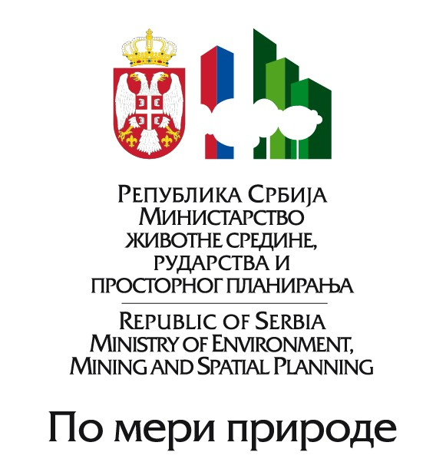

LIST OF PARTICIPANTS TO THE
“SEE RESEARCH FRAMEWORK IN REGIONAL CLIMATE MODELING FOR 2012-2017”
Belgrade, Serbia, April 11-13, 2011

COUNTRY | PARTICIPANT  NAME / SURNAME | POSITION | ORGANISATION | CONTACT ADDRESS  PHONE / MOB  E-MAIL
BOSNIA AND HERZEGOVINA | Mr. Dzenan Zulum | Climatologist | Federal Hydrometeorological Institute | Bardakcije 12, 71000 Sarajevo  Tel: +387 33 27 67 08  Fax: +387 33 27 67 01  Mob: +387 61 50 40 20  dzenanz@fhmzbih.gov.ba  dzenan.zulum@gmail.com
BOSNIA AND HERZEGOVINA | Ms. Nada Rudan | Head of Climatology | Hydrometeorological Institute | Put banjaluckog odreda bb,  Banja Luka  Tel: +387 51 433 521  nada.rudan@meteo-rs.com
BULGARIA | Assoc. Prof. Dr. Vesselin Alexandrov | Director of Meteorology Department | National Institute of Meteorology and Hydrology | Tsarigradsko shose 66  Sofia 1784  Tel: +359 2 462 4512  Fax: +359 2 988 4494  vesselin.alexandrov@meteo.bg
CROATIA | Mr. Ivan Cacic | President of RA VI, Director and PR with WMO | Meteorological and Hydrological Service | Gric 3, Zagreb HR-10000  Tel: +385 1 4565 684  Fax: +385 1 4851 901  cacic@cirus.dhz.hr
FRANCE | Dr. Philippe Dandin | Director of the Climatological service | Meteo-France | 1, quai Branly F-75340  Paris Cedex 07  Tel: +33 5 6107 8300  philippe.dandin@meteo.fr
GERMANY | Dr. Barbara Früh | Head of the Regional Climate Modeling Group | Deutscher Wetterdienst | Frankfurter Strasse 135  63067 Offenbach  Tel: +494 69 8062 2968  Fax: +49 69 8062 2993  barbara.frueh@dwd.de
SLOVENIA | Dr. Gregor Gregoric | Coordinator of DMCSEE | Meteorological Office Environmental Agency | Vojkova 1b, SI-1000 Ljubljana  gregor.gregoric@gov.si
SWITZERLAND | Dr. Mathias D. Müller | Scientist | Institute of Meteorology, Climatology and Remote Sensing | University of Basel, Klingelbergstrasse 27, CH-4056 Basel Tel: +41 61 267 07 00  Fax: +41 61 267 06 89  mathias.mueller@unibas.ch
SWITZERLAND | Dr. Robert Bishop | President | International Centre for Earth Simulation ICES | Geneve  Tel: +41 79 2025 994  bbishop001@hotmail.com
THE FORMER YUGOSLAV REPUBLIC OF MACEDONIA | Dr. Vlado Spiridonov | International Affairs Advisor | Hydrometeorological Service | Skupi bb, Skopje  Mob: +389 75 367 680 vspiridonov@meteo.gov.mk
THE FORMER YUGOSLAV REPUBLIC OF MACEDONIA | Ms. Nina Aleksovska | Head of the Meteorological Department | Hydrometeorological Service | Skupi bb, Skopje  Mob: +389 75 237 927  naleksovska@meteo.gov.mk
USA | Dr. Zavisa Janjic | Scientist | W/NCEP 2, National Centres for Environmental Prediction | WWB Room 207, 52000 Auth Road, Camp Springs, MF 20746  zavisa.janjic@noaa.gov
USA | Dr. William A. Sprigg | Professor | Chapman University | One University Drive  Orange, California 92866  Tel: 714-289-2040  Fax: 714-289-2041  sprigg@chapman.edu
USA | Dr. David Parsons | Director | Meteorology McCasland Chair of Meteorology | 120 David L. Boren Blvd. Suite 5900, Norman, OK 73072-7307  dparsons@ou.edu
USA | Dr. Isidora Jankov | Scientist | University Corporation for Atmospheric Research / NOAA | P. O. Box 3000 Boulder, CO 80307  Tel: +515 294 2270  ijankov@ucar.edu
UN | Mr. Demetrio Innocenti | Associate Programme Officer | UNISDR Regional Office for Europe | Un House, 14 Rue Montoyer, 1000 Brussels, Belgium  Tel: +32 22 902 587  Fax: +32 22 213 8103  innocenti@un.org
WMO | Dr. Ghassem R. Asrar | Director | World Climate Research Programme, WMO | 7 bis, avenue de la Paix, CH – 1211  Tel.:+41 22 730 8111  Fax: +41 22 730 8181  gasrar@wmo.int
SERBIA | Prof. Dr. Marko Ivetic | Vice-Rector for Science | University of Belgrade | Studentski Trg 1,  11000 Belgrade  Tel: +381 11 3207 400  Fax: +381 11 2638 912  marko.ivetic@rect.bg.ac.rs
SERBIA | Dr. Aleksandar Belic | Director | Institute of Physics | Pregrevica 119  11080 Belgrade  Tel:+381 11 316 0260  Fax: +381 11 316 2190  abelic@phy.bg.ac.rs
SERBIA | Prof. Dr. Borivoj Rajkovic | Associate Professor | Institute of the Meteorology, Faculty of Physics, University of Belgrade | Dobracina 16, 11000 Belgrade  Tel: +381 11 2625 831/12  Fax: +381 11 2634 975  bora@ff.bg.ac.rs
SERBIA | Dr. Vladimir Djurdjevic | Assistant Professor | Institute of the Meteorology, Faculty of Physics, University of Belgrade | Dobracina 16, 11000 Belgrade  Tel: +381 11 2625 831/12  Fax: +381 11 2634 975  vdj@ff.bg.ac.rs
SERBIA | Dr. Vesna Ristic Vakanjac | Professor | Faculty of Mining and Geology | Djusina 7, 11000 Belgrade  Tel: +381 11 3219 231  Fax: +381 11 3241 557  vesna.ristic@rgf.bg.ac.rs
SERBIA | Dr. Jovan Despotovic | Professor | Faculty of Civil Engineering | Bulevar Kralja Aleksandra 73,  11000 Belgrade  Tel: +381 11 3370 206  Fax: + 381 11 3370 223  jdespotovic@grf.bg.ac.rs
SERBIA | Dr. Jasna Plavsic | Professor | Faculty of Civil Engineering | Bulevar Kralja Aleksandra 73,  11000 Belgrade  Tel: +381 11 3370 206  Fax: + 381 11 3370 223  jplavsic@grf.bg.ac.rs
SERBIA | Mr. Milan Dacic | Director | Republic Hydrometeorological Service of Serbia | Kneza Viseslava 66, 11000 Belgrade  Tel: +381 11 30 50 923  Fax: +381 11 30 50 847  milan.dacic@hidmet.gov.rs
SERBIA | Ms. Danica Spasova | Deputy Director | Republic Hydrometeorological Service of Serbia | Kneza Višeslava 66, 11000 Belgrade,  Tel: +381 11 30 50 923  Fax: + 381 11 30 50 847  danica.spasova@hidmet.gov.rs
SERBIA | Mr. Goran Pejanovic | Assistant Director | Republic Hydrometeorological Service of Serbia | Bul. oslobođenja 8, 11000 Belgrade  Tel: +381 11 20 66 900  goran.pejanovic@hidmet.gov.rs
SERBIA | Mr. Predrag Petkovic | Assistant Director | Republic Hydrometeorological Service of Serbia | Kneza Višeslava 66, 11000 Belgrade  Tel: +381 11 30 50 860  Fax: + 381 11 30 50 847  predrag.petkovic@hidmet.gov.rs
SERBIA | Mr. Vladimir Dimitrijevic | Head of Numerical Weather Prediction Department | Republic Hydrometeorological Service of Serbia | Kneza Višeslava 66, 11000 Belgrade  Tel: +381 11 30 50 806  vladimir.dimitrijevic@hidmet.gov.rs
SERBIA | Mr. Dejan Vladikovic | Chief of Hydrological Forecasting Division | Republic Hydrometeorological Service of Serbia | Kneza Višeslava 66, 11000 Belgrade  Tel: +381 11 30 50 900  dejan.vladikovic@hidmet.gov.rs
SERBIA | Ms. Ljiljana Dekic | Numerical Weather Prediction Expert | Republic Hydrometeorological Service of Serbia | Kneza Višeslava 66, 11000 Belgrade  Tel: +381 11 30 50 912  ljiljana.dekic@hidmet.gov.rs
SERBIA | Ms. Aleksandra Krzic | Researcher | Institute of Physics | Pregrevica 119  11080 Belgrade, Serbia  Tel: +381 11 20 66 926  aleksandra.krzic@hidmet.gov.rs
SERBIA | Ms. Ana Vukovic | Assistant Professor | Faculty of Agriculture, University of Belgrade | Nemanjina 6, 11080 Zemun-Belgrade Mob: +381 65 220 85 69  pazisadana@yahoo.com
SERBIA | Ms. Mirjam Vujadinovic | Assistant Professor | Faculty of Agriculture, University of Belgrade | Nemanjina 6, 11080 Zemun-Belgrade Mob: +381 63 809 59 08  mirjam0804@yahoo.com
SERBIA | Ms. Jelena Markovic | Researcher | Republic Hydrometeorological Service of Serbia | Bul. oslobođenja 8, 11000 Belgrade  Mob: +381 64 29 38 663  dzeca.markovic@gmail.com

