

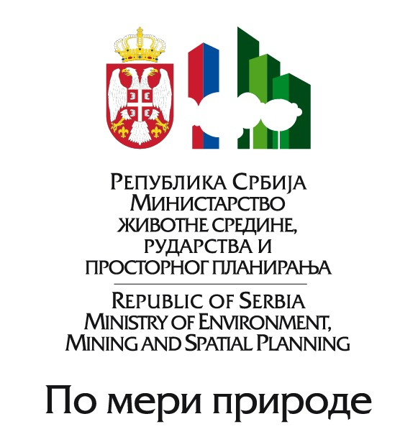

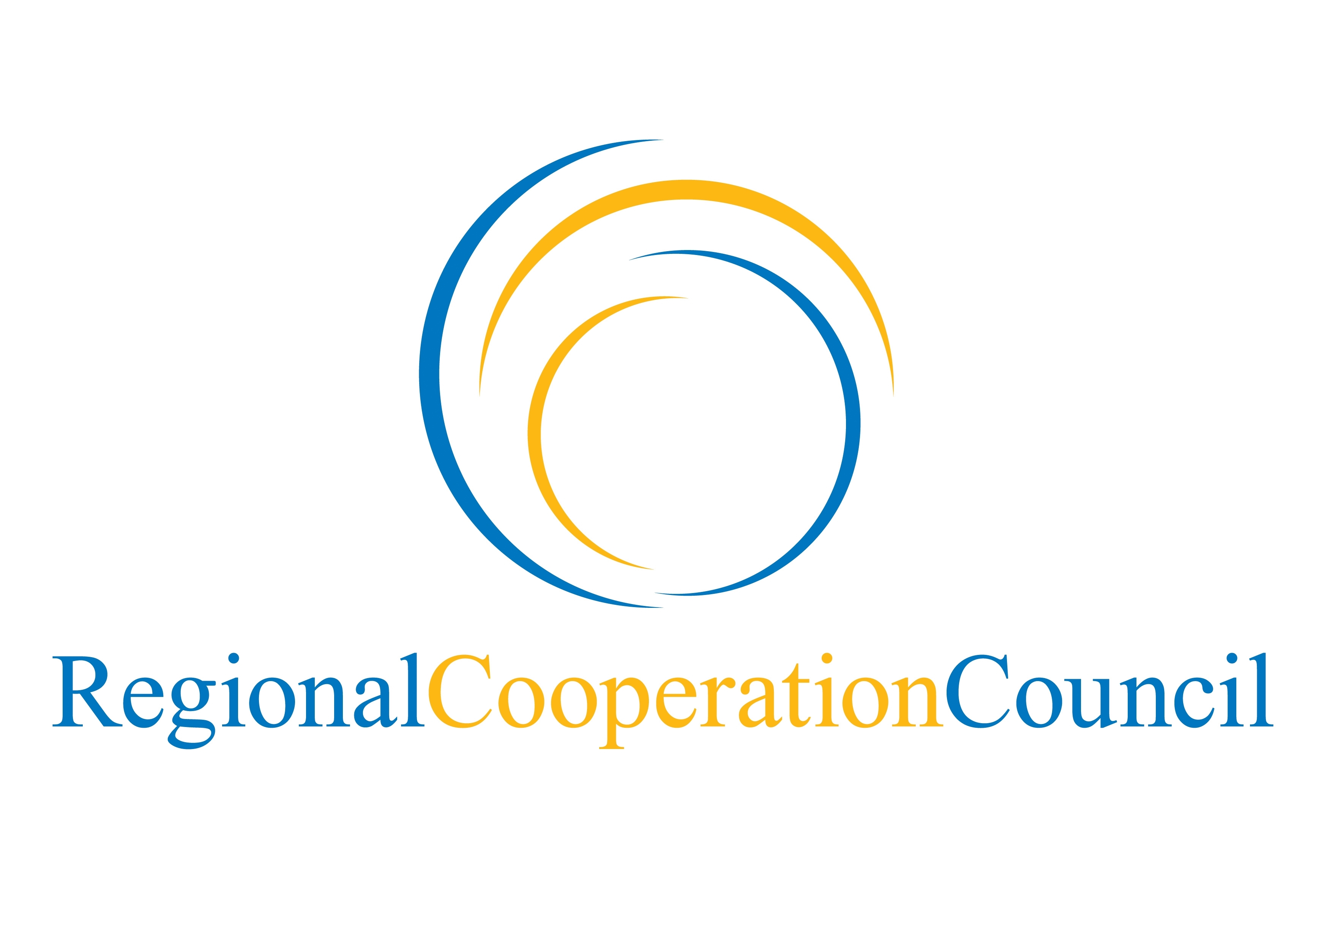

MINISTERIAL MEETING “CLIMATE CHANGE RESEARCH FOR ENVIRONMENTAL PROTECTION, ADAPTATION AND RISK REDUCTION”
Belgrade, Serbia, April 13, 2011
Venue: International Congress Cultural & Business Center “Sava”, Milentija Popovica 9

ANNOTATED AGENDA

13 April 2011
11:00-11:30 | Registration
11:30-11:45 | Opening and welcome addresses by Dr. Oliver Dulic, Minister of Environment, Mining and Spatial Planning; Opening statement by Representative of the USA Embassy in Belgrade (tbc)
11:45-12:15 | Key note address by Mr. Michel Jarraud, Secretary-General of World Meteorological Organization
12:15-13:00 | Setting the Scene:  The Directors of National Meteorological and Hydrological Services (NMHSs), the Regional Cooperation Council (RCC), and the Regional Environmental Center (REC) are invited to unfold the problem of Capacity building, Research and Development infrastructure investments in NMHS’s aiming to support the implementation of the UNFCCC. Review of the outcomes of the Expert meeting “SEE Research Framework in Regional Climate modeling for 2012-2017”
13:00-13:10 | Group photo
13:10-15:00 | Lunch
15:00-16:30 | Statements by Ministers:  The Ministers are kindly invited to present a statement with regard to their activities in connection to the climate change problem including, inter alia, research for environmental protection, adaptation and risk reduction. Ministers are kindly invited to present the situation in their respective countries with regard to the economic losses caused by extreme hydrometeorological events and their infrastructural requirements related to the implementation of the UNFCCC in the ministries, National Meteorological and Hydrological Services, and Environmental Protection Agencies.
16:30-17:00 | The Ministers are invited to consider the recommendations for international cooperation in climate change which will be delivered within the context of the UNFCCC Cancun Adaptation Framework, 4th IPCC Assessment Report and Global Framework for Climate Services. Recommendations will refer to the: capacity building, contribution to climate services, research and infrastructural investments in Hydrometeorological Services in SEE.
17:00-17:05 | Official Closing of the Ministerial meeting
17:05-20:00 | Sightseeing tour*
20:00-22:00 | Dinner hosted by the Ministry of Environment, Mining and Spatial Planning **

* Departure of the bus is planned for 17.20^{h} at the Hotel Continental entrance.
**The dinner will be at the restaurant “Caruso”, Terazije 23, 8th floor

