EL NIÑO/SOUTHERN OSCILLATION (ENSO) DIAGNOSTIC DISCUSSION

issued by

CLIMATE PREDICTION CENTER/NCEP/NWS
and the International Research Institute for Climate and Society
9 May 2013

ENSO Alert System Status: Not Active

Synopsis: ENSO-neutral is favored into the late Northern Hemisphere summer 2013.
During April 2013, ENSO-neutral continued, with near-average sea surface temperatures (SSTs) observed across most of the equatorial Pacific Ocean, and below average SSTs confined to the far eastern equatorial Pacific (Fig. 1). The Niño indices were near zero throughout the month, except for the Niño1+2 region which was between -1.2°C and -0.5°C (Fig. 2). The oceanic heat content (average temperature in the upper 300m of the ocean) remained near average during April (Fig. 3), reflecting near-average subsurface temperatures at depth across most of the central and eastern equatorial Pacific (Fig. 4). The tropical low-level easterly winds remained slightly enhanced over the western half of the Pacific basin, and anomalous upper-level westerly winds prevailed across much of the equatorial Pacific. Tropical convection was enhanced over Indonesia and the western Pacific and suppressed over the central Pacific (Fig. 5). Collectively, these conditions indicate the continuation of ENSO-neutral.
Most models forecast Niño-3.4 SSTs to remain ENSO-neutral into the Northern Hemisphere winter (Fig. 6), with dynamical models tending to predict warmer conditions (-0.3°C to 0.4°C) than the statistical models (-0.7°C to 0°C). There is still low confidence in the forecasts for the latter half of the year, partly because of the so-called “spring barrier,” which historically leads to lower model skill for forecasts made between March and May. Forecast confidence will increase over the next few months. The current forecast indicates that ENSO-neutral will likely continue into the second half of the Northern Hemisphere summer 2013 (see CPC/IRI consensus forecast).
This discussion is a consolidated effort of the National Oceanic and Atmospheric Administration (NOAA), NOAA’s National Weather Service, and their funded institutions. Oceanic and atmospheric conditions are updated weekly on the Climate Prediction Center web site (El Niño/La Niña Current Conditions and Expert Discussions). Forecasts for the evolution of El Niño/La Niña are updated monthly in the Forecast Forum section of CPC's Climate Diagnostics Bulletin. The next ENSO Diagnostics Discussion is scheduled for 6 June 2013. To receive an e-mail notification when the monthly ENSO Diagnostic Discussions are released, please send an e-mail message to: ncep.list.enso-update@noaa.gov.
Climate Prediction Center
National Centers for Environmental Prediction
NOAA/National Weather Service
College Park, MD 20740

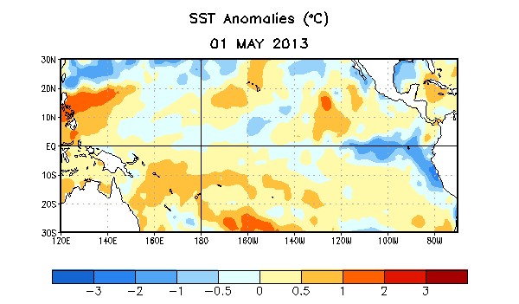
Figure 1. Average sea surface temperature (SST) anomalies (°C) for the week centered on 1 May 2013. Anomalies are computed with respect to the 1981-2010 base period weekly means.

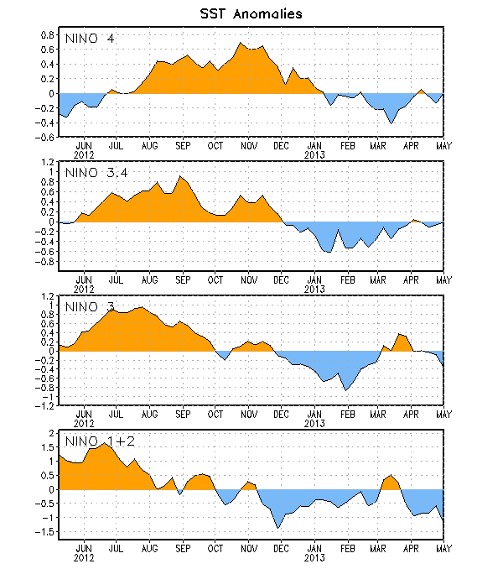
Figure 2. Time series of area-averaged sea surface temperature (SST) anomalies (°C) in the Niño regions [Niño-1+2 (0°-10°S, 90°W-80°W), Niño 3 (5°N-5°S, 150°W-90°W), Niño-3.4 (5°N-5°S, 170°W-120°W), Niño-4 (150ºW-160ºE and 5ºN-5ºS)]. SST anomalies are departures from the 1981-2010 base period weekly means.

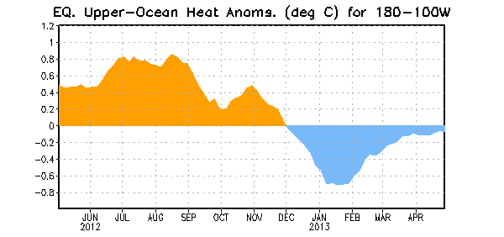
Figure 3. Area-averaged upper-ocean heat content anomaly (°C) in the equatorial Pacific (5°N-5°S, 180º-100ºW). The heat content anomaly is computed as the departure from the 1981-2010 base period pentad means.

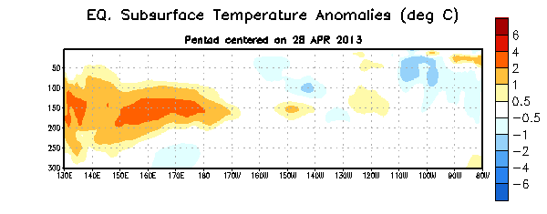
Figure 4. Depth-longitude section of equatorial Pacific upper-ocean (0-300m) temperature anomalies (°C) centered on the pentad of 28 April 2013. The anomalies are averaged between 5°N-5°S. Anomalies are departures from the 1981-2010 base period pentad means.

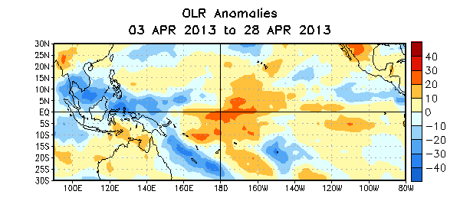

Figure 5. Average outgoing longwave radiation (OLR) anomalies (W/m²) for the four-week period 3 – 28 April 2013. OLR anomalies are computed as departures from the 1979-1995 base period pentad means.

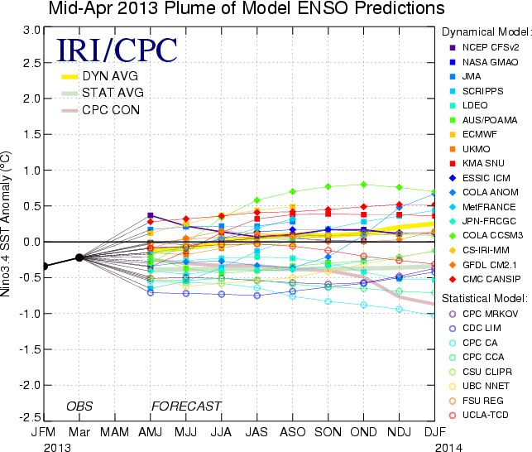
Figure 6. Forecasts of sea surface temperature (SST) anomalies for the Niño 3.4 region (5°N-5°S, 120°W-170°W). Figure courtesy of the International Research Institute (IRI) for Climate and Society. Figure updated 16 April 2013.

