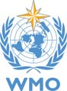
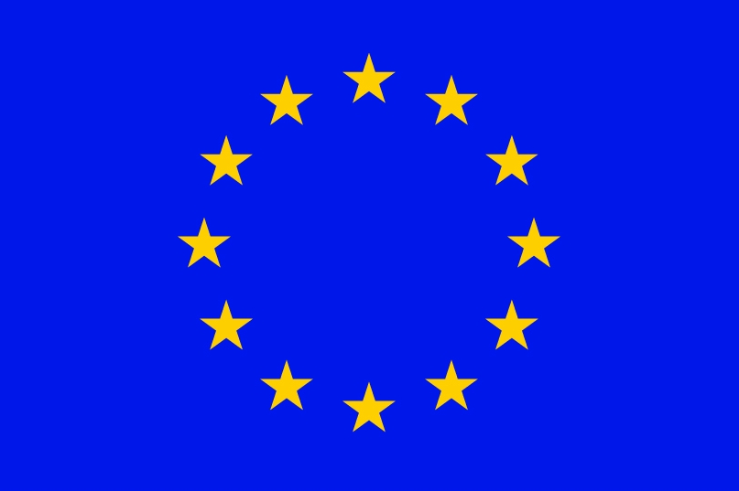
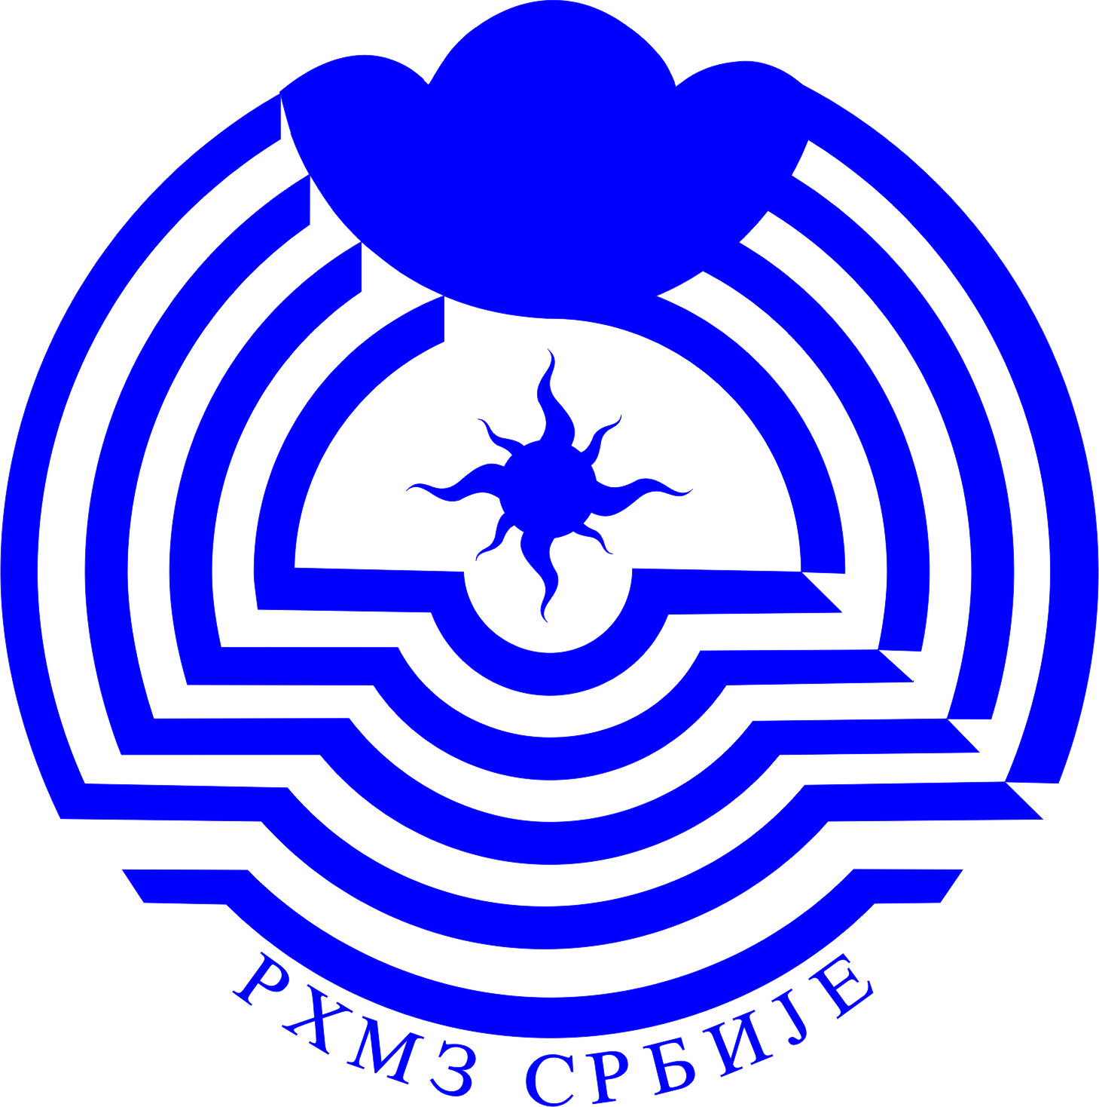
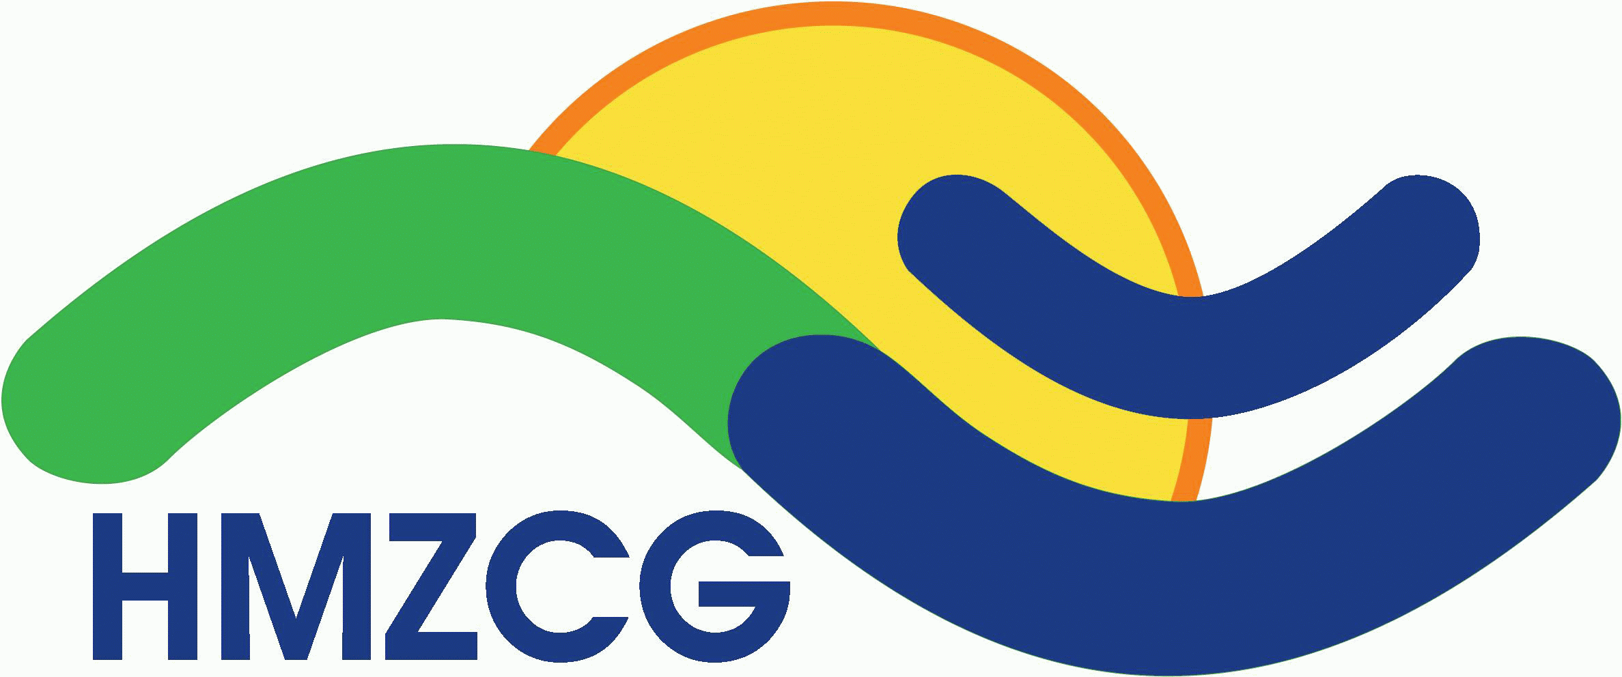

The Eighth Session of the S-E European Climate Outlook Forum (SEECOF-8)
27-29 November 2012, Podgorica, Montenegro

LIST OF PARTICIPANTS

