



Seventh Session of
SOUTHEASTERN EUROPE CLIMATE OUTLOOK FORUM

SEECOF-7 ONLINE MEETING

ANALYSIS AND VERIFICATION OF SEECOF-6 CLIMATE OUTLOOK
FOR 2011-2012 WINTER SEASON FOR SOUTHEASTERN EUROPE (SEE)

CLIMATE OUTLOOK FOR 2011-2012 WINTER SEASON FOR SEE REGION

As stated in the SEECOF-6 Seasonal Climate Outlook for 2011-2012 winter season over Southeastern Europe Consensus Statement (document http://www.seevccc.rs/wp-content/uploads/2011/11/Consensus_Statement_SEECOF-6.pdf). “In summary, current indications are for increased likelihood (relative to climatology) of drier-than-average conditions over most of the Balkan Peninsula (except southernmost parts – zone 1 in Figure 1, right panel) and for southeastern parts of the region (zone 3 in Figure 1, right panel). For the rest of the region (zone 2 in Figure 1, right panel), local influences make the near-normal category most likely. It must be emphasized that even in the event of seasonal totals below the long-term average, shorter spells of heavy precipitation are still possible. Although clear, the precipitation signals for this season are not strong (see predicted probabilities).
This winter, uncertainties in regional predictions for temperature are larger than for precipitation. In summary, there are higher probabilities for below-average than for near– or above–average temperatures in the northeastern part of the region (zone 3 in Figure 1, left panel). By contrast, in southeastern parts (zone 2 in Figure 1, left panel), warmer-than-average conditions are predicted as most likely. For the western and central parts of the SEECOF region (zone 1 in Figure 1, left panel) the uncertainty is large: probabilities for below-, near- or above-average conditions are approximately equal. Though colder-than-average temperatures are possible at times, it is unlikely that values will be as low as last winter“.
Climate outlook for 2011-2012 winter season for the SEE region is presented in Figure 1.

2011/2012 winter temperature outlook | 2011/2012 winter precipitation outlook
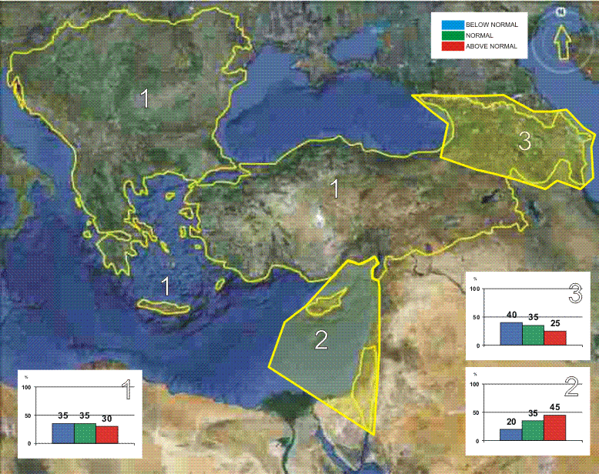 | 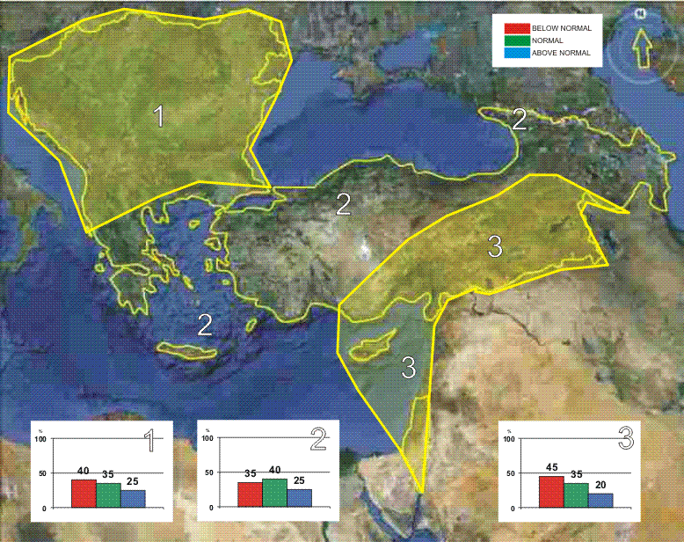
Figure1. Graphical presentation of climate outlook for 2011-2012 winter season for the SEE region.

SHORT ANALYSIS OF THE 2011-2012 WINTER SEASON FOR SEE REGION

Analyses of the 2011-2012 winter season temperature and precipitation anomalies are based on:
- operational products of the European Climate System Monitoring – ECSM (the ECSM system is a technical platform of the DWD), Lead of the WMO RA VI RCC Node on Climate Monitoring, http://www.dwd.de/rcc-cm;
- climate monitoring review of 2011-2012 winter season, (ECSM, DWD, Lead of the WMO RA VI RCC Node on Climate Monitoring), http://www.seevccc.rs/SEECOF/SEECOF-7/STEP%201/RCC_CM_DWD_2011_2012_Winter_season.pdf
- climate monitoring products of the South East European Virtual Climate Change Center - SEEVCCC (Member of the WMO RA VI RCC Node on Climate Monitoring, http://www.seevccc.rs/?p=6 ), and
- National climate monitoring reports of the following SEECOF-6 participating countries: Armenia, Bulgaria, Bosnia and Herzegovina/Federation of Bosnia and Herzegovina, Bosnia and Herzegovina/ Republic of Srpska, Croatia, Cyprus, Greece, Georgia, Former Yugoslav Republic of Macedonia, Republic of Moldova, Montenegro, Romania, Serbia, Slovenia and Turkey (documents available on http://www.seevccc.rs/SEECOF/SEECOF-7/STEP%201/).

Seasonal mean temperature of winter 2011-2012 in the Eastern Mediterranean was between 5ºC and 10ºC; in the Pannonian Plain and near the coasts temperature ranged from 0ºC to 5ºC. In most of the SEECOF region it ranged from -5ºC to 0ºC, while in some parts of eastern Turkey and in the south of Caucasus it was from -15ºC to -10ºC. Seasonal mean temperatures for winter 2011-2012 are presented in Figure 2 (left panel).

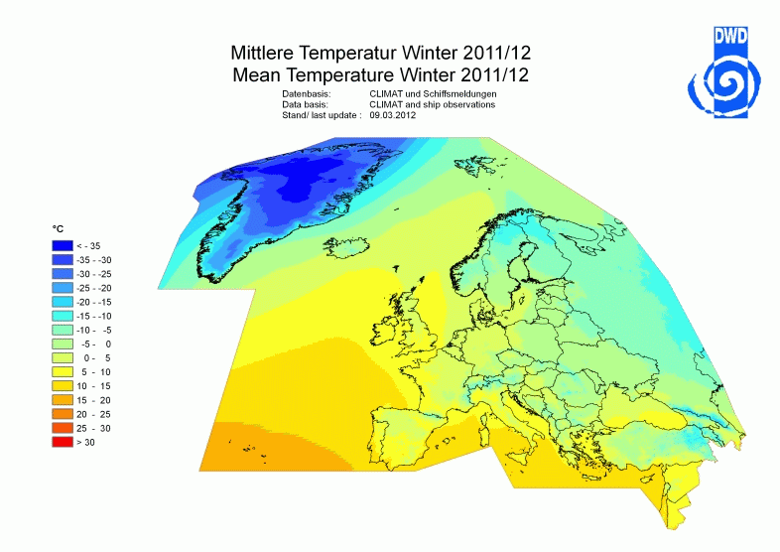 | 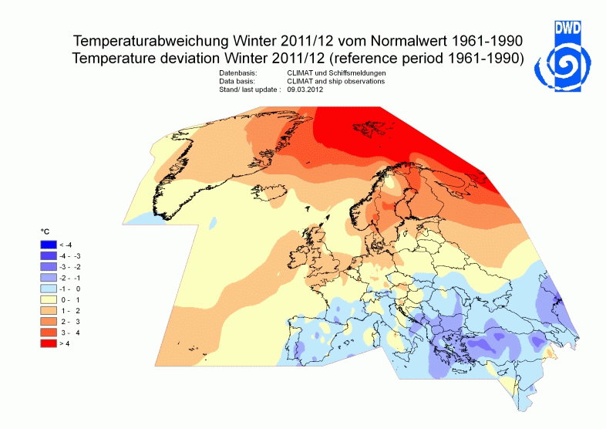
Figure 2. Observed 2011-2012 winter season mean temperatures (left panel) and winter season temperature anomalies (right panel). Source: http://www.dwd.de/rcc-cm
Winter was colder than normal in the central and southern parts of the Balkan Peninsula, eastern Mediterranean, western and central part of Turkey. In some parts of Turkey mean winter anomalies reached almost 3ºC. On the other hand, it was slightly colder than normal (anomalies were between -1ºC and 0ºC, 1961-1990 reference period) in the south of the Pannonian Plain, in the Carpathian region, Caucasus, in the southeastern banks of the Mediterranean Sea and northeastern banks of the Black Sea. Winter was normal only in the western Balkans.
Cold anomalies in the almost whole SEECOF region mainly occurred due to a cold spell in the late winter. After unusually mild weather in December 2011 and in early January 2012, the weather situation changed abruptly in the second half of January. An incursion of extremely cold continental air, coming from northern Russia, brought a sudden cooling to the almost whole SEECOF region. During that cold spell, there has also been considerable snowfall over the SEECOF region due to several intense low pressure systems which developed over the Mediterranean Sea. In the first half of February, the cold wave started weakening, first in the east and then, in mid-February, in the other parts of the SEECOF region as well. Minimum temperatures went down for more than 20 degrees and, for example, in Belgrade, they dropped even below the 2% percentile. During the period from 25 January to 16 February 2012, northern Moldova experienced minimum temperatures of around -30ºC. In the Pannonian Plain minimum temperatures below -20ºC were observed in many places. The Balkan Peninsula had minima mostly below -10ºC, locally below -30ºC in the highlands of Romania and Turkey and down to around -24ºC in northern Greece and northern Serbia. However, most of these minimum temperatures were not new records. Local records were broken e.g. in Bulgaria and Serbia (Novi Sad -26.7ºC). An example of time series of daily minimum temperature in the period December 1, 2011 – February 29, 2012 for selected stations in the SEECOF region can be seen in Figure 4. Mean minimum temperature of the cold spell in most of the SEECOF region was below -10ºC. The exception was in the south of the Balkan Peninsula, near the coasts, in the eastern Mediterranean, with the values between 0ºC and 5ºC. Most areas were even more than 5ºC colder than normal; the peak minima were even 10ºC (Figure 3, left panel).

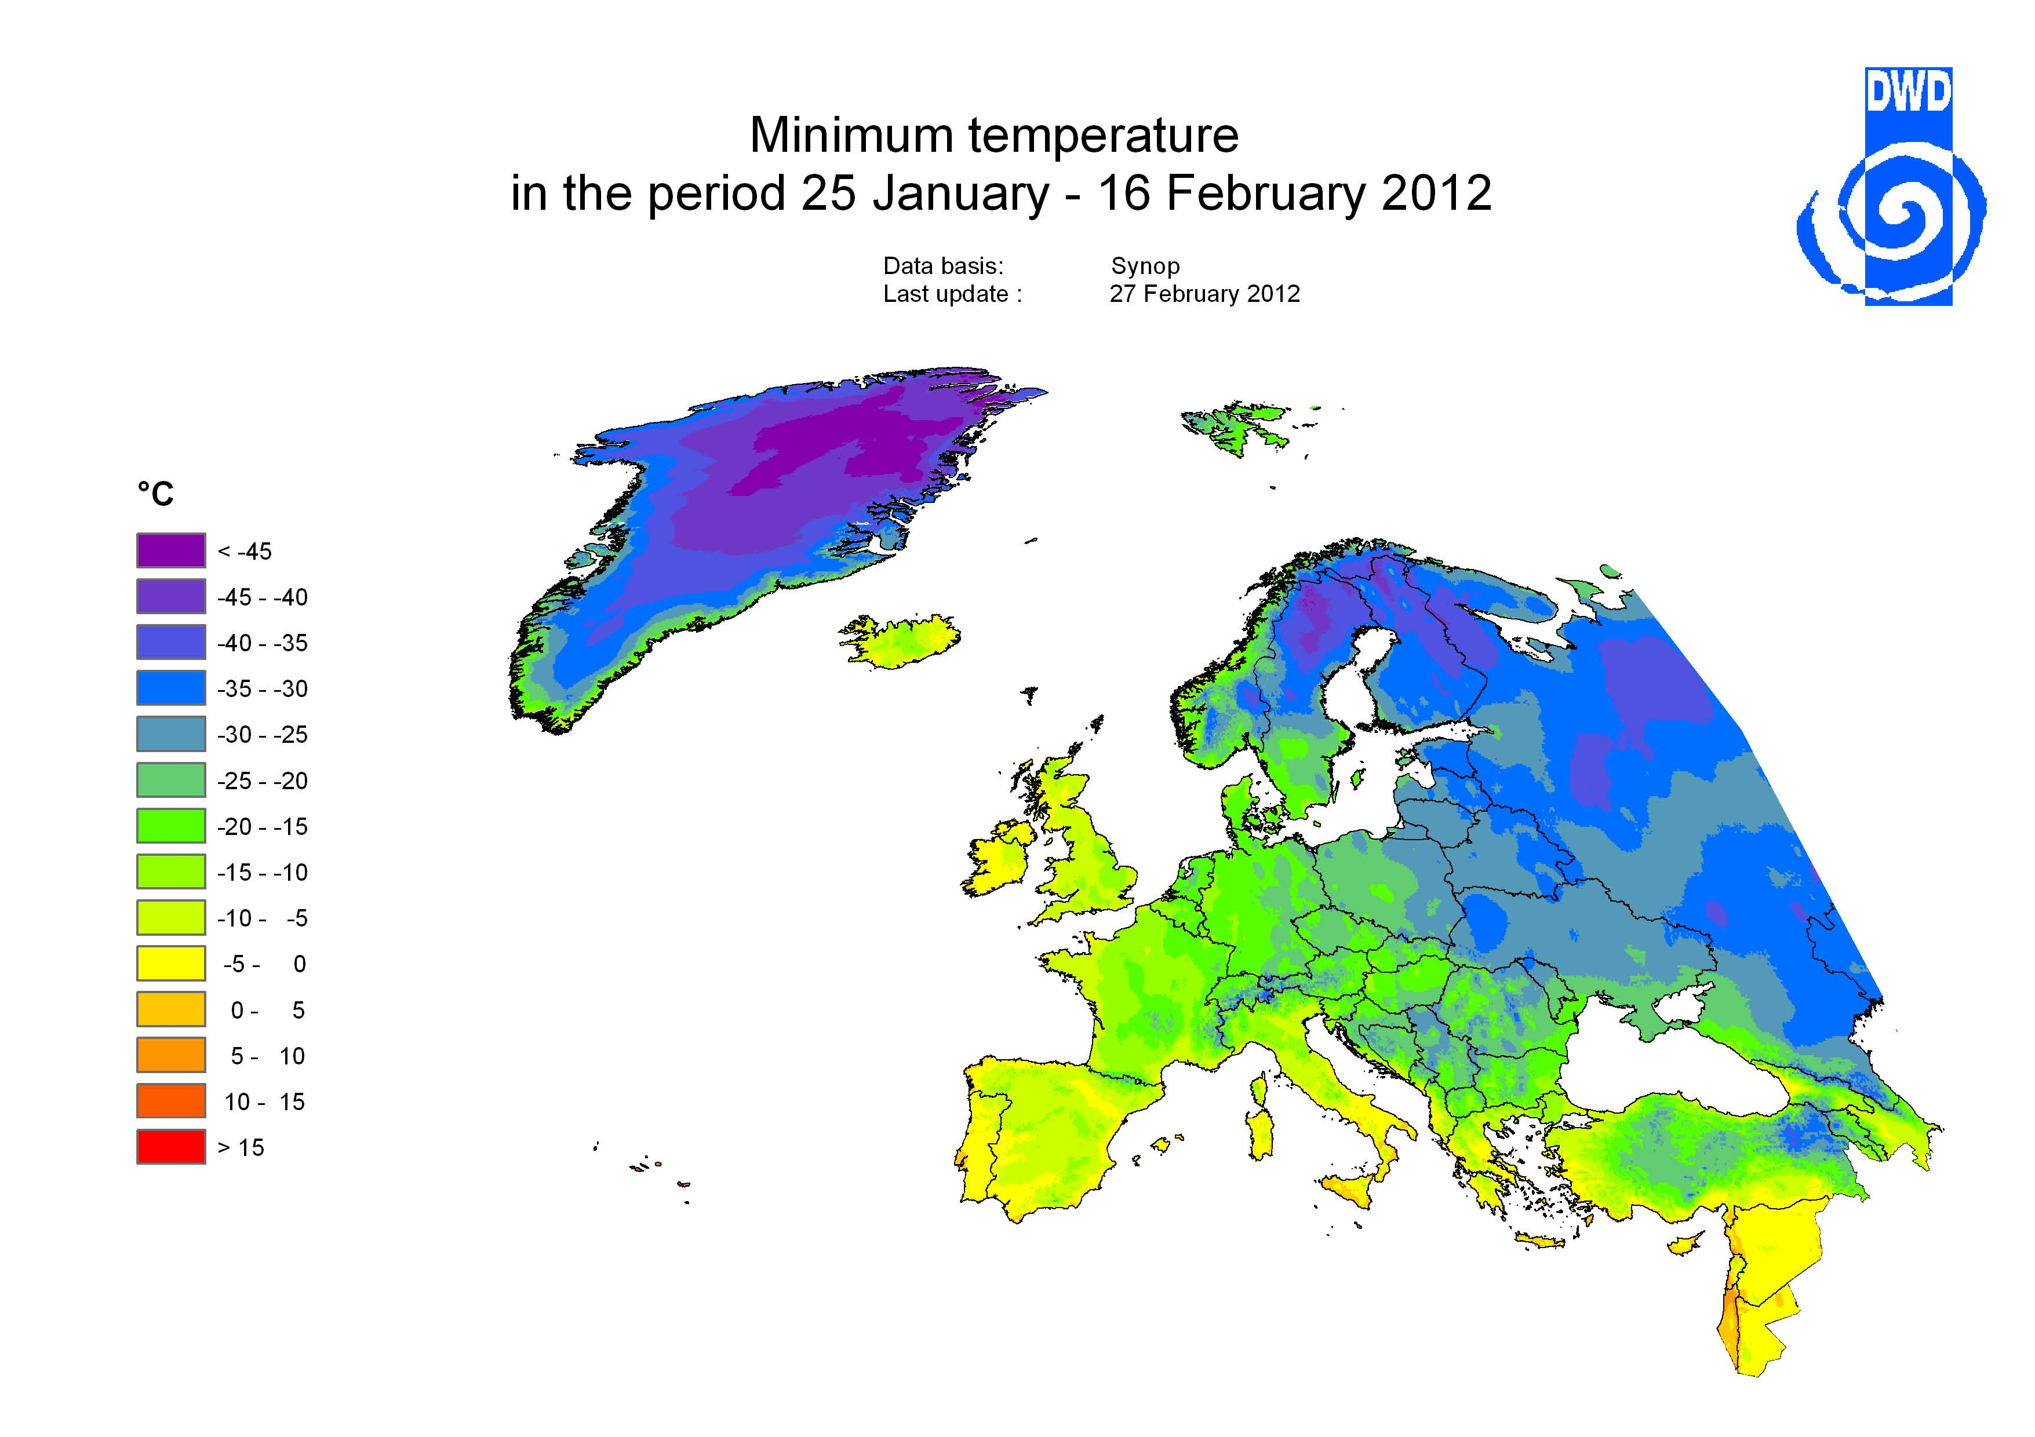 | 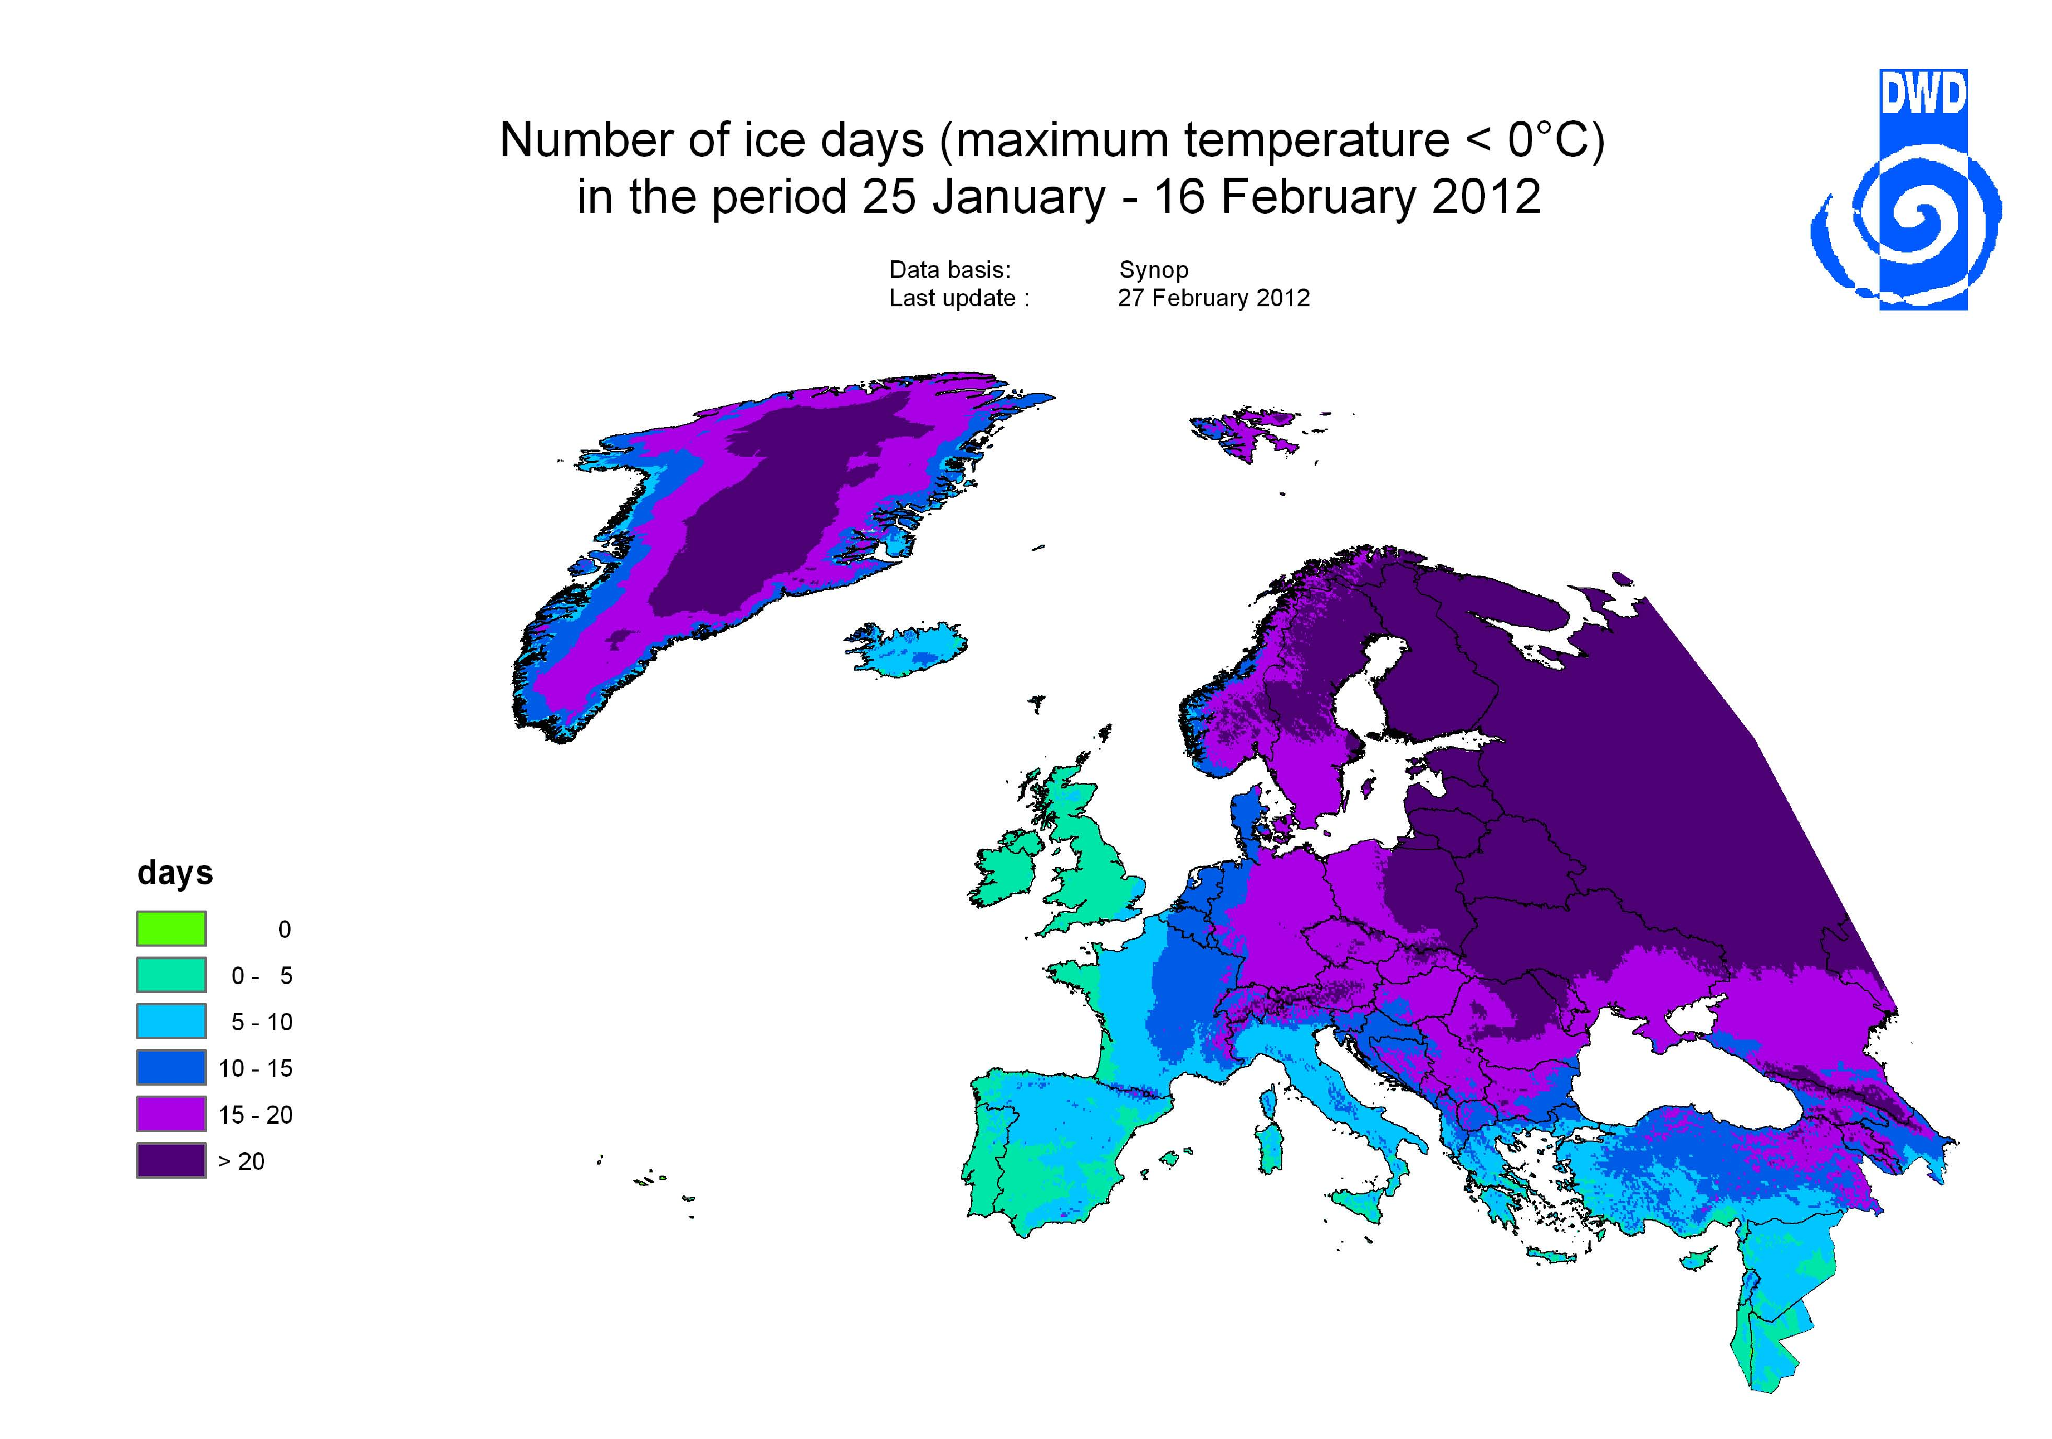
Figure 3. Minimum temperature (left panel) and number of ice days (maximum temperature < 0ºC) (right panel) in the period January 25 - February 16, 2012. Source: http://www.dwd.de/rcc-cm

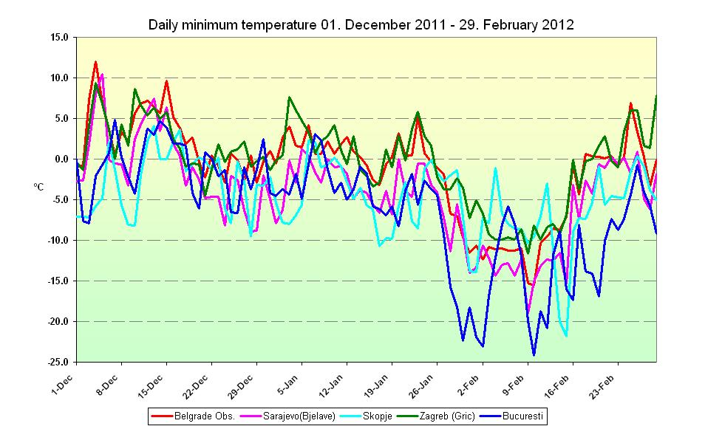 | 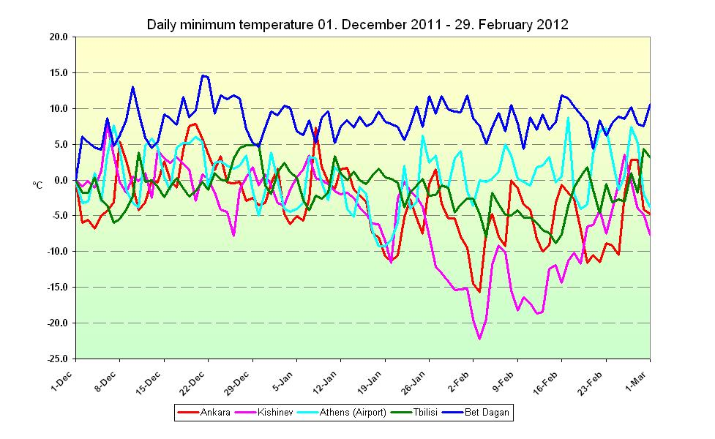
Figure 4. Time series of daily minimum temperature in the period December 1, 2011 – February 29, 2012 for selected stations in the SEECOF region. Source: http://www.seevccc.rs

Maximum temperatures remained below 0ºC (defining ice days) during several successive days almost throughout the whole SEECOF region (Figure 3, right panel). This is usual for the inner parts of the region, but not necessarily for the southern parts, especially for coastal areas, where not more than 5 ice days (days with maximum temperature below 0ºC) are normally recorded in average. Prolonged frost widely occurred even in the above mentioned areas. The northeastern part of the Carpathian region had nearly 20 successive ice days only during the cold spell, while, in February, normal was around 10. Likewise, the long frost period over the Balkan Peninsula and around the Black Seas was highly unusual. Parts of the Black sea were frozen.
Winter precipitation totals over the SEECOF area ranged from less than 20 mm/per month in the east of the Caucasus, up to more than 150 mm/per month in the Eastern Mediterranean, in the eastern coasts of the Aegean Sea, in the inland of western Turkey, along the coasts of the southern Adriatic Sea, the Ionian Sea and in the south of Greece. Some parts along the coasts of the Eastern Mediterranean and the Eastern Aegean Sea took more than 200 mm/per month of the winter precipitation (Figure 5, left panel).

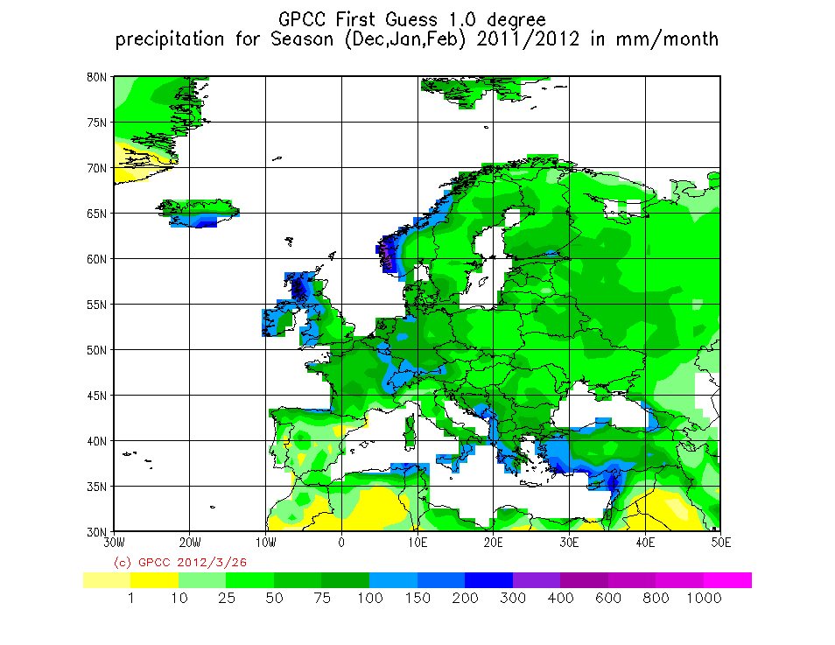 | 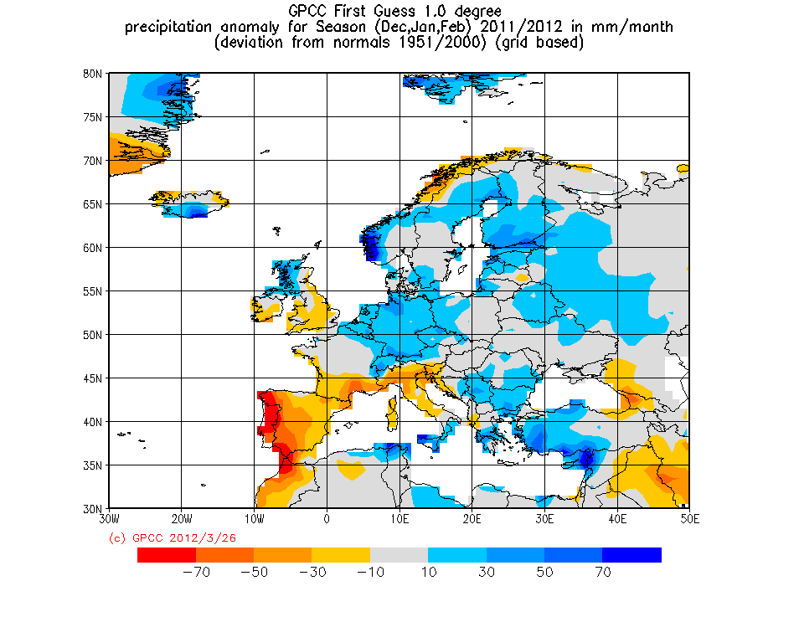
Figure 5. Observed 2011-2012 winter season precipitations in mm per month (left panel) and 2011-2012 winter season precipitation anomalies in mm per month (right panel). Source: http://www.dwd.de/rcc-cm

Winter precipitation anomalies were very diverse within the SEECOF area. It was drier than normal (less then 75%) in the Caucasus region and the northeastern coasts of the Black Sea, Slovenia, in the northern and central Adriatic Sea with inland and some parts of continental Greece. It was, in contrast, wetter than normal (more then 125%) in some places in the far south of Greece, in the northeastern coast of the Mediterranean Sea, in the southwestern coast of the Black Sea, in the eastern parts of Turkey and in some parts of the central and eastern Balkans. The 1951-2000 period was used as a reference period. The 2011-2012 winter season precipitation anomalies are presented in Figure 5 (right panel).
December 2011 was wetter than normal in the Carpathian region. Heavy precipitation was widespread, mostly over the Adriatic Sea with inland, Slovenia and the south banks of Turkey. In this area it was perpetually traced with strong wind, tornados and hail, producing damage. It was, on the other hand, partly dry in the Balkan Peninsula, along the banks of the eastern Mediterranean and along the banks of the eastern and southeastern Black Sea. Most part of the Balkan Peninsula was suffering from a major drought in December. In Serbia, the flow of the Danube River, one of Europe’s largest rivers and busiest shipping routes, decreased to record low levels, stranding about 80 cargo ships at the Serbia-Hungary border. Sunken World War II ships surfaced on the river, and unexploded bombs that fell during the 1940's were found along the Sava River, also in Serbia. In Bulgaria, the Danube was at its lowest level in 70 years and shipping in many areas was forced to halt. At the end of January and at the beginning of February, cold air, together with a strong moisture flux from the central Mediterranean, caused heavy snowfall over parts of southeastern Europe such as the Balkans, Romania, Bulgaria and Turkey. The Balkan Peninsula suffered from snowstorms over and near the Adriatic Sea. Snow depths between 10 cm and 20 cm occurred in the northern and central part of and near the Adriatic, as well as in northern Greece, which is not usual for the Mediterranean region. Locally, snow depths were very high. Snow was widespread and particularly abundant in the Balkan Peninsula; deep snow covers of 50 cm to 100 cm were reported in many places and over 100 cm in the mountain regions of southeastern Europe. Eastern Turkey received up to 3 m of snow in valleys in 1000 m to 1500 m altitude and up to 6 m in higher mountains.
Although the cold spell in the above mentioned period has not been the most severe one since the last century, it was nevertheless a very serious one because it caused many fatalities, economic losses and much discomfort to daily life.
Health problems and accidents were the most serious difficulties. Throughout the SEECOF region (particularly Romania, but also in many other countries), many deaths caused by freezing were to be mourned, especially among the homeless people. Furthermore, medical treatment of frostbite, under cooling and fractures was requested in many cases.
Traffic was much affected. Numerous accidents occurred due to slippery roads. In Romania, Bulgaria and Montenegro, many national roads had to be closed. Buses in Istanbul had to stop service due to high snow loads on the roads. Many flights had to be cancelled or airports had to close temporarily, e.g. in Turkey (Istanbul). Delayed arrivals of trains or even cancellations due to heavy snowfall were reported frequently. Ship traffic was also much affected on some rivers due to freezing, even on larger rivers, e.g. the Sava and the Danube. Ferries in the Aegean Sea had to be cancelled due to stormy winds.
Daily life was affected notably. Many schools were closed for several days due to insufficient heating of school buildings. In Serbia, the government ordered a week-long holiday to save electricity. Households were cut off from electricity in most of the Balkan Peninsula due to high snow loads. Snow-bound villages in Slovenia, Bosnia and Serbia were isolated from the outside world; people had to be saved by helicopters or supplied with food.
In the southern parts of Europe (particularly in the Alpine region and the northern Balkan Peninsula), cold and snowy weather was also related to stronger-than-usual winds, which caused additional discomfort due to a high wind chill. Gusts of more than 125 km/h were measured in valleys in Slovenia, causing damage to agriculture due to wind erosion.

VERIFICATION OF CLIMATE OUTLOOK FOR 2011-2012 WINTER SEASON
The SEECOF-6 climate outlook for 2011-2012 winter season concluded that precipitation increased the likelihood of below than normal conditions over most of the Balkan Peninsula and over the southeastern parts of the SEECOF region. This was partly correct since, in fact, observed winter precipitation in the western parts of the Balkan Peninsula, in the northern Adriatic, in some areas of mid Adriatic with hinterland, in the northern part of Greece, as well as in the south-eastern part of Turkey and Israel, was below normal. On the other hand, 2011-2012 winter precipitation near or above normal observed in the central and eastern part of the Balkan Peninsula was not clearly predicted. For Caucasus and for the most part of Greece and most of Turkey, probabilities for below-, near, or above-normal conditions were approximately equal, so it is impossible to consider verification of climate outlook for 2011-2012 winter season precipitation.
Climate outlook for 2011-2012 winter season temperature, as it was outlined in the Consensus Statement, had higher uncertainties for temperature than for precipitation. In most of the Caucasus, 2011-2012 winter season temperature was below-normal or normal, which is in accordance with the climate outlook for winter season temperature. Also, the climate outlook for the 2011-2012 winter season temperature in the western Mediterranean and in Israel predicted normal or above normal conditions, which was correctly predicted. On the other hand, in the whole region of the Balkan Peninsula and Turkey uncertainty was highest and probabilities for below-, near, or above-normal conditions were approximately equal, so it is impossible to consider verification of climate outlook for 2011-2012 winter season temperature.

APPENDIX A: Contributions to Step 1 of SEECOF-7

- World Meteorological Organization
- Met Office, United Kingdom
- International Research Institute for Climate and Society, United States of America
- European Center for Medium Range Weather Forecast
- Meteo France, Republic of France
- Federal Service for Hydrometeorology and Environmental Monitoring, Russian Federation
- Deutscher Wetterdienst, Federal Republic of Germany
- National Centers for Environmental Prediction, United States of America
- South East European Virtual Climate Change Center hosted by Republic Hydrometeorological Service of Serbia, Republic of Serbia
- Armenian State Hydrometeorological and Monitoring Service, Republic of Armenia
- National Institute of Meteorology and Hydrology, Republic of Bulgaria
- Meteorological and Hydrological Service, Republic of Croatia
- Meteorological Service, Republic of Cyprus
- Hellenic National Meteorological Service, Greece
- The National Environmental Agency of Georgia, Georgia
- Republic Hydrometeorological Institute, Former Yugoslav Republic of Macedonia
- State Hydrometeorological Service, Republic of Moldova
- Hydrometeorological Institute of Montenegro, Montenegro
- National Meteorological Administration, Romania
- Federal Hydrometeorological Service of the Federation of Bosnia and Herzegovina, Federation of Bosnia and Herzegovina, Bosnia and Herzegovina
- Republic Hydrometeorological Service of the Republic of Srpska, Republic of Srpska, Bosnia and Herzegovina
- Republic Hydrometeorological Service of Serbia, Republic of Serbia
- Environmental Agency of the Republic of Slovenia, Republic of Slovenia
- Turkish State Meteorological Service, Republic of Turkey

APPENDIX B: Analysis and verification of SEECOF-6 climate outlook for the 2011-2012 winter season:
Verification summary based on national reports and contributions of the participants of SEECOF-7 online meeting

Country | Seasonal temperature  (DJF) |  | Seasonal precipitation  (DJF) |  | High Impact Events
Country | Observed | SEECOF-6 climate outlook for  temperature | Observed | SEECOF-6 climate outlook for precipitation | High Impact Events
Armenia  (1) | Normal | Normal  to  Below normal | Normal | Normal  (No predictive signal) | On December 21 in Pushkin strong wind with the average value of 26 m/s with gust of 38 m/s was observed.  In Gyumri on January 19 and February 1 strong wind with the average value of 15 m/s and gust of 25 m/s was measured.
Bosnia and Herzegovina, Federation of Bosnia  and  Herzegovina  (1) | Below normal  in the most of the country | Normal  (No predictive signal) | Below normal in the far southwest part  Normal in the western part  Above normal in the  most of the country | Below normal | In February, extreme cold was recorded on many stations all over the country, such as Bihac, Bugojno, Ivan Sedlo, Livno, Mostar, Sarajevo, Sanski Most, Stolac, Tuzla and Zenica.  In February, maximum height of snow cover since the beginning of official measurements has been measured on MS Sarajevo and MS Mostar (MS Sarajevo: 107 cm, MS Mostar: 85 cm).
Bosnia and Herzegovina, Republic of Srpska,  (5,6) | Below normal in the most of territory  Normal  in northern part of the country | Normal  (No predictive signal) | Near normal  to  Above normal  In the most of the country  Below normal in the northwestern part of the country | Below normal | Extreme cold weather occured in February, with unusual depth of snow cover, number of freezing days and winter mean temperature anomaly from -0.4ºC in the north to -2.8ºC in the central and southern part of RS.  Measured temperature minimum at most stations was below  -20ºC (Gacko and Sokolac: -28ºC; Drinic: -27ºC; Bijeljina:  -26.6ºC; Srbac: -26.1ºC), except in the southern part of the country (Trebinje: -7.9ºC).  Daily snow cover maximum at most places on February 13th ranged from 34 cm in Prijedor to 218 cm in Cemerno (Banja Luka: 41cm; Bijeljina: 40cm; Sokolac: 92cm; Bileca: 64cm; Trebinje: 18cm).  According to the total accumulation of snow, February 2012 in most areas achieved the second maximum value in the last 25 years (primary maximum occured in 2005).
Bulgaria  (1,5) | Below Normal | Normal  (No predictive signal) | Above Normal | Below normal | The month of February 2012 was extremely cold with mean monthly temperatures in North Bulgaria of up to 6-7ºC below average. The lowest temperature measured last winter was  -31.4ºC in Sevlievo, North-central Bulgaria, on February 1st, 2012.  There was continuous snow cover almost everywhere in the country from late January to late February, which was rather exceptional. In Sofia, the capital city, there was continuous snow cover from late December to the beginning of March, which is also rare. Maximum snow depth in the mountain stations reached levels above 200 cm, which is also rather rare. There was a strong precipitation event around February 5-6, 2012, mostly in the southeastern part of the country. In the Eastern Rhodope Mountains in the south the reported 24h-precipitation amounts were up to 179 mm and above 100 mm in numerous stations in the region. This event was also associated with a sudden warming in the region. The combined rapid snow melt due to the warming and the abundant rain triggered the collapse of the wall of a small local water reservoir in the Eastern Rhodope Mountains. This caused a sudden flooding of villages along the river below. There were casualties and property loss.
Croatia  (1) | Normal  in the most of the country  Below Normal  in some areas in the hinterland of the northern Adriatic, an area of the middle Adriatic with its hinterland and an island of the southern Adriatic | Normal  (No predictive signal) | Normal  in the most of the country  Below normal  in area of the northern Adriatic and some area of the middle Adriatic with its hinterland | Below normal | No comments for high impact events
Cyprus  (1) | Normal | Above normal | Above normal | Below normal | Hail was recorded during December 8, 9 and 23.  On January 1st, a large number of thunderbolts were recorded in Stavrovouni area, while on January 8, thunderbolts in Kellaki affected the electricity supply of the area. Hail was recorded on January 7, 12, 15 and 26.  On February 28th, with the exception of mountainous areas, snow was also recorded in semi-mountainous areas. On the same day, severe hailstorm was recorded in Ankrounda. On February 29th, snow also fell in the mountainous, semi-mountainous areas and in some inland areas, specifically in the area of Nicosia.
Georgia  (1) | Near normal in west part and in mountains of east part of country  Below normal in plains of east Georgia | Normal  to  Below normal | Below normal to Normal  in the most of the territory  Above normal in Kakheti in east part of country | Normal  (No predictive signal) | No comments for high impact events
Greece  (1) | Below normal | Normal  (No predictive signal) | Below normal in the north part  Above normal in the west Greece, east Aegean Sea and Crete  Normal  in the rest of the country | Below normal  in northern and northwestern part  Normal  (No predictive signal) | January 2012 was, in general, characterized by unusually low temperatures, mainly over the northern and central parts of the country, accompanied by strong frosts, and long lasting snowfalls. It is remarkable that a new record of minimum temperature (-25.1ºC) was set in Florina (old record was  -21.0ºC, set in 1989). Moreover, heavy rainfall and hail were recorded over the southern parts, and gale force winds prevailed at times.  February 2012 followed January and presented a similar behavior. Thus, it was a month with much lower mean temperatures than normal values. In addition, heavy snowfall and high rainfall amounts were recorded in most areas of the country.
Former Yugoslav Republic  of Macedonia  (1) | Below normal | Normal  (No predictive signal) | Above normal | Below normal | No comments for high impact events
Republic of Moldova  (1,2) | Below normal | Normal  (No predictive signal) | Above normal in the most of the country  Normal in some central areas of the country | Below normal | In December, the average monthly temperature exceeded the norm by 3-4°С, which is, in average, observed once in 10 years.  During the first two decades of February, abnormally cold weather was observed in the Republic. Average air temperature for this period was 7-12°C below the norm. Such figures have been observed for the third time since the beginning of instrumental observations.  It was especially cold on February 2 and 12, when in some areas of the northern part of the republic average daily temperature decreased up to -21.5°C .. -24.1°C, which has been, for this month, observed for the first time in the last 50 years. Average air temperature in February was 5-7ºС below the norm, which, in the Republic of Moldova, in average happens once in 15 years.  Minimum air temperature during the winter season reached -32.0ºС (February 12, MS Balti), ranking 3rd in the range of minima since the beginning of instrumental observations. Air temperature maximum during the season was +17ºC (December, MS Cahul).  The number of days with minimum air temperature of ≤ -15ºС during the season on the territory of the country measured 10-17 days (the norm is 4-11 days), which is observed once in 5-10 years (analogue season is 1984-85). The number of days with minimum air temperature ≤ -20ºС was 2-10 days (the norm is 1-4 days), which is observed in average once in 5-15 years.  The number of days with minimum air temperature of ≤ -25ºС measured 1-4 days (the norm is one day), which is observed once in 15 years. The number of days with minimum air temperature ≤ -30ºС was one day (the norm is one day), which is observed once in 20 years.
Montenegro  (1) | Normal  to  Below normal | Normal  (No predictive signal) | Normal | Below normal | From February 1 to 8 a strong cyclonic activity occurred over Montenegro with an exceptional amount of snowfall in the whole state – from the coastal area up to the mountains (example: February 7 - strong wind gusts and heavy snowfall).  At the end of the cyclonic activity on February 8, snow height in some parts of Montenegro was over 100 cm (e.g. in Zabljak 175 cm, Kolasin 123 cm, Plav 115 cm, and Rozaje 103 cm).  A new cyclonic activity started during the night of February 10 with heavy snowfall. Snow was falling up to 10 hours with exceptionally high intensity especially in the surroundings of Kolasin, Cetinje and Niksic. The consequences were new records in snow height (over those from half a century ago). Due to the exceptional snowfall events, the state of emergency was proclaimed.  In comparison to the previous extreme winter situations, i.e. in 1954, 1963, and 2005, the extreme winter of 2012 was also exceptional due to the highest intensity of snowfall ever recorded.
Romania  (1) | Below normal  in the most of the country  Normal in northwestern and central  region of the country | Normal  (No predictive signal) | Above normal in the most of the country  Normal in several parts of the country | Below normal | The February extremely cold episode which imprinted its characteristics over the whole winter was accompanied by abundant snowfall. Strong winds blew snow causing problems in Romanian villages, especially in the southeastern and eastern regions of the country.  The subjective perception among outlook users has been that the winter was a very severe one, even though from the climatological point of view it was not in the top of the most severe winters in Romania: the first 7 weeks of the winter even had milder conditions than normal for that time of the year.
Slovenia  (1) | Above normal | Normal  (No predictive signal) | Below normal | Below normal | There was a major cold period in the first half of February (comparable to one in February 1956) with several cases of the very strong bora wind. Maximum air temperature in Ljubljana was below 0ºC for 14 consecutive days between January 31st and February 13th, 2012. On the other hand, absolute maximum temperatures above 20ºC were recorded at the end of February - breaking 100-year records.
Serbia  (1,2,5) | Below normal in the most of the country  Normal in the northern part the country | Normal  (No predictive signal) | Above normal in the most of the country  Normal in the farthest east of the country | Below normal | During the cold spell that lasted from January 19th to February 13th, absolute temperature minimum for January, with the value of -28.7ºC, was recorded in Sjenica on January 31st; on February 9th, absolute temperature minimum for February, with the value of -28.7ºC, was recorded in Novi Sad and, with the value of -24.0ºC, in Surcin, while, on the same date, absolute yearly minimum was surpassed in Banatski Karlovac with -28.1ºC temperature.  Snow was widespread and particularly abundant in Serbia; deep snow covers of 40 cm - 120 cm were reported in many places, over 100 cm in mountainous regions and up to 162 cm in higher mountains.  Health problems and accidents were the most serious difficulties. Throughout Serbia many deaths caused by freezing were to be mourned, especially among the homeless people. Furthermore, medical treatment of frostbite, under cooling and fractures was requested in many cases. Malfunctioning carbon stoves caused numerous cases of carbon monoxide contamination. According to several media reports, around 30 people altogether lost their lives due to all the consequences of the cold spell.  Traffic was much affected. Numerous accidents occurred due to slippery roads. Ship traffic was also much affected on rivers due to freezing, even on larger rivers, such as the Danube and Sava.  Daily life was affected notably. Many schools were closed for several days due to insufficient heating of school buildings. In Serbia, the government ordered one week holiday to save electricity. Small and medium factories were cut off from electricity due to cold spell. Snow bounded villages in Serbia were isolated from the outside world; people had to be saved by helicopters or supplied with food.  The first appearance of ice was recorded on all minor flows at the end of January, and at the beginning of February on larger rivers such as the Danube, Tisza, Sava and Velika Morava. Partial or complete ice cover with the appearance of ice barriers and ice jams was formed on the mentioned rivers, which caused a disturbance of the natural water flow regime on the rivers. Due to the appearance of ice, river traffic on entire flow of big rivers such as the Danube and Sava was interrupted.  This cold winter was specific due to the appearance of ice on the entire Danube flow, from Regensburg to the Black Sea.
Turkey  (2) | Normal | Normal (no predictive signal) in the most of the territory,  Below normal  in the far northeastern parts | Below normal | Normal (no predictive signal) in the most of the territory  Below normal  in the eastern and southeastern parts | In December 2011, a series of severe events, such as heavy rain, storms and floods, affected several parts of Turkey. The most notable event, heavy rain, floods and tornados, affected the Mediterranean Sea and Aegean region. As a result, agricultural areas and trees were damaged.  During January 2012 heavy snowfall affected the whole country, and heavy rain, hail, storms, tornados and floods damaged agricultural areas, trees, transportation and settlements in several parts of Turkey.  In February 2012, heavy snowfall affected the whole country just as in January, and heavy rain, hail, storms and tornados affected several parts of Turkey. Hail and tornados especially damaged agricultural areas in Antalya. Transportation has occasionally been interrupted in several parts of Turkey.
Note: 1 - Basic climatological period (1961-1990)
2 - Basic climatological period (1971-2000)
3 - Basic climatological period (1951-2000)
4 - Basic climatological period (1981-2000)
5 - Basic climatological period (1981-2010)
6 - Basic climatological period (1961-2010)
7 – No information about basic climatological period

