IRI- SST prediction

Note on interpreting model forecasts
The following graph and table show forecasts made by dynamical and statistical models for SST in the Nino 3.4 region for nine overlapping 3-month periods. Note that the expected skills of the models, based on historical performance, are not equal to one another. The skills also generally decrease as the lead time increases. Thirdly, forecasts made at some times of the year generally have higher skill than forecasts made at other times of the year--namely, they are better when made between June and December than when they are made between February and May. Differences among the forecasts of the models reflect both differences in model design, and actual uncertainty in the forecast of the possible future SST scenario.
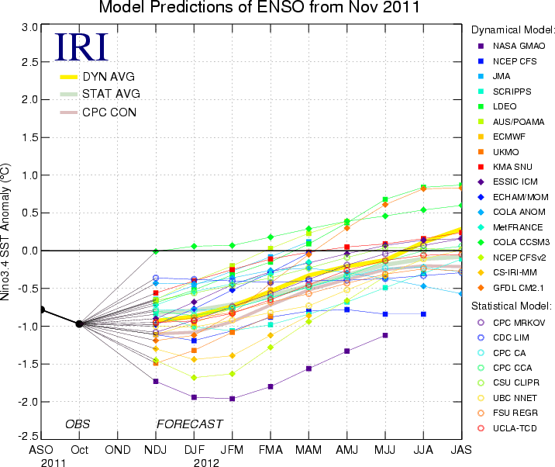
Table 1. Forecast SST Anomalies (deg C) in the Nino 3.4 Region
 | Seasons (2011-2012)
Model | NDJ | DJF | JFM | FMA | MAM | AMJ | MJJ | JJA | JAS
Dynamical models
NASA GMAO model | -1.7 | -1.9 | -2 | -1.8 | -1.6 | -1.3 | -1.1
NCEP Coupled Fcst Sys model | -1.1 | -1.2 | -1.1 | -0.9 | -0.8 | -0.8 | -0.8 | -0.8
Japan Met. Agency model | -0.6 | -0.5 | -0.3 | -0.1 | 0.1
Scripps Inst. HCM | -0.8 | -1 | -1.1 | -1 | -0.8 | -0.7 | -0.5 | -0.3 | -0.1
Lamont-Doherty model | -0.7 | -0.5 | -0.3 | -0.2 | 0.1 | 0.4 | 0.7 | 0.8 | 0.9
POAMA (Austr) model | -0.7 | -0.4 | -0.2 | 0 | 0.2 | 0.4
ECMWF model | -1.1 | -1 | -0.8 | -0.5
UKMO model | -1.5 | -1.3 | -1.1 | -0.9
KMA (Korea) SNU model | -0.6 | -0.4 | -0.3 | -0.1 | -0 | 0.1 | 0.1 | 0.2 | 0.2
ESSIC Intermed. Coupled model | -0.9 | -0.7 | -0.5 | -0.3 | -0.2 | -0 | 0.1 | 0.1 | 0.2
ECHAM/MOM | -1 | -0.8 | -0.5 | -0.3 | -0
COLA ANOM | -0.4 | -0.4 | -0.4 | -0.3 | -0.2 | -0.3 | -0.4 | -0.5 | -0.6
MÉTÉO FRANCE model | -0.7 | -0.5 | -0.4 | -0.3 | -0.2
COLA CCSM3 model | -0 | 0.1 | 0.1 | 0.2 | 0.3 | 0.4 | 0.5 | 0.5 | 0.6
NCEP CFS version 2 | -1.5 | -1.7 | -1.6 | -1.3 | -0.9 | -0.7 | -0.3
CSIR-IRI 3-model MME | -1.3 | -1.4 | -1.4 | -1.1 | -0.9
GFDL CM2.1 Coupled Climate model | -1.2 | -1.1 | -0.8 | -0.4 | -0.1 | 0.3 | 0.6 | 0.8 | 0.8
Average, dynamical models | -0.9 | -0.9 | -0.7 | -0.5 | -0.3 | -0.2 | -0.1
Statistical models
NCEP/CPC Markov model | -1.1 | -0.9 | -0.7 | -0.6 | -0.4 | -0.2 | -0 | 0.1 | 0.2
NOAA/CDC Linear Inverse | -0.4 | -0.4 | -0.4 | -0.4 | -0.4 | -0.4 | -0.4 | -0.3 | -0.3
NCEP/CPC Constructed Analog | -0.8 | -0.8 | -0.8 | -0.6 | -0.5 | -0.4 | -0.2 | -0.2 | -0.3
NCEP/CPC Can Cor Anal | -0.8 | -0.9 | -0.8 | -0.6 | -0.5 | -0.3 | -0.1 | 0 | 0.1
Landsea/Knaff CLIPER | -0.7 | -0.6 | -0.5 | -0.4 | -0.2 | -0.1 | 0 | 0 | 0
Univ. BC Neural Network | -1 | -1 | -0.9 | -0.8 | -0.7 | -0.5 | -0.3 | -0.1 | 0
FSU Regression | -1 | -0.9 | -0.8 | -0.7 | -0.6 | -0.4 | -0.3 | -0.2 | -0.3
TDC - UCLA | -1 | -0.9 | -0.8 | -0.7 | -0.5 | -0.3 | -0.1 | -0.1 | -0.1
Average, statistical models | -0.8 | -0.8 | -0.7 | -0.6 | -0.5 | -0.3 | -0.2 | -0.1 | -0.1
Average, all models | -0.9 | -0.8 | -0.7 | -0.6 | -0.4 | -0.3 | -0.2 | 0 | 0.1

Discussion of current forecasts
Approximately two-thirds of the set of dynamical and statistical model predictions issued during late October and early November 2011 predict La Nina conditions from the November 2011 to January 2012 season currently in progress, continuing into the early part of 2012, with most of the other one-third predicting neutral ENSO conditions. Taking into account the latest observations of SST and the subsurface sea temperature in the eastern tropical Pacific, and low-level zonal wind anomalies and the Southern Oscillation Index, the probabilities for La Nina, neutral and El Nino conditions are estimated at 74%, 26% and close to 0% for La Nina, neutral and El Nino conditions, respectively. At the time of preparing this, the SST observations in the NINO3.4 region were in the weak La Nina range, with an area-averaged weekly anomaly of -0.9 C in the most recent week. Current predictions and observations indicate probabilities of 69% and 62% for La Nina conditions during the December-February and January-March periods, respectively, with corresponding probabilities for ENSO-neutral conditions of 30% and 35%. Probabilities for El Nino conditions are 5% or less through Feb-Apr 2012. After the first quarter of 2012, probabilities for each ENSO condition return toward their climatological values of 25%, 50% and 25% for La Nina, neutral and El Nino, respectively.

Link:

http://iri.columbia.edu/climate/ENSO/currentinfo/SST_table.html

