
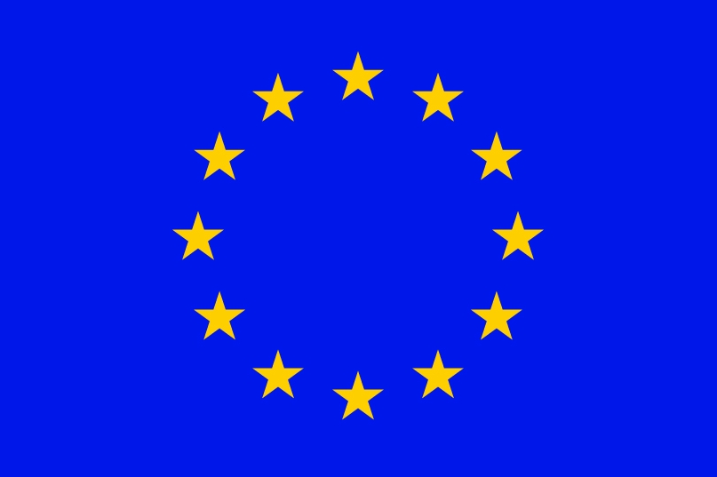


Draft Version

Twenty-seventh Session of
SOUTHEASTERN EUROPE CLIMATE OUTLOOK FORUM (SEECOF-27)
April-May, 2022

SEASONAL OUTLOOK FOR SUMMER SEASON 2022 FOR THE SOUTH EASTERN EUROPE AND CAUCASUS REGION (SEE&C)
Climate experts from WMO RA VI RCC Network Nodes on long-range forecasting (Meteo France, France and Roshydromet, Russia) and WMO RA VI RCC Network Node on climate monitoring (Deutscher Wetterdienst, Germany), UK Met-Office, Global Producing Centre ECMWF, International Research Institute for Climate and Society (IRI, USA), National Centers for Environmental Prediction (NCEP,USA), WMO RA VI RCC South East Europe Virtual Climate Change Centre (SEEVCCC, Serbia) and National Hydrometeorological Services of SEECOF region provided their valuable contribution to the successful implementation of SEECOF-27 by developing the relevant documents and providing scientific guidance and recommendations.
The SEECOF-27 comprised of the following Steps:
- Step 1: qualitative verification of the SEECOF-26 climate outlook for 2021-2022 Winter;
- Step 2: assessment of the current state of the climate including large-scale climate patterns worldwide and assessments of its likely evolution in the course of the next months;
- Step 3: building the consensus forecast for 2022 summer season.
All relevant documentation is posted and updated in SEEVCCC web site: http://www.seevccc.rs

SEECOF-27 CLIMATE OUTLOOK
FOR THE 2022 SUMMER SEASON

Similarly, to MedCOF-18 seasonal climate outlook, SEECOF-27 prediction is based on the output from dynamical models, including, inter alia, the operational products of the SEEVCCC centre, statistical models and teleconnections of large-scale climate features.

The maps show the probabilistic consensus forecast for the tercile categories of anomalies for seasonal mean temperature and precipitation, relative to the 1981-2010 period. Due to the climate-warming trend, anomalies are affected by the selected reference period.

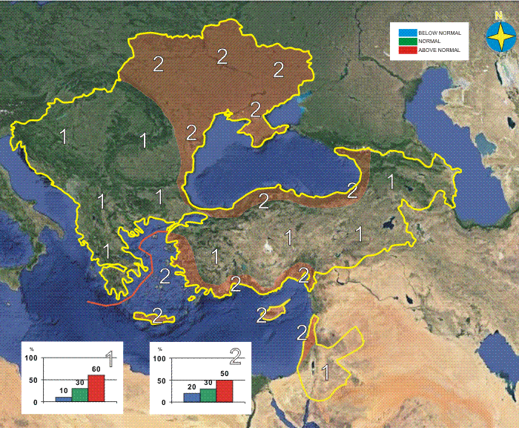 | 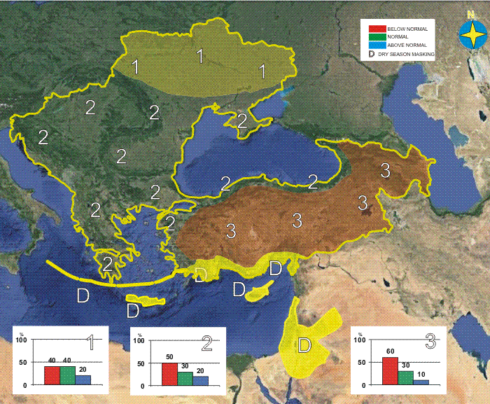
Graphical presentation of the 2022 summer temperature outlook | Graphical presentation of the 2022 summer precipitation outlook

In the entire SEECOF region, summer temperature is likely to be above-normal, with the probability increasing from the northern and north-eastern region, as well as from Aegean, Black and Eastern Mediterranean Sea (Zone 2 in Figure 1) to the remainder of the region (Zone 1 in Figure 1).

Uncertainties in regional predictions are higher for precipitation than for temperature. Most of the Ukraine is likely to experience below- or near-normal conditions in terms of summer precipitation sums. Most of the SEECOF region will receive below-normal precipitation sums with the probabilities increasing from the north-west (Zone 1 in Figure 2) towards east of the region (Zone 3 in Figure 2). It is noteworthy that certain parts of the country, particularly mountainous regions, might receive near- or above-normal summer precipitation totals due to the episodes of enhanced convection accompanied by heavy precipitation. Due to dry season masking, it is not possible to forecast summer precipitation totals along the eastern coasts of the Eastern Mediterranean, Crete, Israel and Jordan.

It should be noted that certain parts of the country, particularly mountain regions might receive near- or above-normal summer precipitation totals due to the episodes of enhanced convection accompanied by heavy precipitation. Due to dry season masking, it is not possible to forecast summer precipitation totals along the eastern coasts of Eastern Mediterranean, Crete, Israel and Jordan.

Reference:
The maps show the probabilistic consensus forecast for tercile categories of anomalies of seasonal-mean temperature and precipitation, relative to the 1981-2010 period.

Any further advice on the forecast signals, shorter-range updates and warnings will be available throughout the summer from the National Meteorological Services, along with the details on the methodology and skill of long-range predictions.

* The graphical representation of climate outlook in this statement is for guidance purposes only, and does not imply any opinion whatsoever concerning the legal status of any country, territory, city or area or of its authorities, or concerning the delimitation of its frontiers or boundaries.

APPENDIX A: Contributors to SEECOF-27

- World Meteorological Organization
- Met Office, United Kingdom
- International Research Institute for Climate and Society, United States of America
- European Canter for Medium Range Weather Forecast
- Meteo France, Republic of France
- Deutscher Wetterdienst, Federal Republic of Germany
- National Canter for Environmental Prediction, United States of America
- Federal Service for Hydrometeorology and Environmental Monitoring, Russian Federation
- South East European Virtual Climate Change Canter hosted by Republic Hydrometeorological Service of Serbia, Republic of Serbia
- North Euro-Asian Climate Outlook Forum (NEACOF) leaded by Federal Service for Hydrometeorology and Environmental Monitoring, Russian Federation
- Mediterranean Climate Outlook Forum (MedCOF), leaded by Agencia Estatal de Meteorologia, Spain
- Institute of Geosciences, Energy, Water and Environment, Albania
- Armenian State Hydrometeorological and Monitoring Service, Armenia
- National Institute of Meteorology and Hydrology, Republic of Bulgaria
- Meteorological and Hydrological Service, Republic of Croatia
- Meteorological Service, Republic of Cyprus
- Hellenic National Meteorological Service, Greece
- The National Environmental Agency of Georgia, Georgia
- Hungarian Meteorological Service, Hungary
- Israel Meteorological Service, State of Israel
- Republic Hydrometeorological Institute, Former Yugoslav Republic of Macedonia
- State Hydrometeorological Service, Republic of Moldova
- Hydrometeorological Institute of Montenegro, Montenegro
- National Meteorological Administration, Romania
- Federal Hydrometeorological Service of the Federation of Bosnia and Herzegovina, Federation of Bosnia and Herzegovina, Bosnia and Herzegovina
- Republic Hydrometeorological Service of the Republic of Srpska, Republic of Srpska, Bosnia and Herzegovina
- Republic Hydrometeorological Service of Serbia, Republic of Serbia
- Turkish State Meteorological Service, Republic of Turkey
- Ukrainian Hydrometeorological Center, Ukraine

