
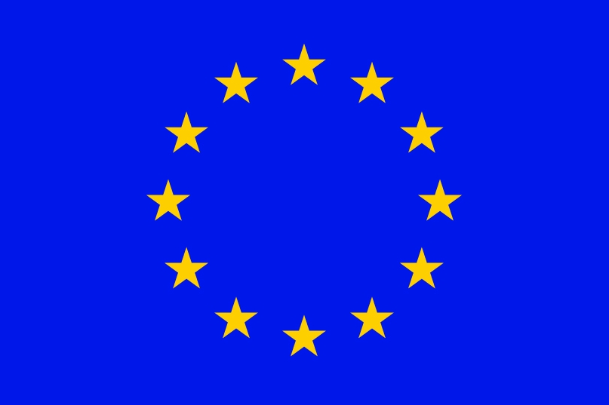


LIST OF SEECOF FOCAL POINTS

 | Country | Name | Institution | Affiliation | Contacts
 |  |  |  |  | Tel | Fax | E-mail
1 | ALBANIA | Mr. Vangjel Mustaqui | IGEWE | Meteorologist | +355 42 250601 | +355 42 250601 | aspetalb@yahoo.com
2 | ARMENIA | Mrs Zarmandukht Petrosyan | Armstatehydromet | Head of Operational Hydrometeorological center | +374 10 536921 | +374 10 532952 | armstate@meteo.am  edittaron@gmail.com
2 | ARMENIA | Ms Haykanush Azizyan | Armstatehydromet |  |  | +374 10 532952 | armstate@meteo.am  shaykuhi86@yandex.ru
3 | AZERBAIJAN | Ms Ulviyya Mammadova | National Hydrometeorological Department of Azerbaijan |  | +994 59 593 26 18 | +994 12 441 11 75 | umamedova@gmail.com
4 | Federation of Bosnia and Herzegovina  BOSNIA AND HERZEGOVINA | Mr. Dzenan Zulum | Federal Hydrometeorological  Institute | Climatologist | +387 61 504 020 | +387 33  44 24 35 | dzenanz@fhmzbih.gov.ba
 | Rapublika Srpska  BOSNIA AND HERZEGOVINA | Ms Nada Rudan | Republic Hydrometeorological  Service of Republika Srpska | Head of Climatology | +387 51 346 492 | +387 51 433 521 | nada.rudan@meteo-rs.com
5 | BULGARIA | Mr. Ilian Gospodinov | National Institute of meteorology and hydrology | Researcher | +359 2  462 46 07 | +359 2  988 03 80 | ilian.gospodinov@meteo.bg
6 | CROATIA | Ms. Dunja Placko-Vrsnak | Meteorological and Hydrological Service |  | +385 1 4565 783 | +385 1 4565 7757 | dunja.placko-vrsnak@cirus.dhz.hr
7 | CYPRUS | Мs. Sofia Louka | Meteorological Service |  |  | +357 2  2305500 | slouca@dom.moa.gov.cy
7 | CYPRUS | Mr. Kleanthis Nicolaides | Meteorological Service | Senior Meteorological  Officer | +357 2  28 02395 | +357 2  2305500 | knicolaides@ms.moa.gov.cy
8 | GEORGIA | Mr George Kordzakhia | National Environment Agency | Advisor | +995 32 439528 |  | giakordzakhia@gmail.com
8 | GEORGIA | Ms. Khatuna Kokosadze | Hydrometeorological Department of the National Environment Agency | Head of Long-Range Forecasting Bureau | +995 32  24 39 533 |  | kh_kokosadze@yahoo.com
9 | GREECE | Mr. Nikolaos Karatarakis | Hellenic National Meteorological Service | Head of Climate application/climatology Department | +302 10 9699032 | +302 10 9628952 | nkhydro@hnms.gr
9 | GREECE | Dr Petroula Louka | Hellenic National Meteorological Service | Numerical Weather Prediction division | +302 10 9699122 | +302 10 9628958 | louka@hnms.gr
10 | HUNGARY | No focal point
11 | ISRAEL | Dr. Itzhak Carmona | Israel Meteorological Service | Research &Development Department | +972 3 9682 173 | +972 3  9604 854 | carmonai@ims.gov.il
12 | JORDAN | Mr. Raed Ahmed Subshi | Head of Forecasting Center | Jordan Meteorological Department | +962 48  94408 |  | raedrafid@yahoo.com
13 | MOLDOVA | Mrs. Lidia Tresclio | State Hydrometeorological Service | Chief of the Meteorology Department | +373 22 77 36 44/35 29 | +373 22 77 36 36/35 29 | lidiat@meteo.md
14 | MONTENEGRO | Ms. Mirjana Ivanov | Hydrometeorological Institute of Montenegro |  | +382 20 655 365 | +382 20 655 197 | mirjana.ivanov@meteo.co.me
15 | ROMANIA | Dr. Roxana Bojariu | National Meteorological Administration | Head of  Climate Section | +40 72 448  5493 | +40 21 316 2140 | bojariu@meteo.inmh.ro
16 | SLOVENIA | Mr. Branko Gregorcic | Environmental Agency of the Republic of Slovenia | Meteorological Office | +386 1 478 41 35 | +386 1 478 40 33 | branko.gregorcic@gov.si
17 | SERBIA | Mr. Goran Pejanovic | National Center for Climate Change, RHMSS | Assistant director | +381 11 20 66 900 | +381 11 30 50 847 | goran.pejanovic@hidmet.gov.rs
17 | SERBIA | Mr. Branko Bijelic | RHMSS | Analyst for long range weather forecast | +381 11 30 50 903 | +381 11 30 50 847 | branko.bijelic@hidmet.gov.rs
18 | The FYR of MACEDONIA | Ms. Nina Aleksovska | Hydrometeorological Service | Head of Meteorological Department | +389 2  309 7105 | +389 2  309 7718 | naleksovska@meteo.gov.mk
19 | TURKEY | Mr. Hakki Atay | Turkish State Meteorological Service Directorate of Climatology | Engineer | +90 312 302 24 42 |  | hatay@mgm.gov.tr
19 | TURKEY | Mr. Ömer Demir | Turkish State Meteorological Service Directorate of Climatology | Engineer | +90 312 302 24 41 |  | omerdemir@mgm.gov.tr
20. | UKRAINE | Ms Nataliya Golenya | Hydrometeorological Center |  | +380 44 2357232 |  | golenya@meteo.gov.ua

