

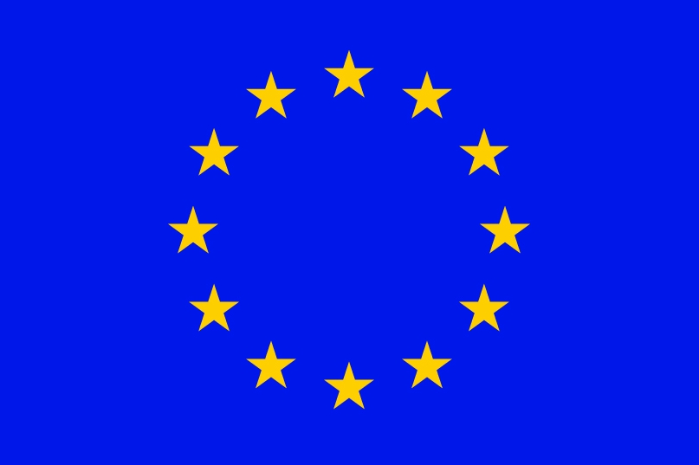

LIST OF SEECOF – 25 ON-LINE FORUM PARTICIPANTS
Belgrade, Serbia, April – May 2021

World Meteorological Organization
European Centre for Medium-Range Weather Forecasts
Federal Service for Hydrometeorology and Environmental Monitoring, Russian Federation
Deutscher Wetterdienst, Federal Republic of Germany
Meteo France, Republic of France
UK Met Office, United Kingdom
International Research Institute for Climate and Society, USA
South East European Virtual Climate Change Center hosted by Republic Hydrometeorological Service of Serbia, Republic of Serbia
Royal Netherlands Meteorological Institute, Kingdom of the Netherlands
Institute of Geoscience, Energy, Water and Environment, Republic of Albania
Armenian State Hydrometeorological and Monitoring Service, Republic of Armenia
National Hydrometeorological Department, Republic of Azerbaijan
National Institute of Meteorology and Hydrology, Republic of Bulgaria
Meteorological and Hydrological Service, Republic of Croatia
Hellenic National Meteorological Service, Greece
Meteorological Service, Republic of Cyprus
Department of Hydrometeorology, Republic of Georgia
Meteorological Service of the Republic of Hungary, Republic of Hungary
Israel Meteorological Service, State of Israel
Jordan Meteorological Department, the Hashemite Kingdom of Jordan
Republic Hydrometeorological Institute, the Former Yugoslav Republic of Macedonia
State Hydrometeorological Service, Republic of Moldova
Hydrometeorological Institute of Montenegro, Republic of Montenegro
Federal Hydrometeorological Service of the Federation of Bosnia and Herzegovina, Federation of Bosnia and Herzegovina, Bosnia and Herzegovina
Republic Hydrometeorological Service of the Republic of Srpska, Bosnia and Herzegovina
National Meteorological Administration, Republic of Romania
Republic Hydrometeorological Service of Serbia, Republic of Serbia
Meteorological Office, Republic of Slovenia
Turkish State Meteorological Service, Republic of Turkey
Ukrainian Hydrometeorlogical Center, Ukrainian National Republic

