|  |  |  |  |  |
| --- | --- | --- | --- | --- |
|  | [Resultado de imagen de escwa](https://www.google.es/url?sa=i&rct=j&q=&esrc=s&source=imgres&cd=&cad=rja&uact=8&ved=2ahUKEwjW0Kur94zeAhWJyIUKHRWbCBsQjRx6BAgBEAU&url=https://es-la.facebook.com/unescwa/&psig=AOvVaw1mf2IqxJ_bnsfLeV_RokMO&ust=1539847029574616) | لوجو الهيئة.png | [Imagen relacionada](https://www.google.es/url?sa=i&rct=j&q=&esrc=s&source=images&cd=&cad=rja&uact=8&ved=2ahUKEwiM7Z7o94zeAhVRrxoKHSwTACcQjRx6BAgBEAU&url=https://commons.wikimedia.org/wiki/File:Emblem_of_the_Arab_League.svg&psig=AOvVaw0aQP2Fi_zWggwZA8DJbE_7&ust=1539847127580983) | Logo AEMET |
| Logos_RCC_v4 | | |  | http://www.undp-aap.org/sites/undp-aap.org/files/acmad.jpg |

**11th Session of the Mediterranean Climate Outlook Forum**

**20th Session of South East European Climate Outlook Forum**

**13th Session of Climate Outlook Forum for Northern Africa**

**3rd session of Arab Climate Outlook Forum**

26-29 November 2018

Cairo, Egypt

**INFORMATION NOTE FOR PARTICIPANTS**

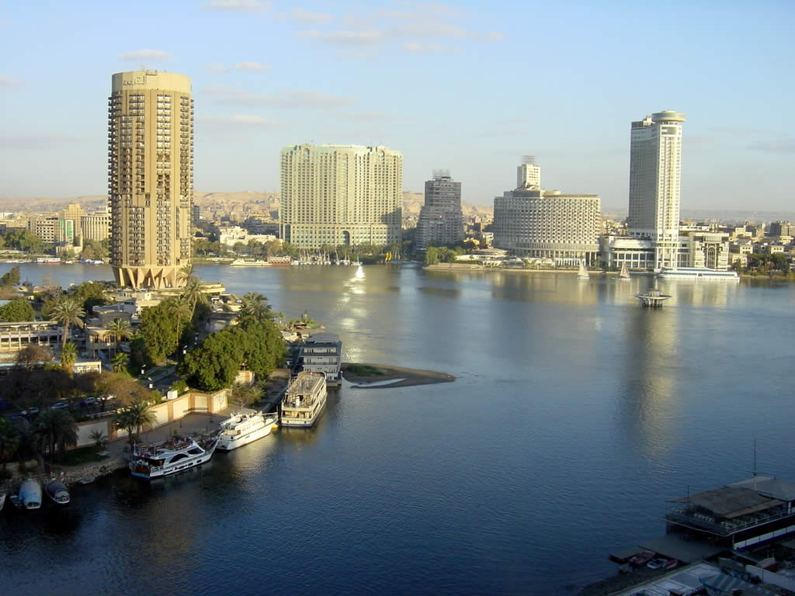

**VENUE**

The Egyptian Meteorological Authority (EMA) will host the 11th session of the Mediterranean Climate Outlook Forum (MedCOF-11), 20th session of the South East European Climate Outlook Forum (SEECOF-20), the 13thsession of North PRESANORD, and 3rd session of Arab Climate Outlook Forum (Arab COF-3). The Events will take place on 26-29 November 2018, at **EMA headquarters,** Al Khalifa El Maamoun St., Kobry El-Qubba, Cairo, Egypt.

These forumsare being co-organized by the World Meteorological Organization (WMO), Economic and Social Commission for Western Asia (ESCWA), EMA, League of Arab States (LAS), and State Meteorological Agency of Spain (AEMET).

**WORKSHOP ORGANIZATION**

Registration of participants will take place at the meeting venue from 08:30 till 09:00 on 26 November 2018. The meeting will start at 09:00 on 26 November and conclude on 29 November around 17:00

The working language will be English only, and there will be no arrangements for interpretation.

Detailed information on the working arrangements and schedule of the Workshop will be provided in the Provisional Agenda and the Program in due course.

Computer-connected projection facilities will be available for presentations. White boards/flip charts and general office supplies will be available to facilitate discussions.

The participants are strongly encouraged to **bring their own laptop**. Internet access is available in the Conference Hall at the Egyptian Meteorological Authority through WI-FI. Instructions to avail the facility will be provided at the time of the meeting.

Please do not forget to bring the adaptor and cable connection !

In case of difficulties, please send a message to **wafaa\_eg2012@hotmail.com** explaining what kind of difficulty you are facing, so that we can organize the sessions in the best possible way.

**ACCOMMODATION/HOTEL INFORMATION**

Block booking has been made at the **Royal Marshal hotel** for all nominated participants and experts at a preferred rate, (Single) at 40.00 $ per night, breakfast inclusive (Double) at 60.00 $ per night, breakfast inclusive. **Participants will be asked to pay directly to the Hotel.**

|  |  |
| --- | --- |
| **IMG-20181023-WA0004.jpg** | **Royal Marshal hotel**  4A El Khalifa El Maamoun Str.  Roxy-Heliopolis  Cairo, Egypt  Phone: (202)24546700  (202)24550001  (202)24550011  (202)24550050  Fax: (202)24550197  E-mail: royal@marshalhotels.com  Website: www.marshalhotels.com |

Room reservation will be made by organizers. For this purpose, **please, complete the form in Annex 1, as soon as possible and send it to local organizers Ms Wafaa Wasfy, (wafaa\_eg2012@hotmail.com) with copy to Dr. Ashraf Zakey (ashzakey@gmail.com) .**

**CATERING & SOCIAL EVENTS**

Coffee & tea breaks will be offered by the host every morning and afternoon.

The lunch will be served during the RCOFs sessions, free of charge for WMO/ESCWA supported participants. Other (self-funded) participants have to pay for lunch around **250 - 300LE**.

**VISA AND PASSPORT REQUIREMENTS**

Entry visa is required for participants from some of the countries. Therefore, all participants are requested to inquire about visa requirements from respective Consulates or Embassies of Egypt. For more information, please visit the website of the Ministry of Foreign Affairs of Egypt at:**https://www.mfa.gov.eg**

The hosting institution mayprovide an invitation letter to support the visa application for participants requiring a visa, upon their request to be addressed to local contacts.

**TRANSPORTATION**

From/to the Airport

The Royal Marshall Hotel is 11 km from Cairo International Airport, the hotel provides suitable car to transport the participant from the airport to the hotel for **(Approx 11 $)** per person. Also suitable car for the transport of participants for at least 14 people from the airport to the hotel for **a total (Approx 36 $)**

By Taxi

To reach the Hotel from Cairo Airport, you can take a taxi (**Approx 12 USD**).

**Important Note:** All the taxis parked in front of the arrival terminals have high level security permits and reliability to provide protection and safe services for all Cairo guests.

Local transportation

Local transportation between the Royal Marshal hotel and the venue will be arranged by EMA every day.

**OTHER USEFUL TIPS**

Currency And Banks

The currency in Egypt is Egyptian Pound. Most businesses, tour operators, airlines and hotels accept major credit cards. Banking hours are generally from 08:30 to 17:00 on week days, while Banking hours in Cairo airport 24 hours a day.

The average exchange rate on 25 October 2018 was as follows:

1 CHF= 17.88 LE

1 USD = 17.86 LE

1 EURO = 20.39 LE

Electricity

The voltage in Egypt is 220 V / 50 Hz.

The plugs used in Egypt are " C / F "

|  |
| --- |
| c&f.jpg |

Life And Health Insurance

The organizers will not assume any responsibility for life and major health insurance, nor for expenses related to medical treatment or accidents.

Time Zone

Standard Time in Egypt: GMT + 02:00 Cairo

Climate Information:

Climate data for November in Cairo is listed below:

Mean precipitation: 1 - 4 mm

Mean humidity: 60 - 65 %

Mean maximum temperature:23 - 27 °C

Mean minimum temperature: 12 - 16 °C

**CONTACTS**

**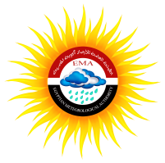**LOCAL ORGANIZER:

**Technical Issues**

**Dr. Ashraf Zakey**

Under Secretary of state for research and climate

Egyptian Meteorological Authority

Tel.: +201152566113

E-mail: ashzakey@gmail.com

**Local Logistics**

**Ms Wafaa Wasfi**

Public Relations & Media Manager

Egyptian Meteorological Authority

Tel.: +201221118517

E-mail: wafaa\_eg2012@hotmail.com

|  |  |
| --- | --- |
| WMO  **Ms Anahit Hovsepyan**  Scientific Officer  World Climate Applications & Services Division (WCAS)  Climate Prediction and Adaptation Branch (CLPA)  Climate and Water Department (CLW)  World Meteorological Organization  7bis, Avenue de la Paix  Case Postal No. 2300  1211 Geneva 2  Switzerland  Phone: +41 22 730 8212  E-mail: ahovsepyan@wmo.int |  |
|  |  |

**ANNEX 1**

**HOTEL RESERVATION FORM**

|  |  |  |  |  |  |  |  |  |  |
| --- | --- | --- | --- | --- | --- | --- | --- | --- | --- |
| **No.** | **Guest’s Name** | **Country/ Nationality** | **Arrival Port** | **Flight No.** | **Date and Time of arrival** | **Departure Port** | **Date and Time of departure** | **Flight No.** | **Request Booking in Royal Marshal** |
| 1 |  |  |  |  |  |  |  |  |  |
| 2 |  |  |  |  |  |  |  |  |  |
| 3 |  |  |  |  |  |  |  |  |  |