National Climate Bulletin and the assessment of the SEECOF-19 Climate outlook for **CYPRUS** for summer season JJA 2018

**Summary**

Cyprus Department of Meteorology prepares regular seasonal climate outlooks, based on the products of SEECOF seasonal forecasts. The present outlook concerns the outlook for the three summer months of June, July and August 2018, which is based on the deviations from the means of the climatological period 1981-2010.

Generally from the climatological point of view, the area of the east Mediterranean, but specially the area of Cyprus, during summer is characterized by the high mean maximum and minimum normal (1981-2010) temperatures. Normal accumulated precipitation is reaching minimum as a result of the general synoptic situation.

The assessment is performed bearing in mind the consensus statement of SEECOF17 which was stating that:

the area of Cyprus as regarded from the suggested climate statement, for the period of Summer JJA, would have being in area 3 concerning Temperature (Fig 1) and for Precipitation in area musked as «D» (ie Dry musk) as pressented in figure 2. So as shown in figure 1, Cyprus is a part of the area where the probability of temperature being lower than normal would be 10%, 20% would be normal and 70% would be above normal. As presented in more details below June was normal and July and August were rather warmer than normal.

Regarding the accumulated precipitation and as is presented in more details for each month below it must be mentioned that during summer precipitation in Cyprus is in the form of thunderstorms, an isolated meteorological phenomenon. So for Cyprus as a part of Dry zone it can be stated that the Dry musk applies in general, but due to thundery activity accumulated precipitation during summer may be high in some places.

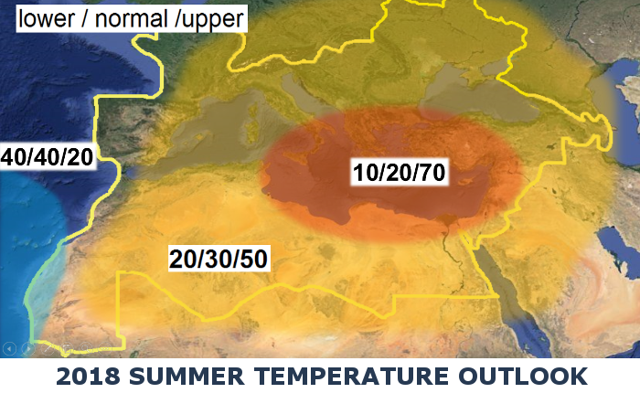Figure 1. Graphical presentation of the 2017 summer temperature outlook

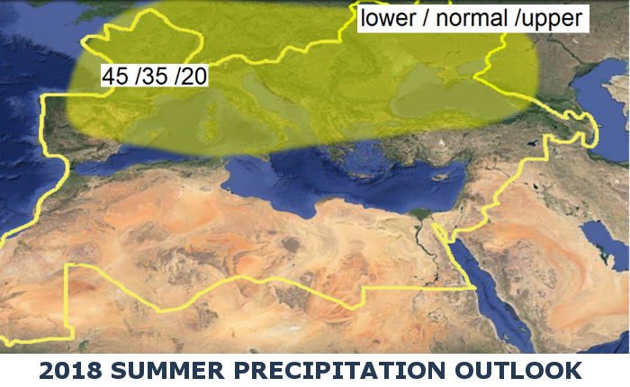

Figure 2. Graphical presentation of the 2017 summer precipitation outlook

Find also below a table presenting the general anomalies of SEECOF products and extreme events of the recorded summer weather.

|  |  |  |  |  |  |
| --- | --- | --- | --- | --- | --- |
| Country | Seasonal temperature (JJA) | | Seasonal precipitation  (JJA) | | High Impact Events |
| Observed | SEECOF-19 climate outlook for  temperature | Observed | SEECOF-19 climate outlook for precipitation |
| **CYPRUS** | **June**  Normal  **July**  Above Normal  **August**  Above Normal | **June**  Normal  **July**  Normal  **August**  Normal, except southeast coast (1 to 2°C below normal) | **June**  Above Normal  **July**  Below normal  **August**  Below Normal | **June**  Below Normal  **July**  West part below Normal, East part above Normal  **August**  Normal, except NW part above normal and SE part below normal | **June**  June was a month ranked 6th from all Junes available in high accumulated precipitation, (mean area average accumulated precipitation) a record of 27.1mm of accumulated precipitation resulting to 411% of the climatological precipitation (6.6mm). This is evidenced mainly from the chart of the distribution of the mean area average precipitation of June instead from the records available from the table below.  The accumulated precipitation was a result of local thunderstorms the period from the 1st to the 5th and from the 11th to the 19th of June which in some cases were accompanied by hail. These thunderstorms caused serious damages in agriculture.  About the evaluation of the recorded temperatures both maximum and minimum (table below) were around normal, suggesting that **June** was almost a normal month. Extremes were also recorded with great positive departures of 4 to 6°C, like Paphos airport where the absolute maximum if the station was 31.7°C departing 4.1°C from the normal (27.6°C), or over Athalassa station, where the highest daily maximum temperature of 40.8°C was 6.8°C greater than normal of 34.0°C.  **July**  Both maximum and minimum, were above normal. The recorded maximum temperature was around 0.5-1.5°C above normal over the most areas of Cyprus. Daily maximum temperatures that were above normal (deviating by 4°C or more from normal) were also recorded in many stations. Except the highest daily maximum temperature of Prodromos that was 33.7°C (with a normal of 27.9°C), note the highest daily maximum of Larnaka and Achna that was 37.8°C and 38.5°C respectively (with normal of 32.5°C and 33.2°C).  Ηighest daily minimum temperatures were also recorded, with positive departures greater than 4°C, like Polis Chrysochous, where a minimum of 27°C was by 5.9°C above station’s normal (21.1°C) and the station of Larnaka, where a minimum of 27.3°C was by 5.3°C above station’s normal (22°C).  During **July** 13 EMMA warnings with yellow awareness level were issued, concerning extreme high temperatures, not only maximum but also minimum temperatures.  On 16th, 20th and 24th of **July** isolated showers resulted in accumulated precipitation of 29% of normal.  **August**  Extremes were recorded with positive departures greater than 4°C, like Achna station where the highest daily maximum temperature (38.6°C) was 5.1°C greater than normal (33.5°C) and Prodromos station, where the highest daily maximum temperature (32.7°C) was 4.7°C greater than normal (28°C). Generally, the highest maximum of the month was recorded on 1st of **August** over the inland station of Athalassa and it was 41.1°C with the normal being 36.9°C.  For the dates 2, 3, 8, 9, 10, 12, 14, 15, 17 and 23 of August EMMA warnings for high temperature were issued.  Daily minimum temperatures were also recorded, like Prodromos, where a minimum of 12.9°C was 5.2°C below station’s normal (18.1°C), a negative departure greater than 4°C.  On the 2nd, 4th, 5th, 7th, 8th and 21st of **August** episodes of local showers and isolated thunderstorms resulted in accumulated precipitation of 55% of normal. |

**Evaluation of June’s seasonal forecast for the area of Cyprus**

**June**

The seasonal forecast suggested that **June’s** temperature would be generally normal while the Balkans and great parts of Asia Minor would be warmer than normal. Regarding the accumulated precipitation Cyprus was expected to be dry with the accumulated precipitation ranging below 50% for the entire area of Cyprus.

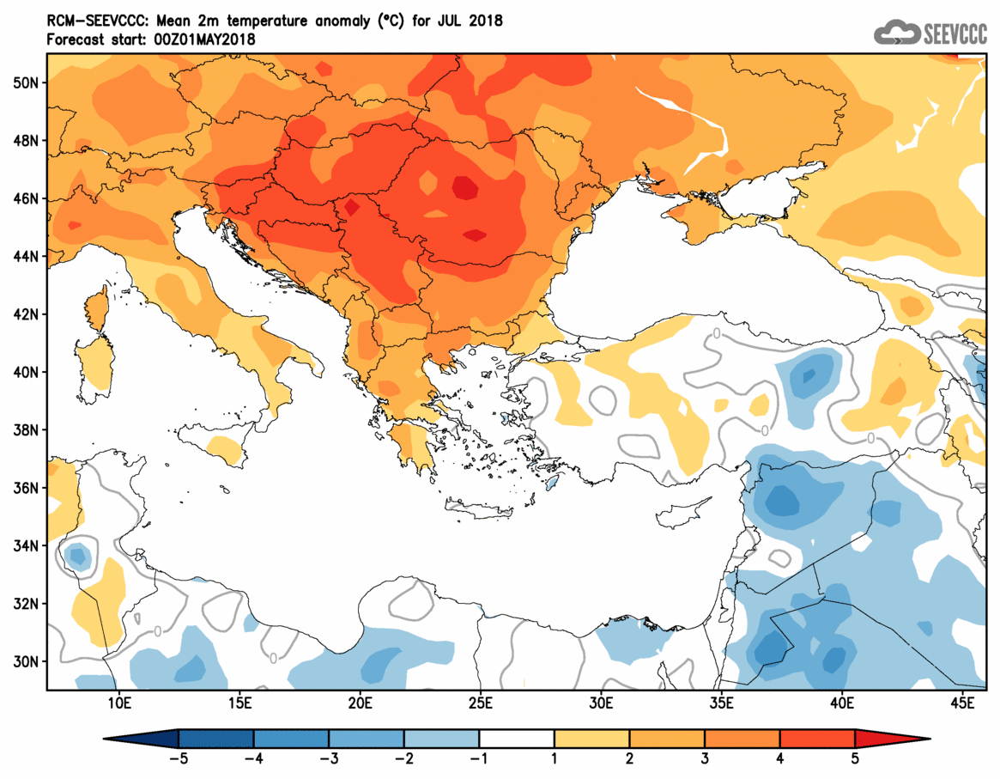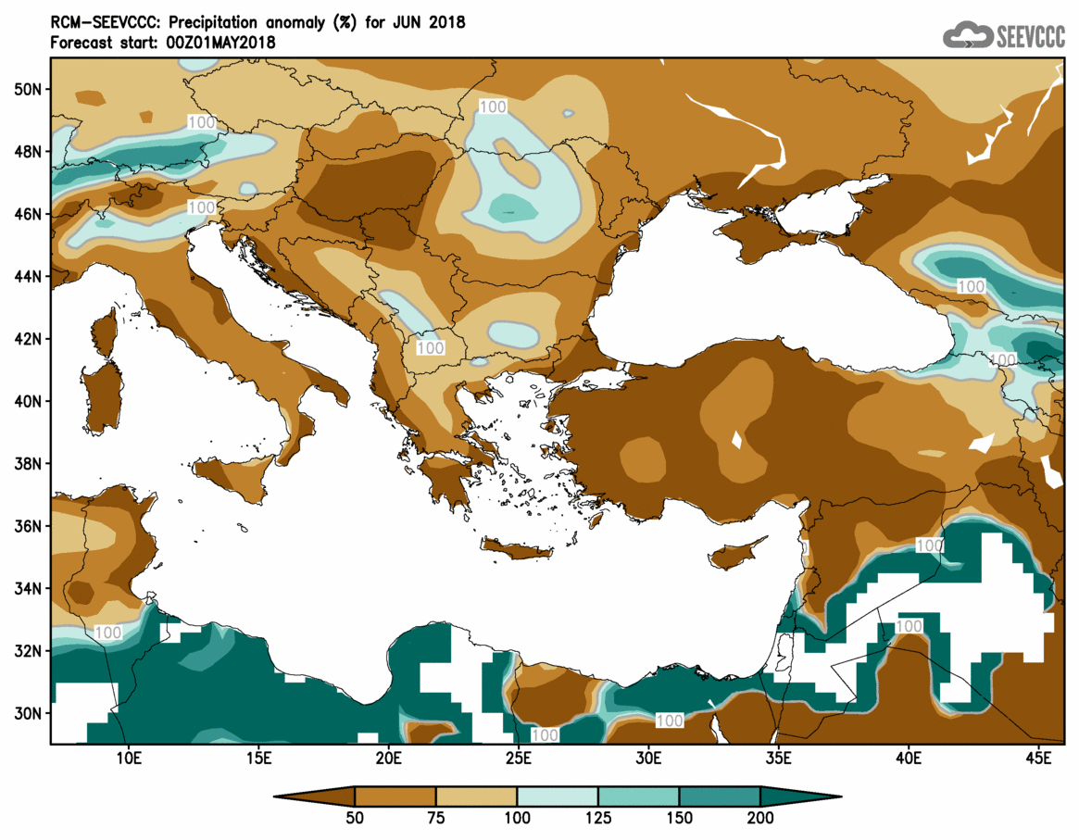

Percentage of the mean monthly precipitation (%) compared with the normal of June

Divergence of the mean monthly temperature (oC) from normal during June

Concerning the models’ evaluation for **June**, a general judgment is that the model performed well, both qualitatively and quantitatively, concerning the temperature but poor in forecasting the months accumulated precipitation. It must be mentioned that during summer month’s precipitation is resulted mainly from thundery activity which has very localised characteristics and that judging is very difficult due to models limitations. Never the less June was a month ranked 6th from all Junes available in high accumulated precipitation, (mean area average accumulated precipitation) a record of 27.1mm of accumulated precipitation resulting to 411% of the climatological precipitation (6.6mm). This is evidenced mainly from the chart of the distribution of the mean area average precipitation of June instead from the records available from the table below.

The accumulated precipitation was a result of local thunderstorms the period from the 1st to the 5th and from the 11th to the 19th of June which in some cases were accompanied by hail.



About the evaluation of the recorded temperatures both maximum and minimum (table below) were around normal, suggesting that **June** was almost a normal month. Extremes were also recorded with great positive departures of 4 to 6°C, like Paphos airport where the absolute maximum if the station was 31.7°C departing 4.1°C from the normal (27.6°C), or over Athalassa station, where the highest daily maximum temperature of 40.8°C was 6.8°C greater than normal of 34.0°C.

For the purpose of better visualization of **June** accumulated precipitation, a chart of Cyprus with the total preliminary accumulated precipitation is presented.

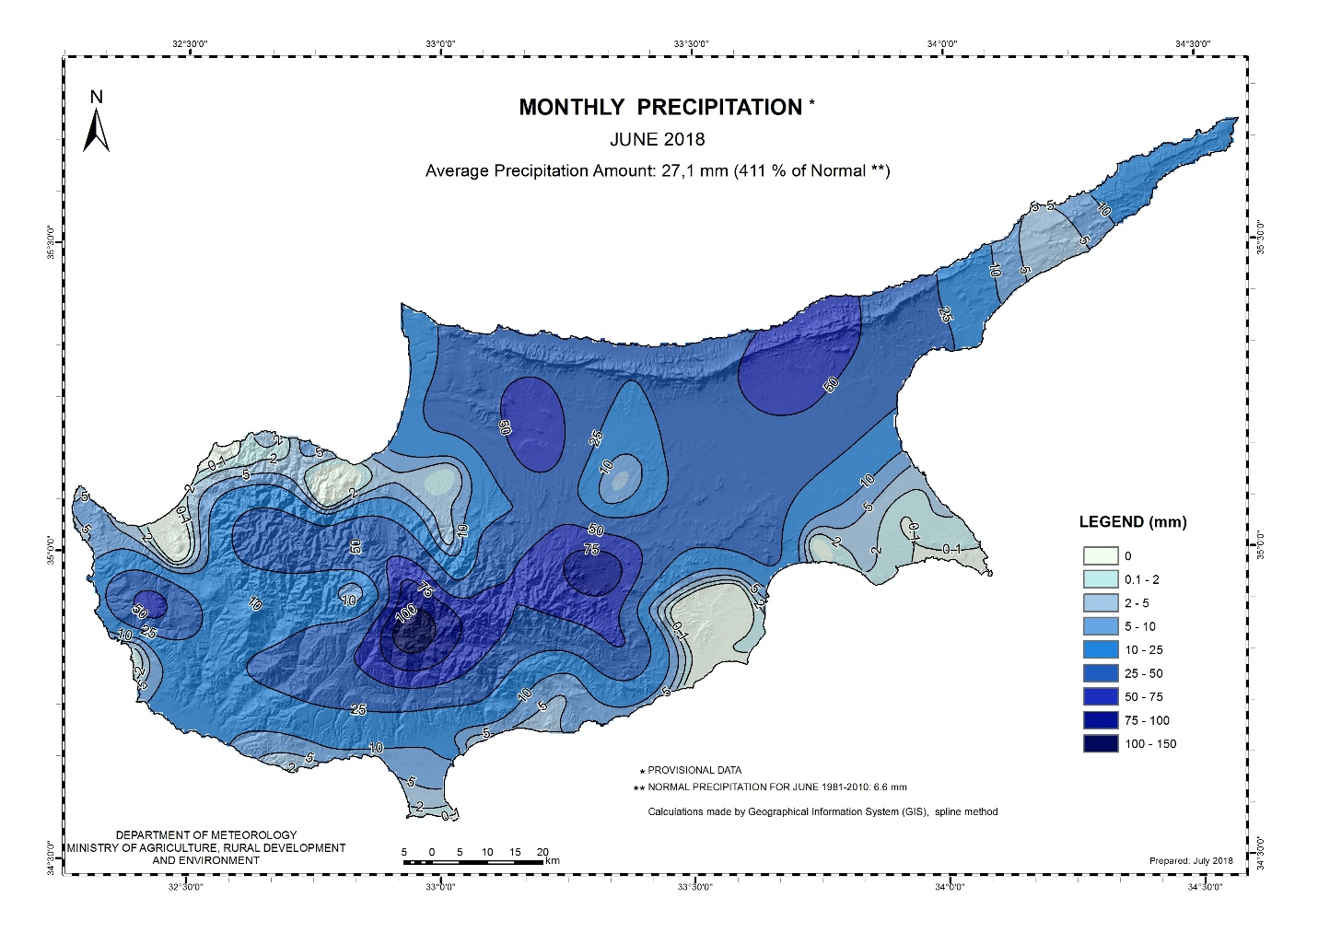

A Cyprus chart with the normal (period 1981 to 2010) accumulated precipitation for the month of **June** is also presented.

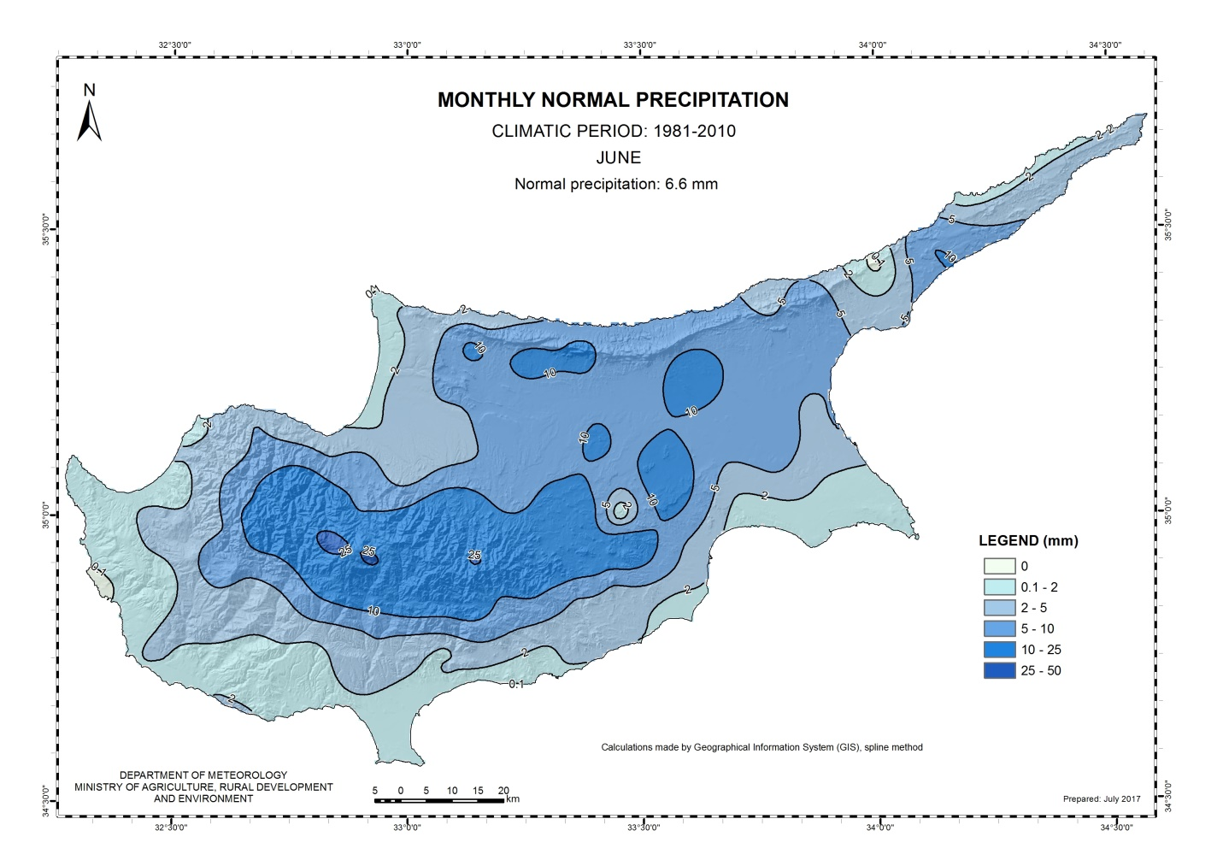

**Evaluation of July’s seasonal forecast for the area of Cyprus**

The seasonal forecast suggested that **July’s** temperature would be normal alike Asia Minor. Regarding the accumulated precipitation Cyprus west part was expected to be below 50% of normal but over the east part accumulated precipitation was expected to range up to 200% of normal.

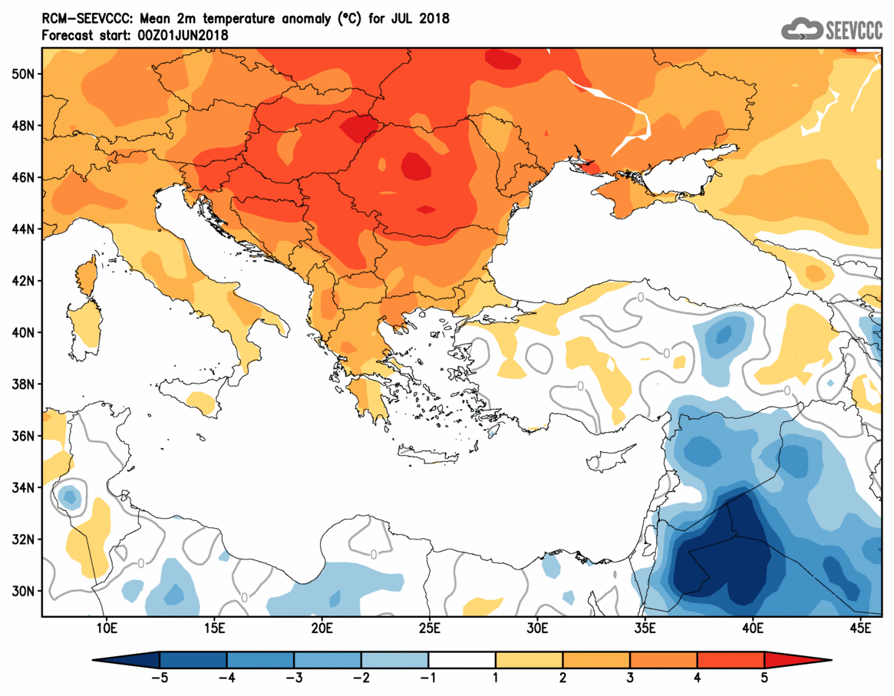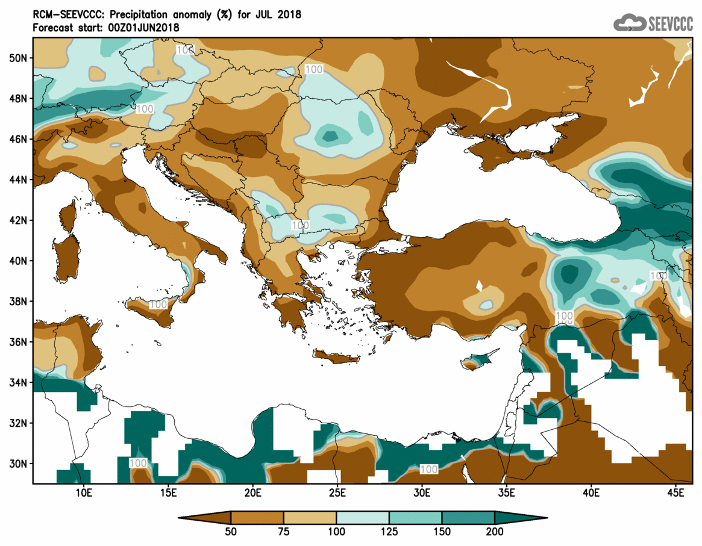

Percentage of the mean monthly precipitation (%) compared with the normal of July

Divergence of the mean monthly temperature (oC) from normal during July

Concerning the models evaluation for **July**, a general judgment is that the model did not perform well both qualitatively and quantitatively concerning not only for the temperature but also for the seasonal accumulated precipitation. It must be mentioned that during summer month’s precipitation is resulted mainly from thundery activity which has very localised characteristics and that judging is very difficult due to models limitations.

In a more detailed evaluation of the recorded temperatures, both maximum and minimum (table below), were above normal. The recorded maximum temperature was around 0.5-1.5°C above normal over the most areas of Cyprus. Daily maximum temperatures that were above normal (deviating by 4°C or more from normal) were also recorded in many stations. Except the highest daily maximum temperature of Prodromos that was 33.7°C (with a normal of 27.9°C), note the highest daily maximum of Larnaka and Achna that was 37.8°C and 38.5°C respectively (with normal of 32.5°C and 33.2°C).

Ηighest daily minimum temperatures were also recorded, with positive departures greater than 4°C, like Polis Chrysochous, where a minimum of 27°C was by 5.9°C above station’s normal (21.1°C) and the station of Larnaka, where a minimum of 27.3°C was by 5.3°C above station’s normal (22°C).

During **July** 13 EMMA warnings with yellow awareness level were issued, concerning extreme high temperatures, not only maximum but also minimum temperatures.

On 16th, 20th and 24th of **July** isolated showers resulted in accumulated precipitation of 29% of normal.



For the purpose of better visualization of **July** accumulated precipitation, a chart of Cyprus with the total preliminary accumulated precipitation is presented.

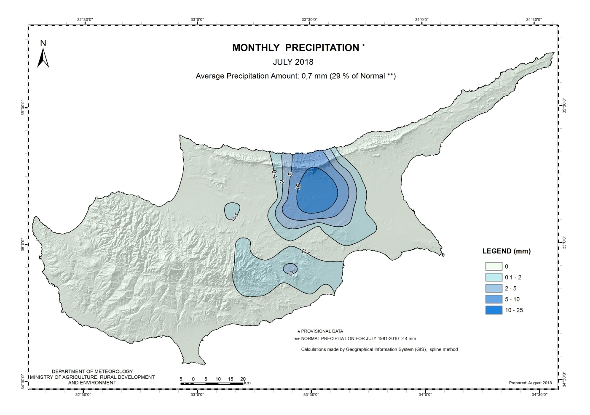

A Cyprus chart with the normal (period 1981 to 2010) accumulated precipitation for the month of **July** is also presented.

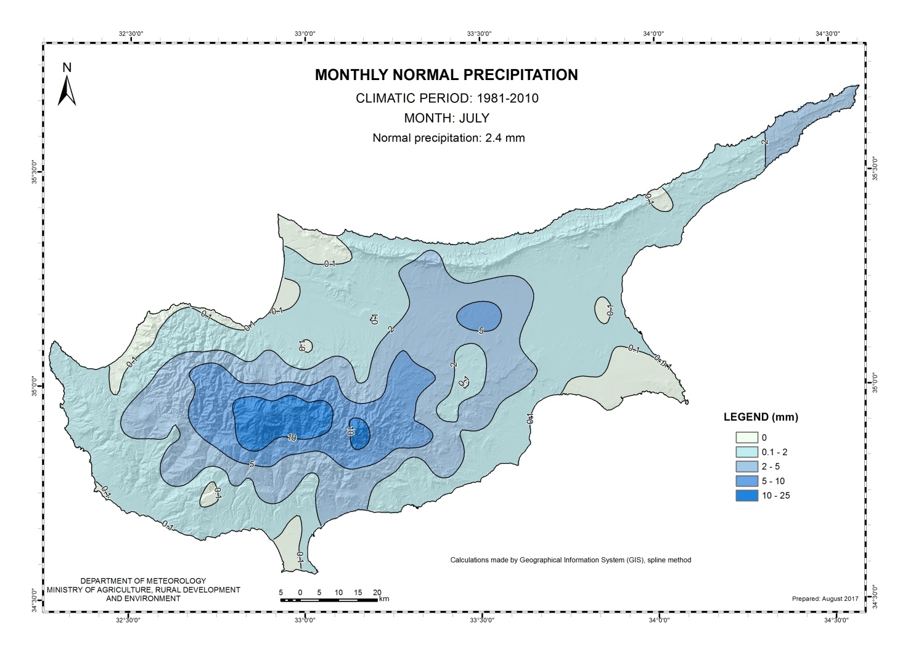

**Evaluation of August’s seasonal forecast for the area of Cyprus**

**August’s** seasonal forecast suggested that temperature over Cyprus would be generally normal, except southeast coast that would be 1-2°C lower than normal. Normal temperature characterized also Minor Asia, while Middle East would be lower than normal. The amount of the accumulated precipitation inland was expected to be around normal, while over the northern and western part is expected to range above normal and over the southern and eastern part was expected to range below normal.

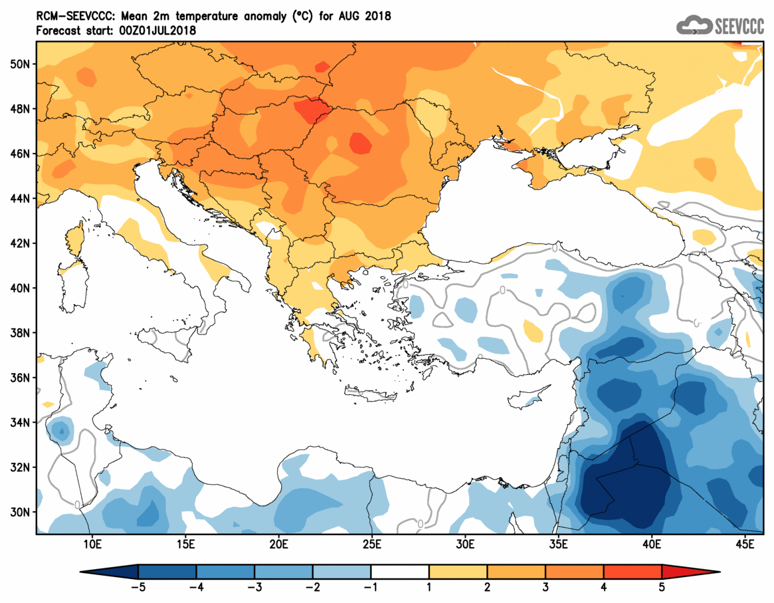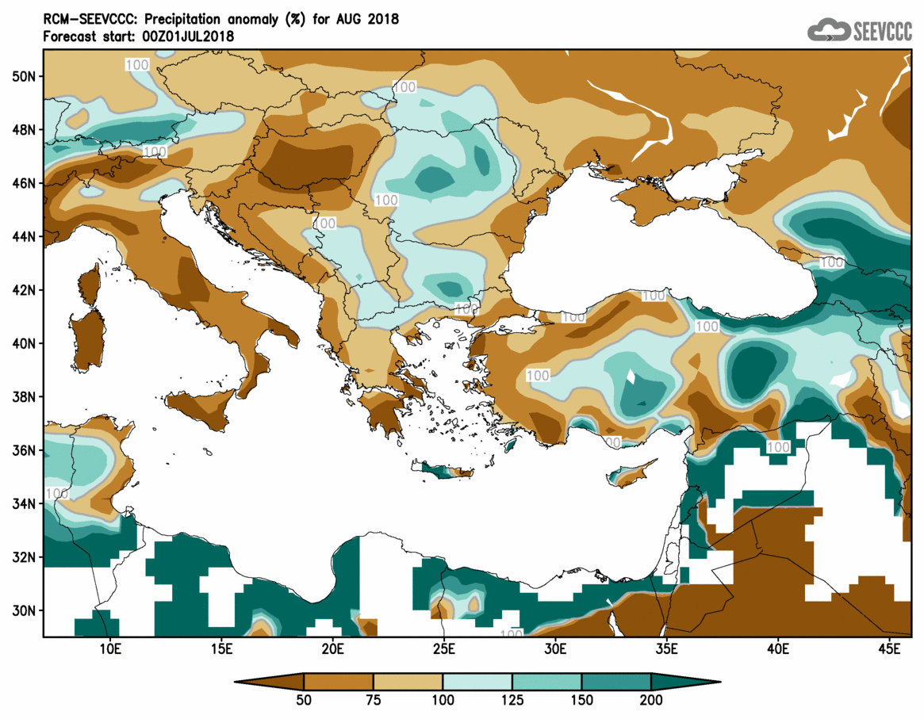

Divergence of the mean monthly temperature (oC) from normal during August

Percentage of the mean monthly precipitation (%) compared with the normal of August

Concerning the models evaluation for **August** a general judgment is that the model did not perform so well concerning the temperature. Almost all of the mean daily maximum and mean daily minimum temperatures were above normal, except the station of Achna that the mean daily maximum temperature and the mean minimum temperature were around normal. It must be mentioned that during summer month’s precipitation is resulted mainly from thundery activity which has very localised characteristics and that judging is very difficult due to models limitations.

Extremes were also recorded with positive departures greater than 4°C, like Achna station where the highest daily maximum temperature (38.6°C) was 5.1°C greater than normal (33.5°C) and Prodromos station, where the highest daily maximum temperature (32.7°C) was 4.7°C greater than normal (28°C). Generally, the highest maximum of the month was recorded on 1st of **August** over the inland station of Athalassa and it was 41.1°C with the normal being 36.9°C.

For the dates 2, 3, 8, 9, 10, 12, 14, 15, 17 and 23 of August EMMA warnings for high temperature were issued.

Daily minimum temperatures were also recorded, like Prodromos, where a minimum of 12.9°C was 5.2°C below station’s normal (18.1°C), a negative departure greater than 4°C.

On the 2nd, 4th, 5th, 7th, 8th and 21st of **August** episodes of local showers and isolated thunderstorms resulted in accumulated precipitation of 55% of normal.



For the purpose of better visualization of **August** accumulated precipitation, a chart of Cyprus with the total preliminary accumulated precipitation is presented.

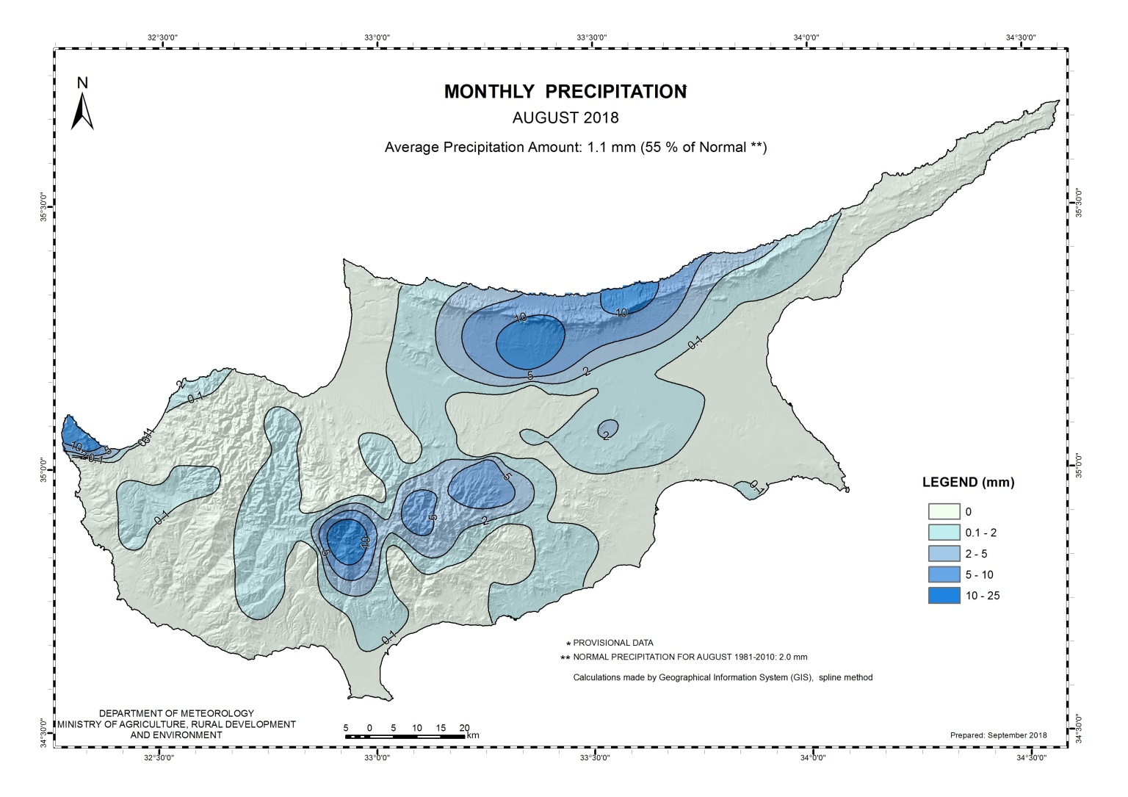

A Cyprus chart with the normal (period 1981 to 2010) accumulated precipitation for the month of **August** is also presented.

