EL NIÑO/SOUTHERN OSCILLATION (ENSO) DIAGNOSTIC DISCUSSION

issued by

CLIMATE PREDICTION CENTER/NCEP/NWS

and the International Research Institute for Climate and Society

11 October 2018

ENSO Alert System Status: El Niño Watch

Synopsis: El Niño is favored to form in the next couple of months and continue through the Northern Hemisphere winter 2018-19 (70-75% chance).

ENSO-neutral continued during September, but with increasingly more widespread regions of above-average sea surface temperatures (SSTs) across the equatorial Pacific Ocean (Fig. 1). Over the last month, all four Niño index values increased, with the latest weekly values in each region near +0.7°C (Fig. 2). Positive subsurface temperature anomalies (averaged across 180°-100°W) also increased during the last month (Fig. 3), due to the expansion and strengthening of above-average temperatures at depth across the equatorial Pacific (Fig. 4). Convection was increasingly suppressed over Indonesia and around the Date Line (Fig. 5). Low-level westerly wind anomalies were evident over the western and east-central Pacific, with some of the strongest anomalies occurring over the eastern Pacific during the past week. Upper-level wind anomalies were easterly over the east-central Pacific. Overall, the oceanic and atmospheric conditions reflected ENSO-neutral, but with recent trends indicative of a developing El Niño.
The majority of models in the IRI/CPC plume predict El Niño to form during the fall and continue through the winter (Fig. 6). The official forecast favors the formation of a weak El Niño, consistent with the recent strengthening of westerly wind anomalies and positive temperature trends in the surface and subsurface ocean. In summary, El Niño is favored to form in the next couple of months and continue through the Northern Hemisphere winter 2018-19 (70-75% chance; click CPC/IRI consensus forecast for the chance of each outcome for each 3-month period).
This discussion is a consolidated effort of the National Oceanic and Atmospheric Administration (NOAA), NOAA’s National Weather Service, and their funded institutions. Oceanic and atmospheric conditions are updated weekly on the Climate Prediction Center web site (El Niño/La Niña Current Conditions and Expert Discussions). Forecasts are also updated monthly in the Forecast Forum of CPC's Climate Diagnostics Bulletin. Additional perspectives and analysis are also available in an ENSO blog. The next ENSO Diagnostics Discussion is scheduled for 8 November 2018. To receive an e-mail notification when the monthly ENSO Diagnostic Discussions are released, please send an e-mail message to: ncep.list.enso-update@noaa.gov.

Climate Prediction Center
National Centers for Environmental Prediction
NOAA/National Weather Service
College Park, MD 20740

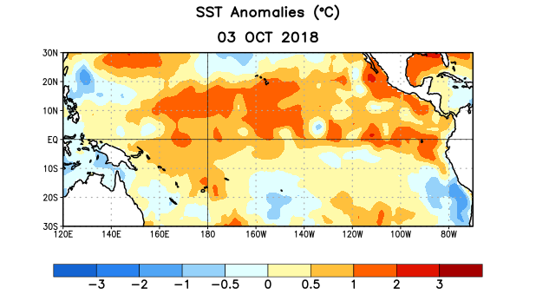
Figure 1. Average sea surface temperature (SST) anomalies (°C) for the week centered on 3 October 2018. Anomalies are computed with respect to the 1981-2010 base period weekly means.

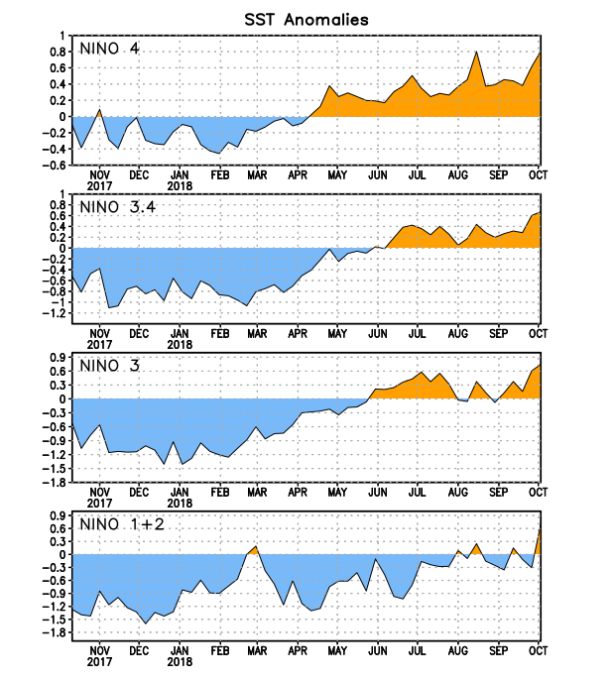
Figure 2. Time series of area-averaged sea surface temperature (SST) anomalies (°C) in the Niño regions [Niño-1+2 (0°-10°S, 90°W-80°W), Niño-3 (5°N-5°S, 150°W-90°W), Niño-3.4 (5°N-5°S, 170°W-120°W), Niño-4 (5ºN-5ºS , 150ºW-160ºE)]. SST anomalies are departures from the 1981-2010 base period weekly means.
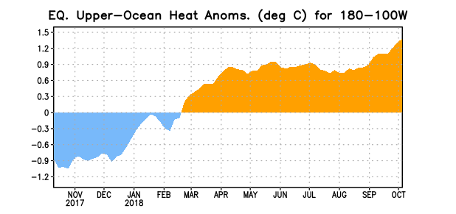
Figure 3. Area-averaged upper-ocean heat content anomaly (°C) in the equatorial Pacific (5°N-5°S, 180º-100ºW). The heat content anomaly is computed as the departure from the 1981-2010 base period pentad means.

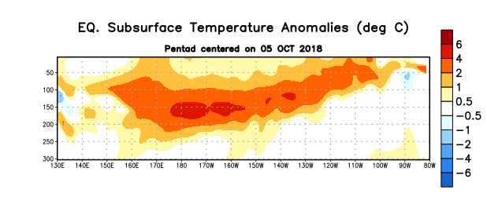
Figure 4. Depth-longitude section of equatorial Pacific upper-ocean (0-300m) temperature anomalies (°C) centered on the pentad of 5 October 2018. Anomalies are departures from the 1981-2010 base period pentad means.

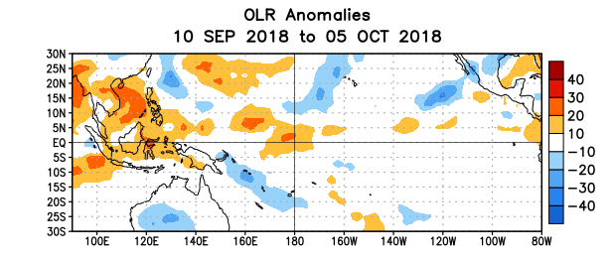
Figure 5. Average outgoing longwave radiation (OLR) anomalies (W/m²) for the period 10 September – 5 October 2018. OLR anomalies are computed as departures from the 1981-2010 base period pentad means.

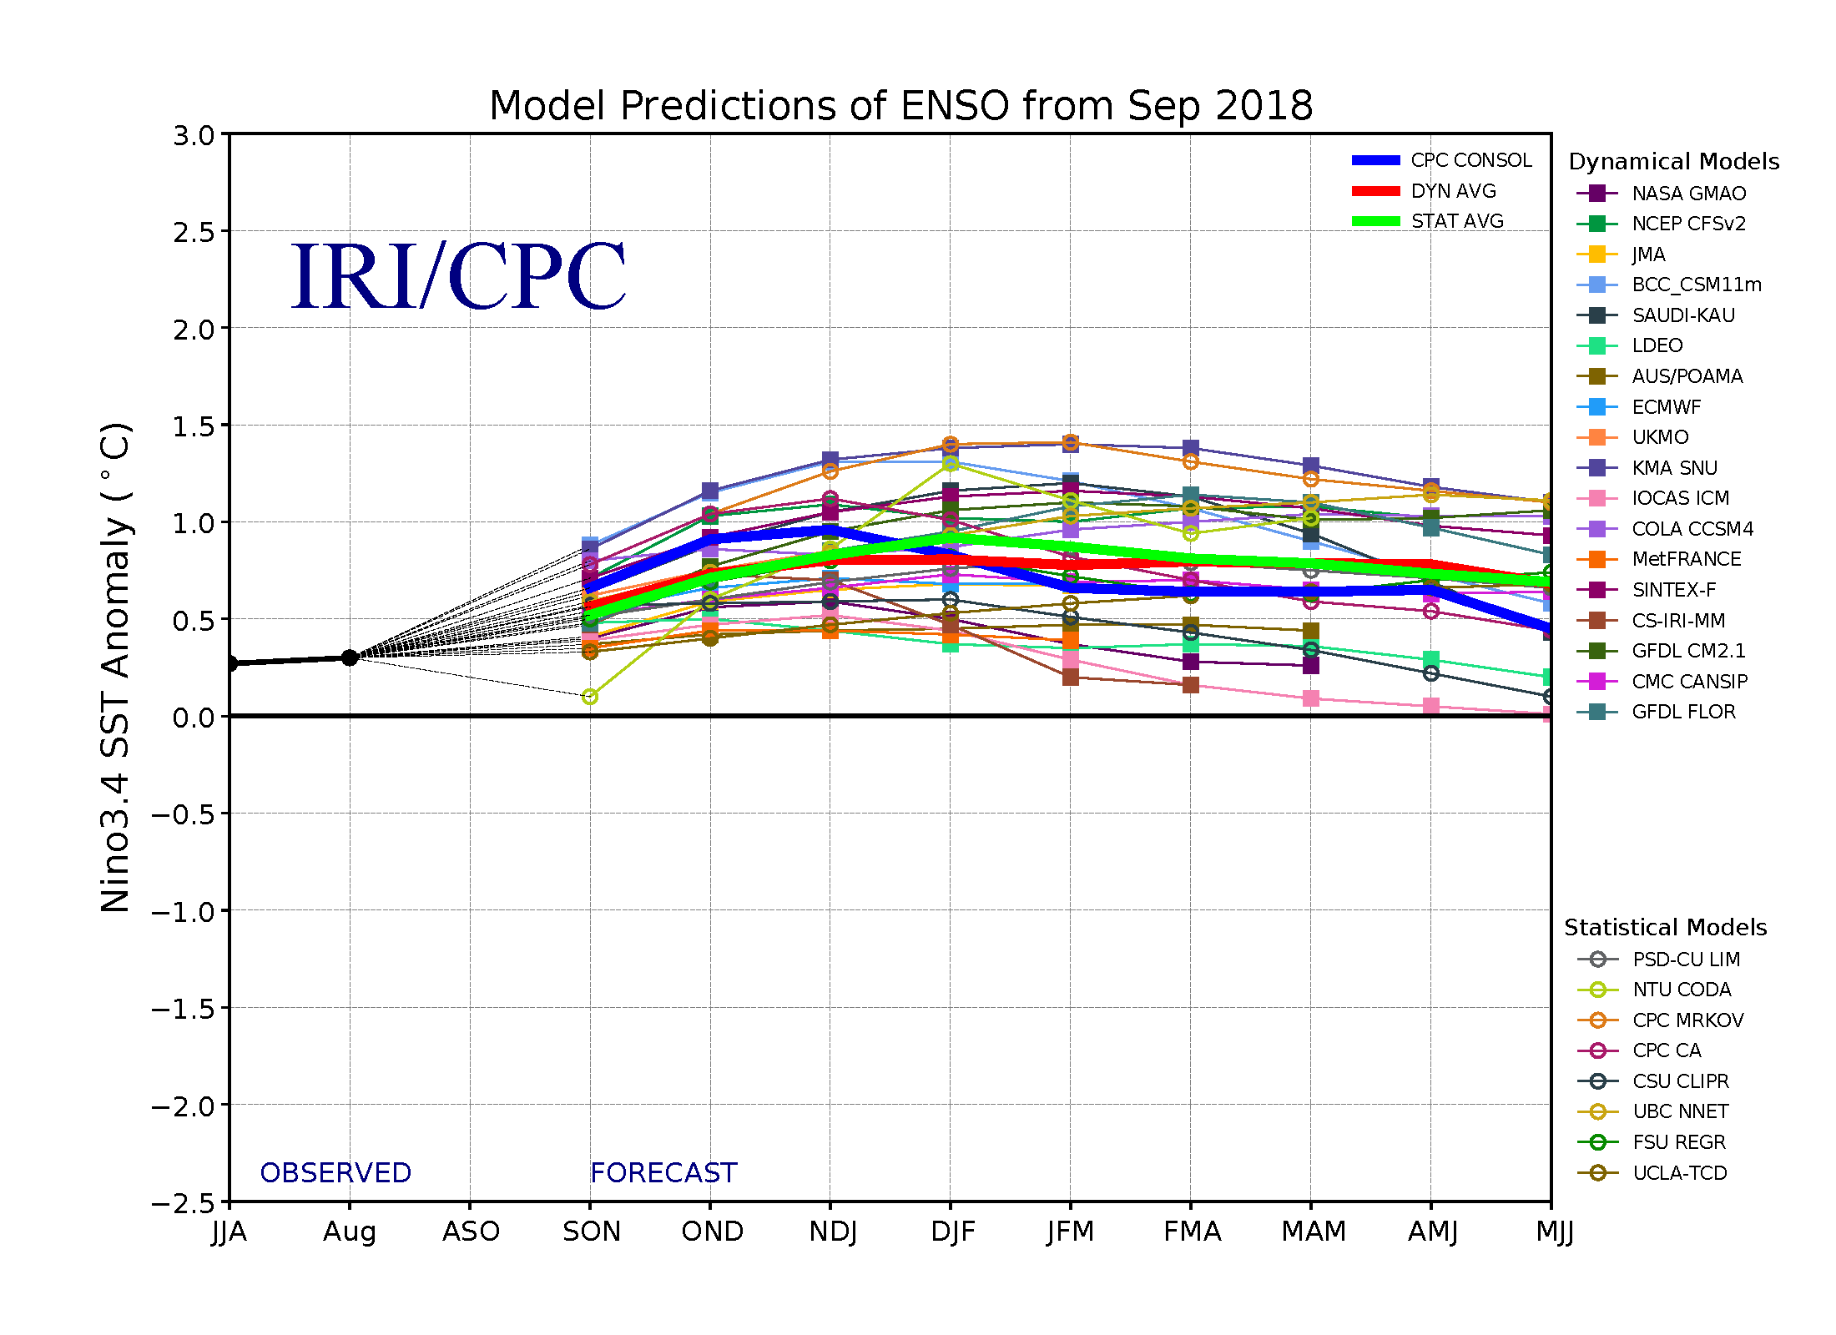
Figure 6. Forecasts of sea surface temperature (SST) anomalies for the Niño 3.4 region (5°N-5°S, 120°W-170°W). Figure updated 19 September 2018.

