EL NIÑO/SOUTHERN OSCILLATION (ENSO) DIAGNOSTIC DISCUSSION

issued by

CLIMATE PREDICTION CENTER/NCEP/NWS

and the International Research Institute for Climate and Society

8 November 2018

ENSO Alert System Status: El Niño Watch

Synopsis: El Niño is expected to form and continue through the Northern Hemisphere winter 2018-19 (~80% chance) and into spring (55-60% chance).

ENSO-neutral continued during October, despite widespread above-average sea surface temperatures (SSTs) across the equatorial Pacific Ocean (Fig. 1). All four Niño regions showed increased SST anomalies in October, with the latest weekly values near +1.0°C in the Niño-4, Niño-3.4 and Niño3 regions, and +0.2°C in the Niño-1+2 region (Fig. 2). Positive subsurface temperature anomalies (averaged across 180°-100°W) also continued (Fig. 3), due to the persistence of above-average temperatures at depth across the eastern half of the equatorial Pacific Ocean (Fig. 4). However, atmospheric convection remained slightly suppressed near the Date Line and over Indonesia (Fig. 5). Low-level westerly wind anomalies were observed over the eastern Pacific during October, while weak upper-level westerly wind anomalies were present over the far western Pacific. The traditional and equatorial Southern Oscillation indices were near zero. Despite the above-average ocean temperatures across the equatorial Pacific Ocean, the overall coupled ocean-atmosphere system continued to reflect ENSO-neutral.
The majority of models in the IRI/CPC plume predict a Niño3.4 index of +0.5°C or greater to continue through the rest of the fall and winter and into spring (Fig. 6). The official forecast favors the formation of a weak El Niño, with the expectation that the atmospheric circulation will eventually couple to the anomalous equatorial Pacific warmth. In summary, El Niño is expected to form and continue through the Northern Hemisphere winter 2018-19 (~80% chance) and into spring (55-60% chance; click CPC/IRI consensus forecast for the chance of each outcome for each 3-month period).
This discussion is a consolidated effort of the National Oceanic and Atmospheric Administration (NOAA), NOAA’s National Weather Service, and their funded institutions. Oceanic and atmospheric conditions are updated weekly on the Climate Prediction Center web site (El Niño/La Niña Current Conditions and Expert Discussions). Forecasts are also updated monthly in the Forecast Forum of CPC's Climate Diagnostics Bulletin. Additional perspectives and analysis are also available in an ENSO blog. The next ENSO Diagnostics Discussion is scheduled for 13 December 2018. To receive an e-mail notification when the monthly ENSO Diagnostic Discussions are released, please send an e-mail message to: ncep.list.enso-update@noaa.gov.

Climate Prediction Center
National Centers for Environmental Prediction
NOAA/National Weather Service
College Park, MD 20740

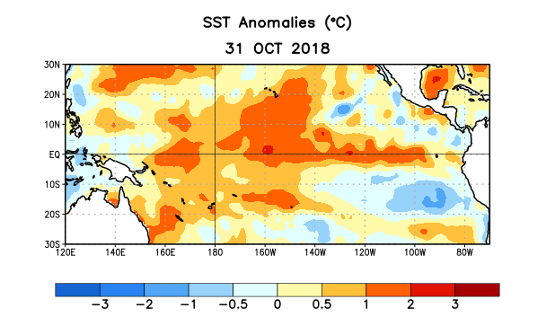
Figure 1. Average sea surface temperature (SST) anomalies (°C) for the week centered on 31 October 2018. Anomalies are computed with respect to the 1981-2010 base period weekly means.

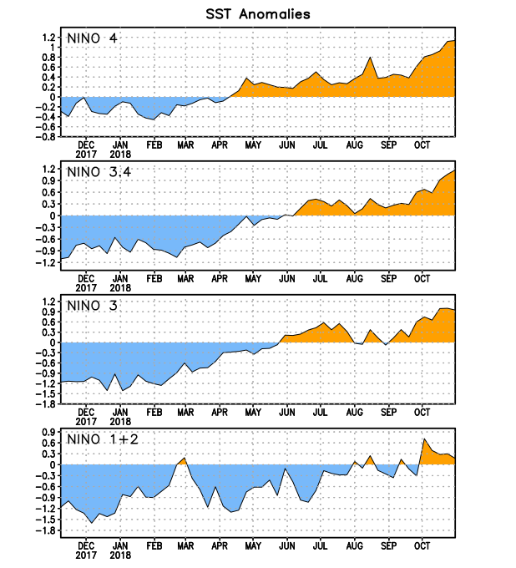
Figure 2. Time series of area-averaged sea surface temperature (SST) anomalies (°C) in the Niño regions [Niño-1+2 (0°-10°S, 90°W-80°W), Niño-3 (5°N-5°S, 150°W-90°W), Niño-3.4 (5°N-5°S, 170°W-120°W), Niño-4 (5ºN-5ºS , 150ºW-160ºE)]. SST anomalies are departures from the 1981-2010 base period weekly means.
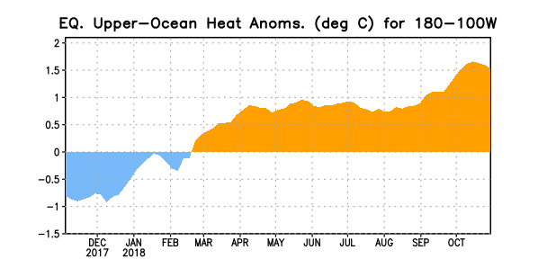
Figure 3. Area-averaged upper-ocean heat content anomaly (°C) in the equatorial Pacific (5°N-5°S, 180º-100ºW). The heat content anomaly is computed as the departure from the 1981-2010 base period pentad means.

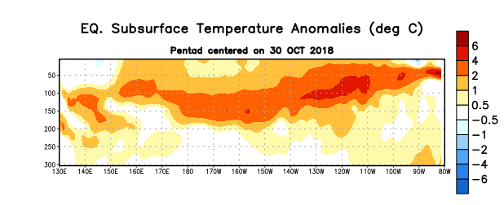
Figure 4. Depth-longitude section of equatorial Pacific upper-ocean (0-300m) temperature anomalies (°C) centered on the pentad of 30 October 2018. Anomalies are departures from the 1981-2010 base period pentad means.

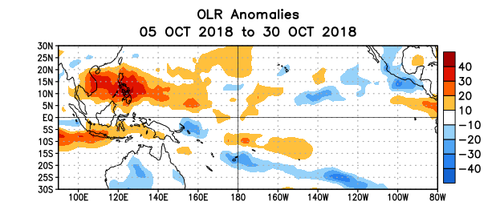
Figure 5. Average outgoing longwave radiation (OLR) anomalies (W/m²) for the period 5– 30 October 2018. OLR anomalies are computed as departures from the 1981-2010 base period pentad means.

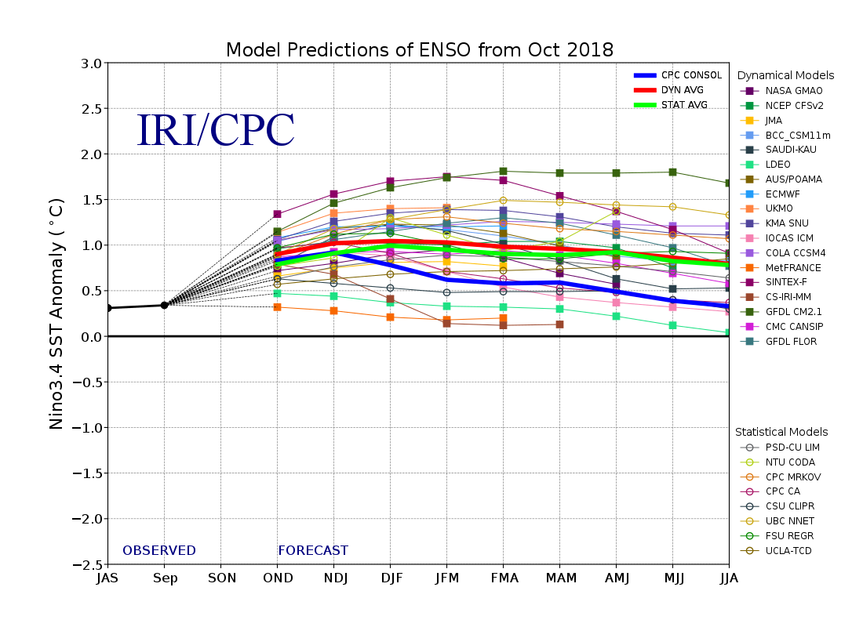
Figure 6. Forecasts of sea surface temperature (SST) anomalies for the Niño 3.4 region (5°N-5°S, 120°W-170°W). Figure updated 19 October 2018.

