



Nineteenth Session of
SOUTHEASTERN EUROPE CLIMATE OUTLOOK FORUM (SEECOF-19)
April-May, 2018

SEASONAL OUTLOOK FOR SUMMER SEASON 2018 FOR THE SOUTH EASTERN EUROPE AND CAUCASUS REGION (SEE&C)
Climate experts from WMO RA VI RCC Network Nodes on long-range forecasting (Meteo France, France and Roshydromet, Russia) and WMO RA VI RCC Network Node on climate monitoring (Deutscher Wetterdienst, Germany), UK Met-Office, Global Producing Centre ECMWF, International Research Institute for Climate and Society (IRI, USA), National Centers for Environmental Prediction (NCEP,USA), WMO RA VI RCC South East Europe Virtual Climate Change Centre (SEEVCCC, Serbia) and National Hydrometeorological Services of SEECOF region provided their valuable contribution to the successful implementation of SEECOF-19 by developing the relevant documents and providing scientific guidance and recommendations.
The SEECOF-19 comprised of the following Steps:
- Step 1: qualitative verification of the SEECOF-18 climate outlook for 2017-2018 Winter;
- Step 2: assessment of the current state of the climate including large-scale climate patterns worldwide and assessments of its likely evolution in the course of the next months;
- Step 3: building the consensus forecast for 2018 summer season.
All relevant documentation is posted and updated in SEEVCCC web site: http://www.seevccc.rs

SEECOF-19 CLIMATE OUTLOOK
FOR THE 2018 SUMMER SEASON

Similarly to MedCOF-10 seasonal climate outlook, SEECOF-19 prediction is based on the output from dynamical models, including, inter alia, the operational products of the SEEVCCC centre, statistical models and teleconnections of large-scale climate features.

During April 2018, La Nina pattern was still over the Pacific Ocean. The majority of models are predicting tendency of returning ENSO to the neutral condition at least through the summer 2018. NAO was positive during April and is likely to decrease to neutral phase during late summer. Above-average conditions of the eastern Mediterranean and Black Sea SST‘s have been observed during the past few months and this condition is most likely to persist during the upcoming summer The East Atlantic Teleconnection Pattern was positive during April, and is likely to be in a positive phase during June and July. During summer, IOD is predicted to be in a neutral phase. TNA seems to be developing a negative anomaly, but still close to neutral. TASI is currently below normal values, and is expected to continue like that for the summer.
The maps show the probabilistic consensus forecast for the tercile categories of anomalies for seasonal mean temperature and precipitation, relative to the 1981-2010 period. Due to the climate warming trend, anomalies are affected by the selected reference period.

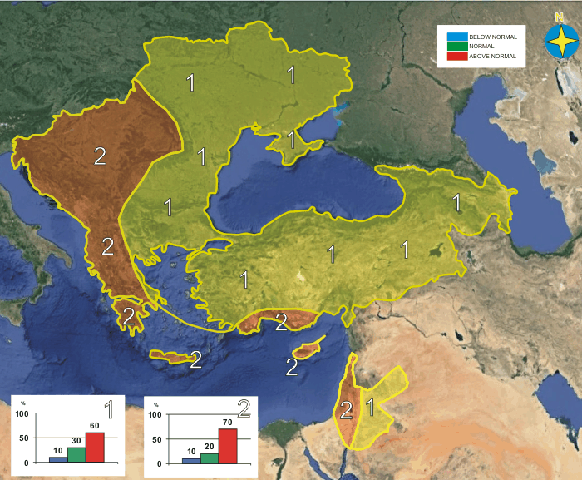\
Figure 1. Graphical presentation of the 2018 summer temperature outlook

The entire SEECOF region is likely to experience above-average summer temperature. Probability for the above-average summer temperature is increasing across the areas spreading from northern-northeastern toward western and southern parts of the SEECOF region. Probability for exceeding average summer temperature is lower in eastern part of the Balkan Peninsula, Ukraine, along the coasts of the Aegean and Black Sea, most of Turkey, South Caucasus region as well as in Jordan (zone 1 in Figure 1), while probability for above-average conditions is highest for the Pannonia Plain, Central and Western Balkans, most of the Greece, along the coasts of Adriatic, Ionian and Eastern Mediterranean Sea with belonging coasts, as well as in Israel (zone 2 in Figure 1). The generalized relatively high warm signal is probably partly due to the background climatic warming trend.

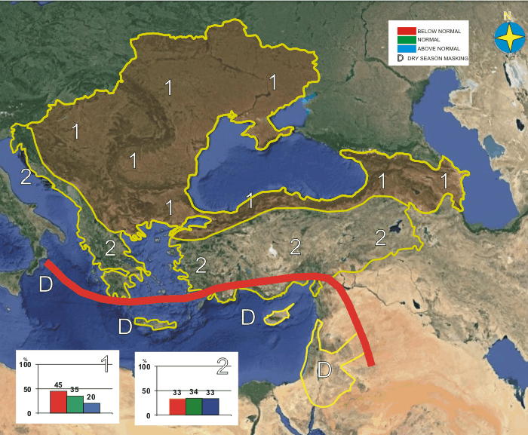
Figure 2. Graphical presentation of the 2018 summer precipitation outlook
Uncertainties in regional predictions are higher for precipitation than for temperature. Drivers like TASI and TNA suggest drier than normal summer in northern part of SEECOF domain, along the coasts of Black Sea as well as in the South Caucasus region. Summer precipitation sums in most of the SEECOF region (zone 1 in Figure 2) are likely to be below-average, with the exception of the coasts of the Adriatic, Ionian and Aegean Sea with the belonging hinterland, south of the Balkan Peninsula, as well as in continental part of Turkey (zone 2 in Figure 2) with approximately equal probabilities for below-, near- or above normal-averages.
It should be noted that certain parts of the country, particularly mountain regions may observe near- or above- normal summer precipitation due to the episodes of enhanced convection accompanied by heavy precipitation. Due to dry season masking, it is not possible to forecast summer precipitation totals for the Eastern Mediterranean with belonging coasts and hinterland, Crete as well as in Israel and Jordan.

Reference:
The maps show the probabilistic consensus forecast for tercile categories of anomalies of seasonal-mean temperature and precipitation, relative to the 1981-2010 period.

Any further advice on the forecast signals, shorter-range updates and warnings will be available throughout the summer from the National Meteorological Services, along with the details on the methodology and skill of long-range predictions.

* The graphical representation of climate outlook in this statement is for guidance purposes only, and does not imply any opinion whatsoever concerning the legal status of any country, territory, city or area or of its authorities, or concerning the delimitation of its frontiers or boundaries.

APPENDIX A: Contributors to SEECOF-19

- World Meteorological Organization
- Met Office, United Kingdom
- International Research Institute for Climate and Society, United States of America
- European Canter for Medium Range Weather Forecast
- Meteo France, Republic of France
- Deutscher Wetterdienst, Federal Republic of Germany
- National Canter for Environmental Prediction, United States of America
- Federal Service for Hydrometeorology and Environmental Monitoring, Russian Federation
- South East European Virtual Climate Change Canter hosted by Republic Hydrometeorological Service of Serbia, Republic of Serbia
- Institute of Geosciences, Energy, Water and Environment, Albania
- Armenian State Hydrometeorological and Monitoring Service, Armenia
- National Institute of Meteorology and Hydrology, Republic of Bulgaria
- Meteorological and Hydrological Service, Republic of Croatia
- Meteorological Service, Republic of Cyprus
- Hellenic National Meteorological Service, Greece
- The National Environmental Agency of Georgia, Georgia
- Hungarian Meteorological Service, Hungary
- Israel Meteorological Service, State of Israel
- Republic Hydrometeorological Institute, Former Yugoslav Republic of Macedonia
- State Hydrometeorological Service, Republic of Moldova
- Hydrometeorological Institute of Montenegro, Montenegro
- National Meteorological Administration, Romania
- Federal Hydrometeorological Service of the Federation of Bosnia and Herzegovina, Federation of Bosnia and Herzegovina, Bosnia and Herzegovina
- Republic Hydrometeorological Service of the Republic of Srpska, Republic of Srpska, Bosnia and Herzegovina
- Republic Hydrometeorological Service of Serbia, Republic of Serbia
- Turkish State Meteorological Service, Republic of Turkey
- Ukrainian Hydrometeorological Center, Ukraine

