MEDCOF-10 Climate Bulletin (1st DRAFT)
Large Scale Monitoring Section
prepared by Météo-France

I. DESCRIPTION OF THE CLIMATE SYSTEM (April 2018)
I.1.Oceanic analysis
Over the Pacific Ocean: still a "La Niña" pattern :
- Along the equator, little change in SSTs with negative anomalies east of the date line (Niño 3.4 index of -0.3°C, warming since March) and warm anomalies to the west ( GLORYS 1992-2009, MERCATOR-Océan). In sub-surface, the cold anomaly (Eastern Pacific) has reduced in April (see fig. I.I.4).
- In the northern hemisphere, mainly positive anomalies. No clear PDO pattern visible, althought the index remains negative ( -0.8 for this month, see https://www.ncdc.noaa.gov/teleconnections/pdo/ )
- In the southern hemisphere, warm anomalies remaining in the Western part of the basin, especially around New Zealand. And a large negative anomaly in the Eastern sub-tropics.
Over the Maritime Continent and the Indian Ocean :
- warm anomalies (<1°C) in the Northern hemisphere. To the South (up to 20°S), still a contrast between a warm western part and a cool eastern part of the basin.
- DMI close to zero (source : MERCATOR-Ocean)
Over the Atlantic:
- In the North Atlantic, warm anomalies to the West, and cold anomalies to the East, close to Europe. SSTs remain colder than normal off the western coast of Africa. Positive anomalies over the north-eastern arctic part of the basin.
- along the equator, neutral conditions (positive trend between March and April)
Over the Mediterranean:
- SSTs globally warmer than normal.
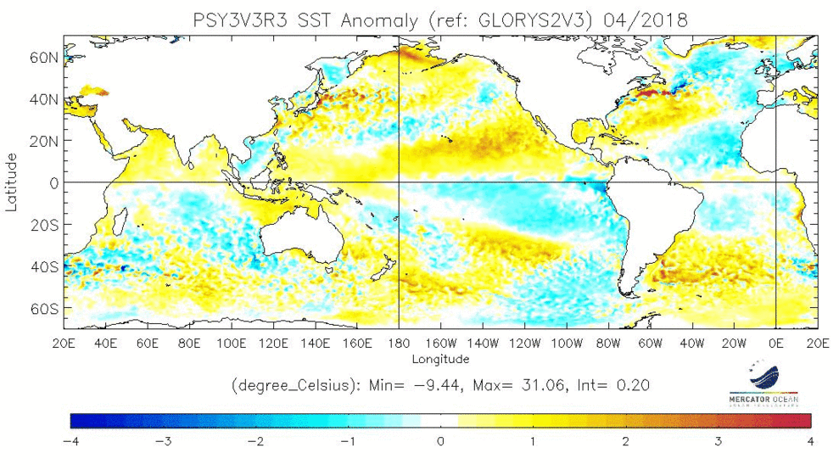
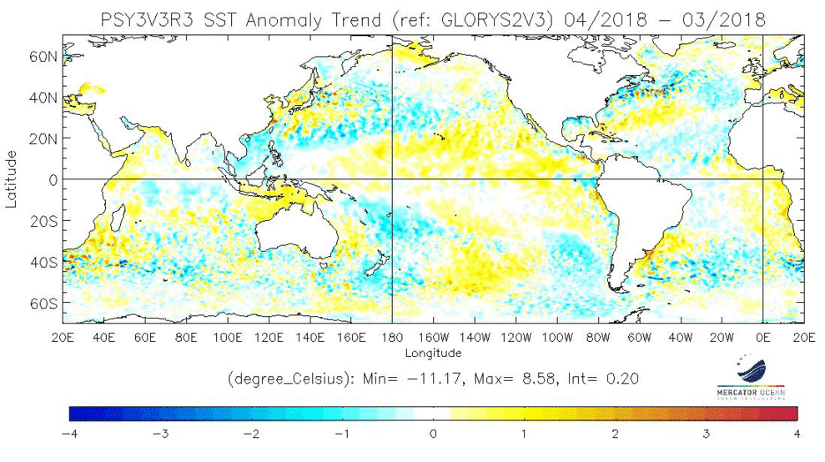
fig.I.1.1: top: SST Anomalies (°C) . Bottom: SST tendency (current – previous month), (reference Glorys 1992-2013).
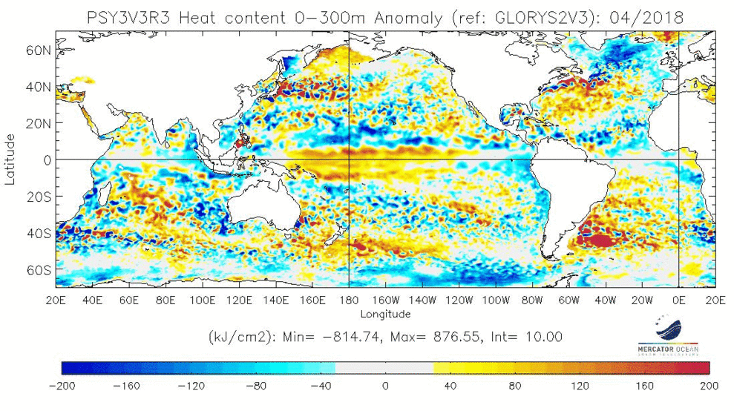
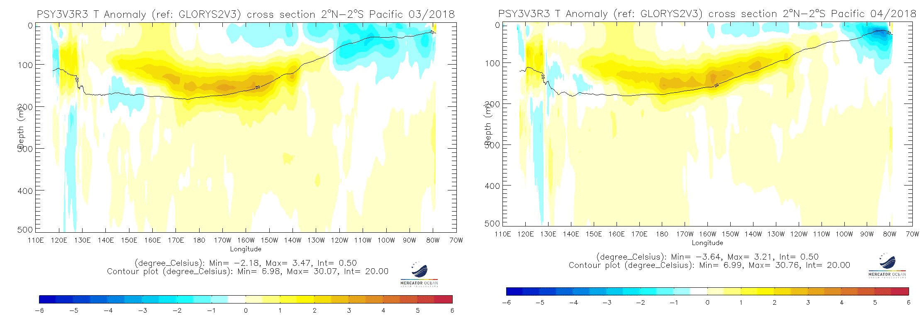
fig.I.1.2: map of Heat Content Anomalies (first 300m, kJ/cm2, reference Glorys 1992-2013)

fig.I.1.4: Oceanic temperature anomaly in the first 500 meters in the Equatorial Pacific (previous and current month)

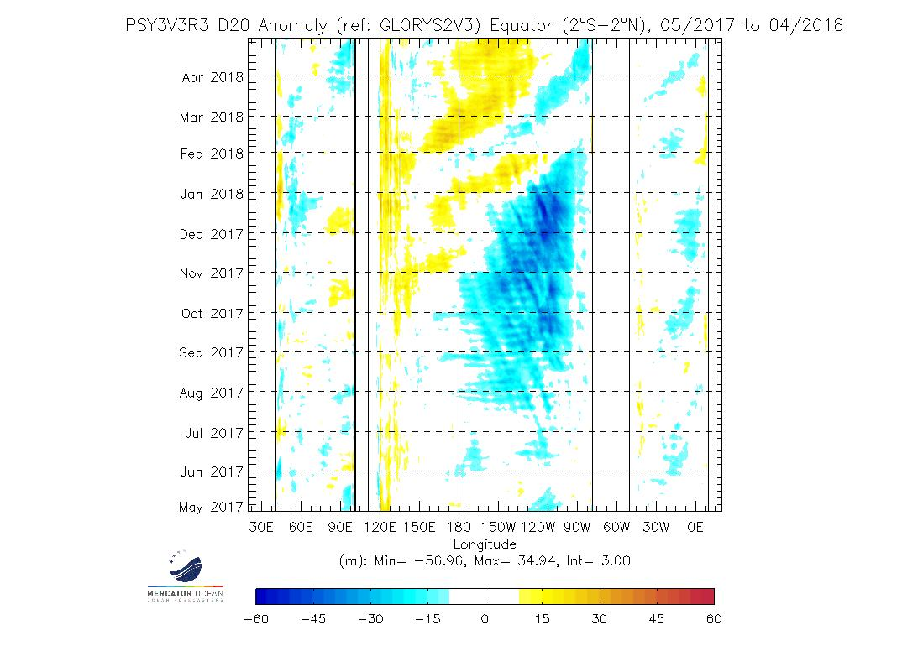
fig.I.1.5: Hovmüller diagram of Thermocline Depth Anomalies (m) (depth of the 20°C isotherm) along the equator for all oceanic basins over a 6 month period

I.2. ATMOSPHERE
I.2.a General Circulation
Velocity Potential Anomaly field in the high troposphere (fig. 1.2.1 – insight into Hadley-Walker circulation anomalies) :
- no typical "La Niña" response in April around the equatorial Pacific. Anomalies look like MJO impacts (MJO was active in April).
- the main anomaly dipole concerned Africa (upward anomaly motion) and the Maritime Continent (Downward anomaly motion), consistent with MJO in phases 7,8,1,2 and 3.
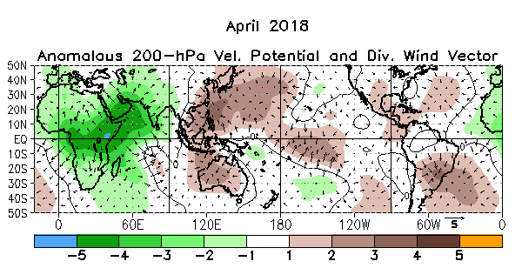
fig.I.2.1.a: Velocity Potential Anomalies at 200 hPa and associated divergent circulation anomaly. Green (brown) indicates a divergence-upward anomaly (convergence-downward anomaly). http://www.cpc.ncep.noaa.gov/products/CDB/Tropics/figt24.shtml
SOI :
- SOI index lower than in March, close to neutrality at +0.5 (NOAA Standardized SOI: https://www.ncdc.noaa.gov/teleconnections/enso/indicators/soi/ ).

MJO (fig. I.2.1.b)
- Active MJO all along the month in phases 7, 8, 1, 2 and 3
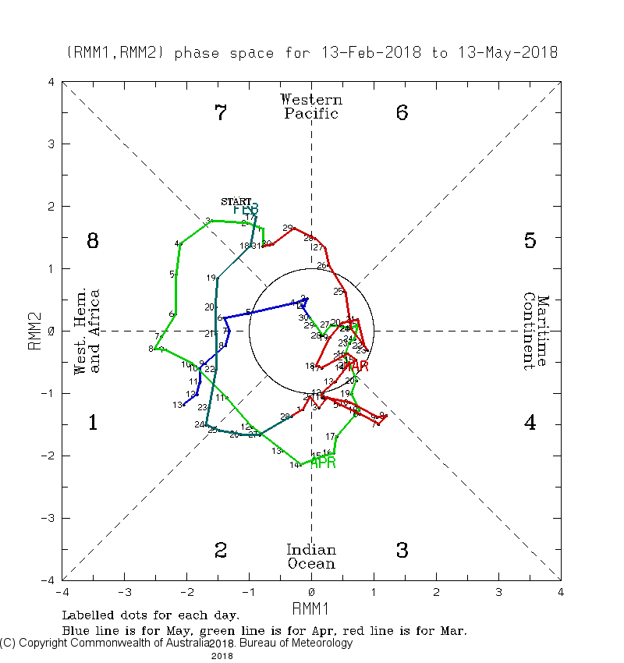
fig.I.2.1.b: indices MJO http://www.bom.gov.au/climate/mjo/

Stream Function anomalies in the high troposphere (fig. 1.2.2 – insight into teleconnection patterns tropically forced):
Cyclonic anomalies over the eastern Pacific, very similar to the ones observed in Feb. and March, and consistent with La Niña composites. Consequently, the positive anaomly that spreads up to SW of the USA could be originated from La Niña.
Anywhere else, no noticeable anomalies in the inter-tropical area.
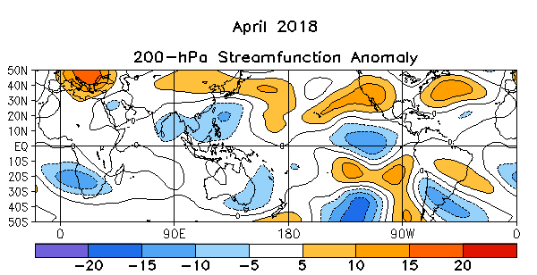
fig.I.2.2: Stream Function Anomalies at 200 hPa. http://www.cpc.ncep.noaa.gov/products/CDB/Tropics/figt22.shtml

Geopotential height at 500 hPa (fig.1.2.3 – insight into mid-latitude general circulation):
- over Northern Atlantic and Europe, anomalys project on the positive phases of NAO and EA (East Atlantic). Active perturbations have concerned essentially Western Europe.
- on the North-American continent, anomaly dipole between the SW (+) and NE (-) : therefore, the atmospheric circulation had a significant North component during the month over Canada and the USA.

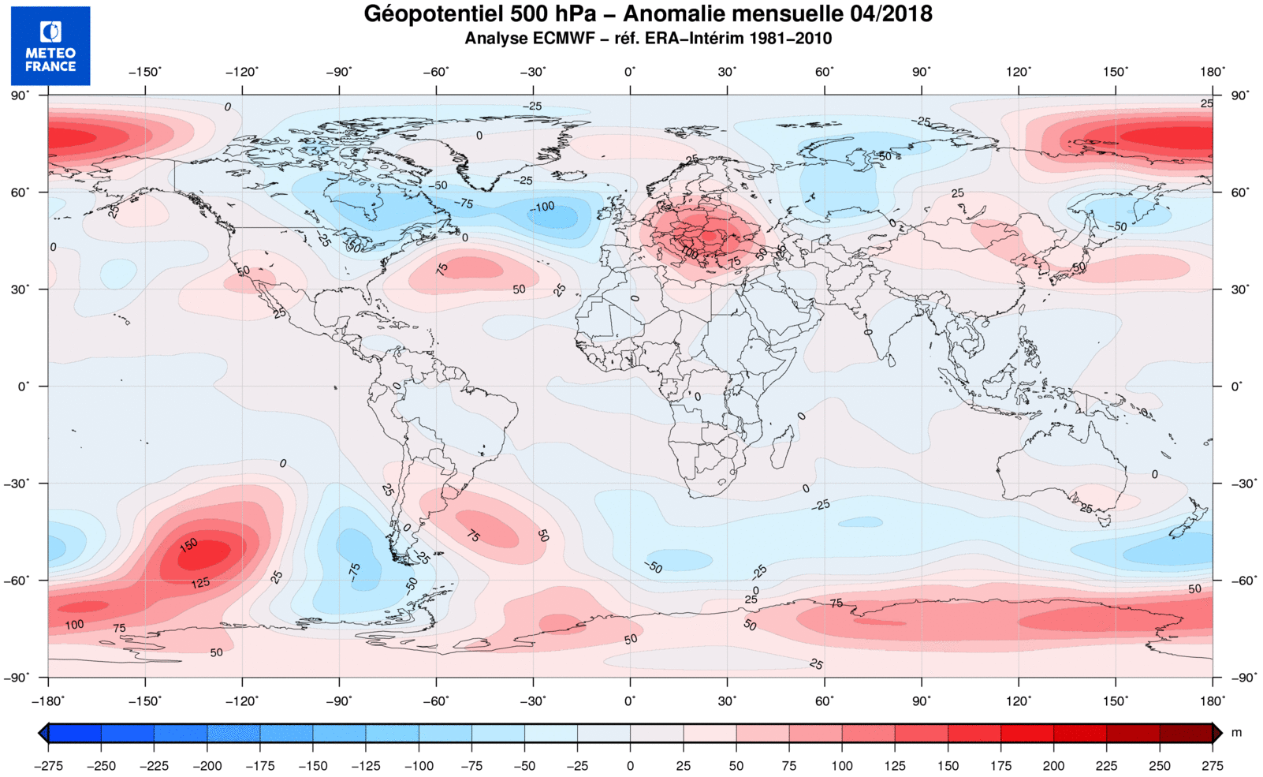
fig.I.2.3: Anomalies of Geopotential height at 500hPa (Meteo-France)

I.2.b Precipitation
- In the equatorial band, quite consistent response to La Niña. Anyway, contrary to March, there are significant differences over the Maritime Continent, where MJO had strongly weakened convection.
- strong positive anomaly over the Indian Basin (cf negative VP200 anomalies).
- strong contrast over Africa, with deficit of precipitations around the Gulf of Guinea.
- over Europe, strong West-East contrast, consistent with Z500 anomalies
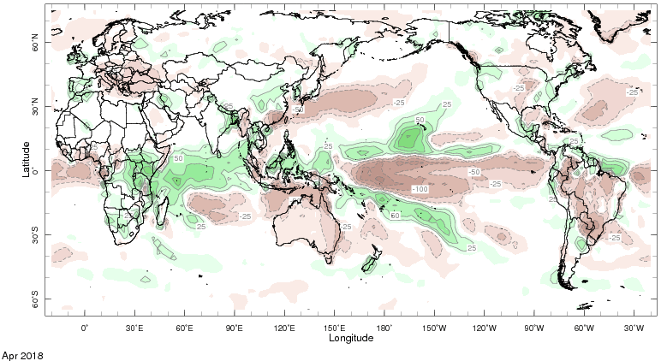
fig.I.2.6: Rainfall Anomalies (mm) (departure to the 1979-2000 normal) – Green corresponds to above normal rainfall while brown indicates below normal rainfall. http://iridl.ldeo.columbia.edu/maproom/.Global/.Precipitation/Anomaly.html

I.2.c Temperature
- large positive anomaly over the European continent (up to +5°C)
- large negative anomaly over the USA and Canada (up to -5°C)

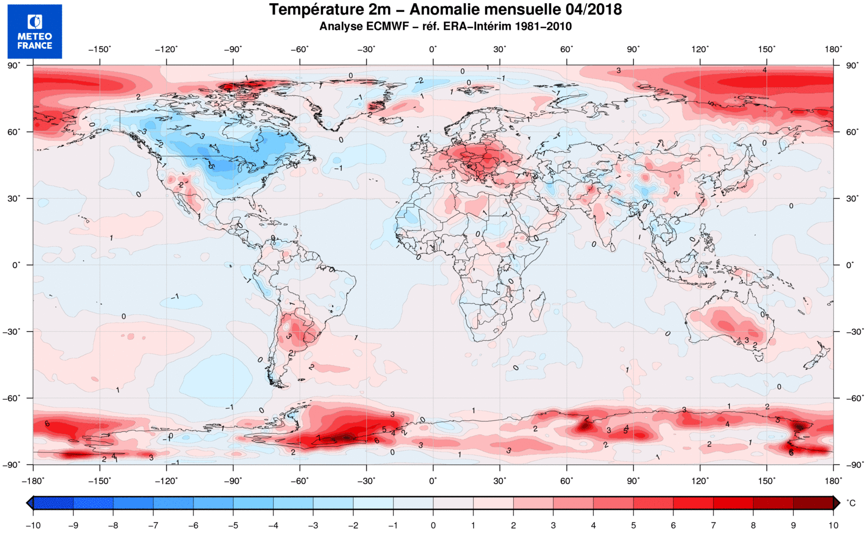
fig.I.2.9: Temperature Anomalies (°C) (Meteo-France)

I.2.d Sea ice
In the Arctic : remaining close to record-low extent (2nd lowest, behind 2017). Record low for the Bering Sea.
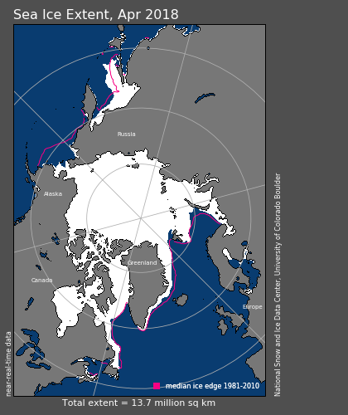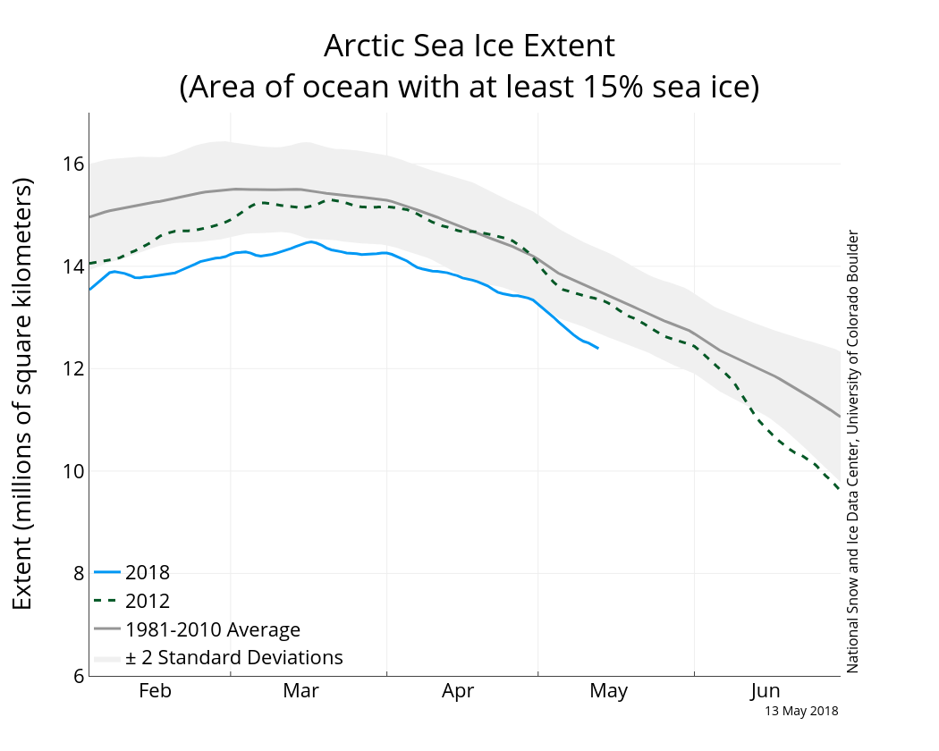
fig.I.2.11: Sea-Ice extension in Arctic The pink line indicates the averaged extension (for the 1979-2000 period). http://nsidc.org/data/seaice_index/
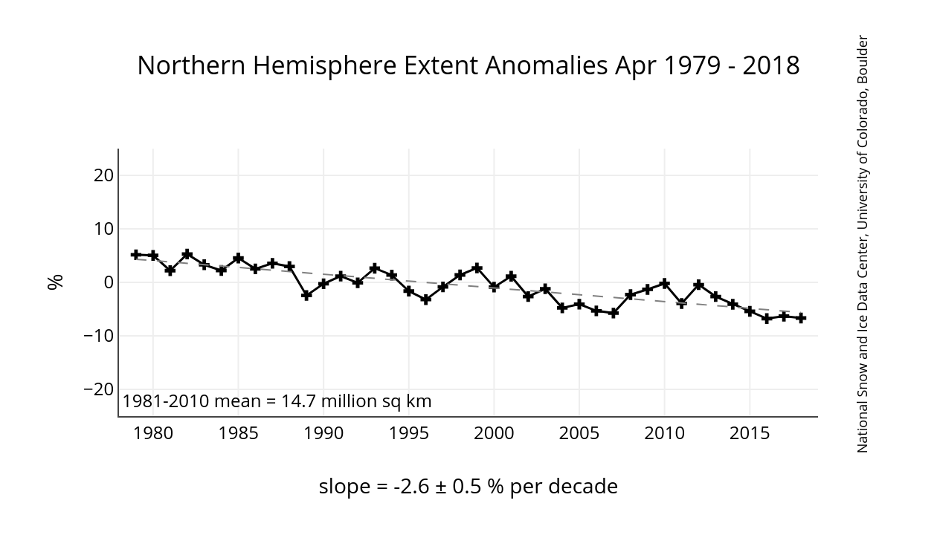
fig 1.2.13 : Monthly Sea Ice Extent Anomaly Graph in Arctic for the month of analysis (http://nsidc.org/data/seaice_index/)

