EL NIÑO/SOUTHERN OSCILLATION (ENSO) DIAGNOSTIC DISCUSSION

issued by

CLIMATE PREDICTION CENTER/NCEP/NWS
and the International Research Institute for Climate and Society
13 April 2017

ENSO Alert System Status: Not Active

Synopsis: ENSO-neutral conditions are favored to continue through at least the Northern Hemisphere spring 2017, with increasing chances for El Niño development by late summer and fall.
ENSO-neutral conditions continued during March, with near-average sea surface temperatures (SSTs) across the central equatorial Pacific and above-average SSTs in the eastern Pacific (Fig. 1). The latest weekly Niño index values were near zero in the Niño-4 and Niño-3.4 regions, and +0.8 and +0.9°C farther east in the Niño-3 and Niño-1+2 regions, respectively (Fig. 2). The upper-ocean heat content anomaly, averaged across the central and eastern Pacific (Fig. 3), decreased to near zero during March, a reflection of above-average temperatures at depth in the east offset by below-average temperatures in the central Pacific (Fig. 4). Atmospheric convection remained suppressed over the central tropical Pacific and enhanced over the Maritime Continent (Fig. 5). The low-level easterly winds were enhanced over the central and western tropical Pacific, and weaker than average over the eastern Pacific. Also, upper-level westerly winds were anomalously easterly over the western and far eastern Pacific, while the Southern Oscillation Index was near average. Overall, the ocean and atmosphere system is consistent with ENSO-neutral conditions.

Most models predict the continuation of ENSO-neutral (3-month average Niño-3.4 index between -0.5°C and 0.5°C) through the late Northern Hemisphere spring (April-June; Fig. 6). However, at least one-half of the dynamical model forecasts, including the NCEP CFSv2, anticipate an onset of El Niño as soon as the April-June season. Because of typically lower skill in forecasts made at this time of the year, and the lingering La Niña-like tropical convection and wind patterns over the western half of the Pacific basin, the forecaster consensus favors ENSO-neutral during April-June with a 60-65% chance. Thereafter, there are increasing odds for El Niño toward the second half of 2017 (~50% chance from approximately August-December). In summary, ENSO-neutral conditions are favored to continue through at least the late Northern Hemisphere spring 2017, with increasing chances for El Niño development by late summer and fall (click CPC/IRI consensus forecast for the chance of each outcome for each 3-month period).

This discussion is a consolidated effort of the National Oceanic and Atmospheric Administration (NOAA), NOAA’s National Weather Service, and their funded institutions. Oceanic and atmospheric conditions are updated weekly on the Climate Prediction Center web site (El Niño/La Niña Current Conditions and Expert Discussions). Forecasts are also updated monthly in the Forecast Forum of CPC's Climate Diagnostics Bulletin. Additional perspectives and analysis are also available in an ENSO blog. The next ENSO Diagnostics Discussion is scheduled for 11 May 2017. To receive an e-mail notification when the monthly ENSO Diagnostic Discussions are released, please send an e-mail message to: ncep.list.enso-update@noaa.gov.

Climate Prediction Center
National Centers for Environmental Prediction
NOAA/National Weather Service
College Park, MD 20740

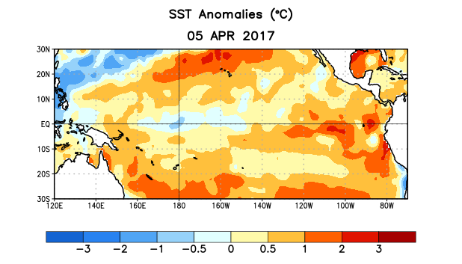
Figure 1. Average sea surface temperature (SST) anomalies (°C) for the week centered on 5 April 2017. Anomalies are computed with respect to the 1981-2010 base period weekly means.

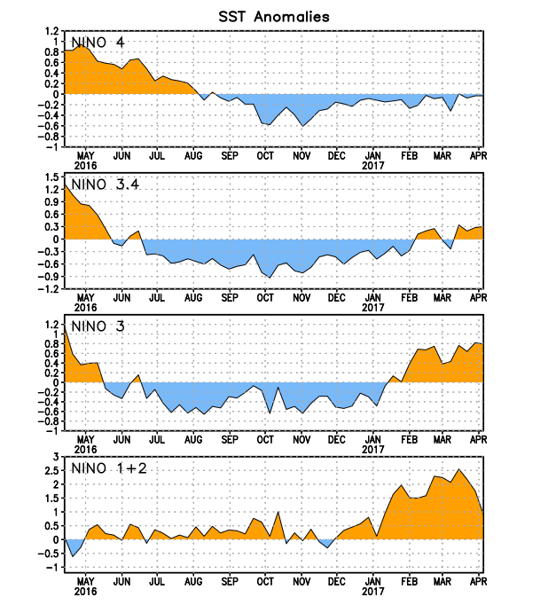
Figure 2. Time series of area-averaged sea surface temperature (SST) anomalies (°C) in the Niño regions [Niño-1+2 (0°-10°S, 90°W-80°W), Niño 3 (5°N-5°S, 150°W-90°W), Niño-3.4 (5°N-5°S, 170°W-120°W), Niño-4 (5ºN-5ºS , 150ºW-160ºE]. SST anomalies are departures from the 1981-2010 base period weekly means.
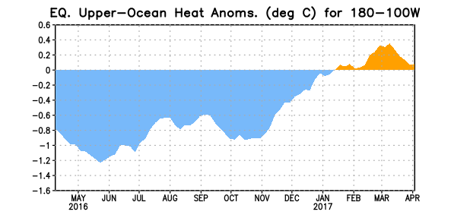
Figure 3. Area-averaged upper-ocean heat content anomaly (°C) in the equatorial Pacific (5°N-5°S, 180º-100ºW). The heat content anomaly is computed as the departure from the 1981-2010 base period pentad means.

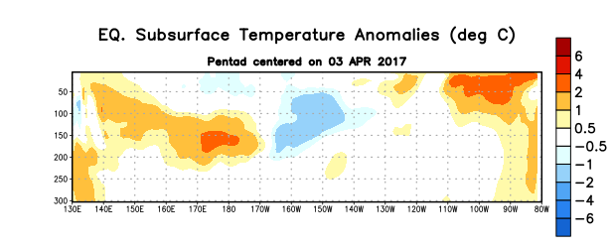
Figure 4. Depth-longitude section of equatorial Pacific upper-ocean (0-300m) temperature anomalies (°C) centered on the pentad of 3 April 2017. The anomalies are averaged between 5°N-5°S. Anomalies are departures from the 1981-2010 base period pentad means.

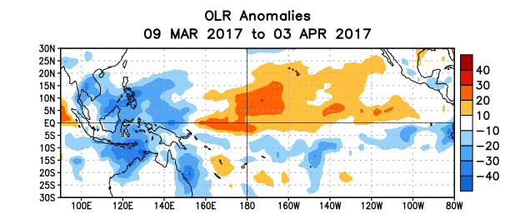
Figure 5. Average outgoing longwave radiation (OLR) anomalies (W/m²) for the period 9 March – 3 April 2017. OLR anomalies are computed as departures from the 1981-2010 base period pentad means.

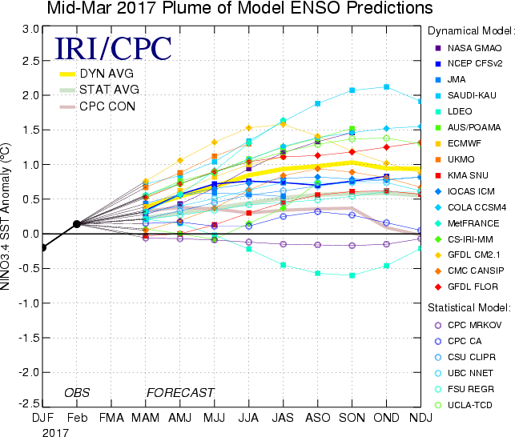

Figure 6. Forecasts of sea surface temperature (SST) anomalies for the Niño 3.4 region (5°N-5°S, 120°W-170°W). Figure updated 15 March 2017.

