



Thirteenth Session of
SOUTHEAST EUROPE CLIMATE OUTLOOK FORUM

SEECOF-15 ONLINE MEETING

ANALYSIS AND VERIFICATION OF SEECOF-14 CLIMATE OUTLOOK
FOR 2015/2016 WINTER SEASON FOR SOUTHEAST EUROPE (SEE)

CLIMATE OUTLOOK FOR 2015/2016 WINTER SEASON FOR SEE REGION

As stated in the SEECOF-14 Consensus Statement for Seasonal Climate Outlook for the 2015/2016 winter season over Southeast Europe (document
http://www.seevccc.rs/SEECOF/SEECOF-14/COF/Consensus%20Statement%20for%20Climate%20outlook%20for%20Winter%202015-2016.pdf ) positive anomalies for the winter mean temperatures are favored over the entire SEECOF region (see Figure 1). The signal in seasonal temperature is the strongest over the southern half of the Balkan Peninsula and the western coast of Turkey (zone 1 in Figure 1).

For winter precipitation anomalies, models favor a south-north gradient. Over the northern half of the Balkan Peninsula and northwestern part of the Caucasus region there is an enhanced probability for above-normal precipitation (zone 3 in Figure 2). Below-normal precipitation is favored over southern Greece, Cyprus and the southeastern Mediterranean area (zone1 in Figure 2). Higher level of uncertainty for precipitation dominates the rest of the SEE region (zone 2 in Figure 2).
Sub-seasonal variations, not predictable a long time in advance, may dominate at times, so regular updates to the forecast are strongly recommended. In addition, regional factors (for example sea surface temperatures in the smaller basins of the region) may shape local variability to a higher degree than usual.

The climate outlook for the 2015/2016 winter season for the SEE region is presented in Figure 1.

2015/2016 winter temperature outlook | 2015/2016 winter precipitation outlook
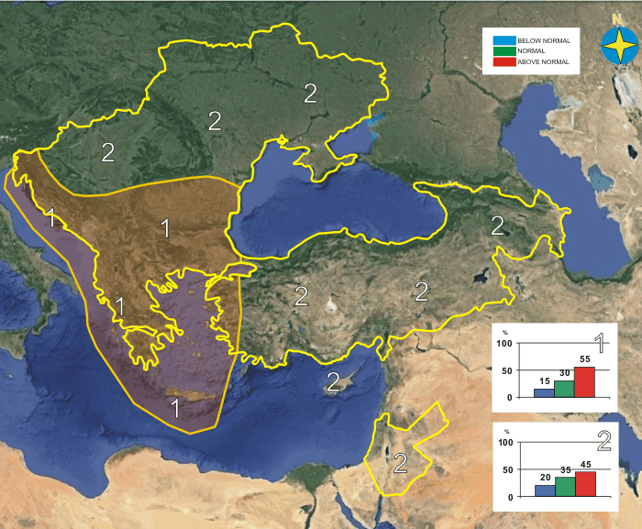 | 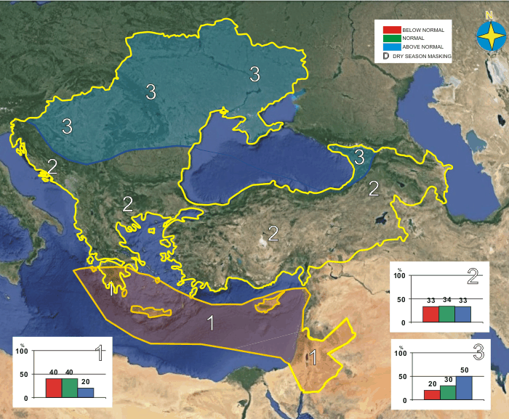
Figure1. Graphical presentation of the Climate outlook for the 2015/2016 winter season for the SEE region.

SHORT ANALYSIS OF 2015/2016 WINTER SEASON FOR THE SEE REGION

The analyses of the 2015/2016 winter season temperature and precipitation anomalies are based on:
- operational products of the European Climate System Monitoring – ECSM (the ECSM system is a technical platform of the DWD, Lead of the WMO RA VI RCC Node on Climate Monitoring),
http://www.dwd.de/EN/climate_environment/climatemonitoring/europe/europe_node.html,
- climate monitoring review of the 2015/2016 winter season (ECSM, DWD, Lead of the WMO RA VI RCC Node on Climate Monitoring),
http://www.seevccc.rs/SEECOF/SEECOF-15/STEP1/RCC_CM_DWD_SeasonalClimReport_2015_2016_DJF.pdf;
- climate monitoring products of the South East European Virtual Climate Change Center – SEEVCCC (Member of the WMO RA VI RCC Node on Climate Monitoring, http://www.seevccc.rs/?p=6 ); and
- National climate monitoring reports of the following SEECOF-14 participating countries: Armenia, Bulgaria, Bosnia and Herzegovina/Federation of Bosnia and Herzegovina, Bosnia and Herzegovina/ Republic of Srpska, Croatia, Cyprus, Georgia, Greece, Israel, the Former Yugoslav Republic of Macedonia, Republic of Moldova, Serbia, Slovenia, Turkey and Ukraine (documents available on http://www.seevccc.rs/SEECOF/SEECOF-15/STEP1/).

Winter 2015/2016 was warmer than normal in almost the entire SEECOF region, with the exception of Israel and Jordan. In most of the SEECOF region it was much warmer than normal; apart from Turkey, Eastern Mediterranean and western part of the South Caucasus region, where it was warmer than normal. Certain countries in the western half of the SEECOF region observed one of the 10 warmest winters on record (for example: ranking as the 3rd warmest winter in Serbia and Bosnia and Hercegovina, Republic of Srpska, 5th warmest in Slovenia and 6th warmest in Hungary). In most of the SEECOF region, positive mean winter temperature anomalies ranged between 1-2ºC; in the Pannonian Plain, central and eastern parts of the Balkan Peninsula and on the north of Ukraine even exceeding 4ºC, while in Israel and Jordan they reached up to 1ºC.

The mean winter temperature ranged between 10ºC and 15ºC along the coasts of the Adriatic, Ionian and Aegean Sea, along the southern coasts of the Black Sea, as well as along the northern and eastern coasts of the Eastern Mediterranean, Cyprus, most of Israel and Jordan. Most of the Eastern Mediterranean observed even higher temperatures, ranging between 15ºC and 20ºC, while along the western coasts of the Black and Caspian Sea with its hinterland, in the western part of the Turkey, in the Pannonian Plain and most of the Balkan Peninsula, the temperature was in a range from 5ºC to 10ºC. In Ukraine, Moldova, Carpathian and the region of Dinaric Alps, as well as in mountainous region in eastern of Turkey and in some parts of the Caucasus, temperature ranged from -5ºC to 0ºC; in the higher mountains of eastern Turkey it was between -15ºC and -10ºC. Mean seasonal temperatures for the winter 2015/2016 period are shown in Figure 2 (left panel).

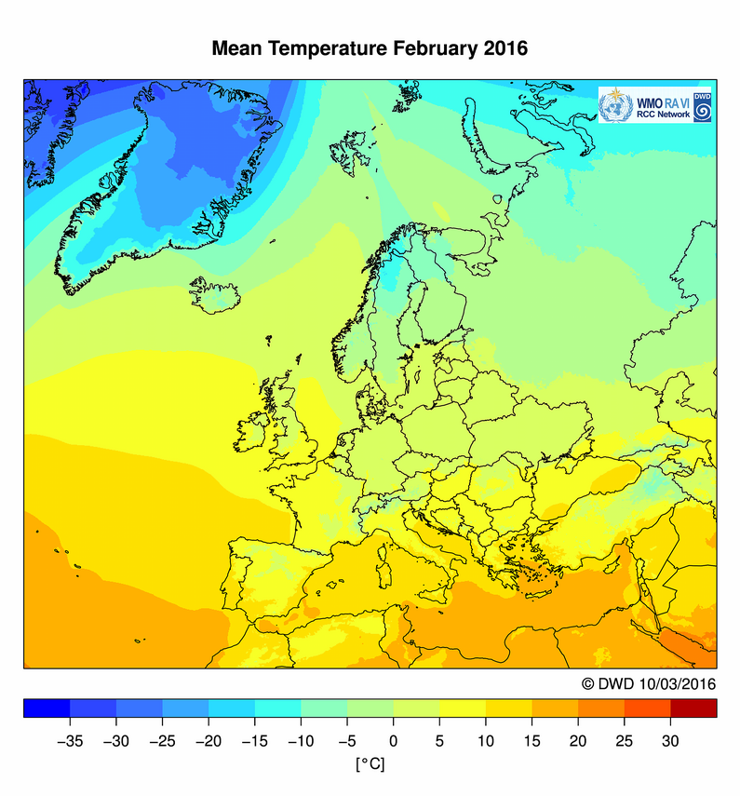 | 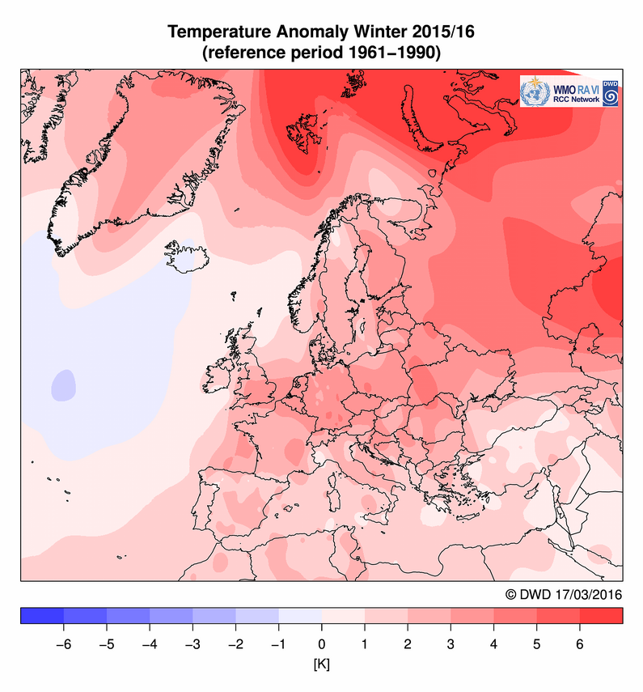
Figure 2. The observed 2015/2016 winter season mean temperatures (left panel) and winter season temperature anomalies (right panel). Source: http://www.dwd.de/rcc-cm

December 2015 was warmer than normal in most of the SEECOF region with anomalies ranging between 1ºC and 2ºC; in the Pannonian Plain, western and eastern parts of the Balkans and on the northeast of South Caucasus between 2ºC and 3ºC; in Ukraine and in northern part of Romania between 3ºC and 4ºC, and in northwestern part of Ukraine above 4ºC. On the other hand, it was colder than normal in the continental parts of Turkey and in south of the South Caucasus with temperatures ranging between 1ºC and 2ºC, while some parts of central Turkey registered negative anomalies above 3ºC. For example, extreme maximum temperature of 23.9°C was recorded on December 23rd in Polis (Cyprus), with the departure of 4°C or more from normal.

January 2016 mean temperature was above normal in the Pannonian Plain, western, central and southern Balkans, western part of Ukraine and in the South Caucasus, while most of the SEECOF region experienced near normal conditions. Positive anomalies during January reached and exceeded 3ºC in western Balkans and on the east of the South Caucasus. Absolute minimum air temperature of -9.7°C was recorded in Prodomas on Cyprus (normal value 0.7°C).

In February 2016 weather conditions were much warmer than normal across the entire SEECOF region. In many countries historical records were broken. In most of the SEECOF region positive anomalies in February ranged between 3ºC and 4ºC, while in most of Ukraine and in some parts of central and eastern Balkans they reached even 7ºC. For example, 12 stations in Serbia observed record-breaking daily maximum air temperatures (for example, Smederevska Palanka 24.9 ºC Kragujevac 25.2ºC, Krusevac 25.5ºC); 60% of the territory of Moldova experienced record-breaking daily maximum air temperatures; several stations on Cyprus observed record-breaking maximum daily air temperatures (Mytulini of 26.2°C set on February 23rd - (ref. climatological period 1955-2015), Kalamata, 26.0°C set on February 17th (1956-2015) and Tymbaki, 27.0°C set on February 23rd (1959-2015)); also several statins in the Former Yugoslav Republic of Macedonia observed record breaking maximum daily air temperatures (Skopje, 24.3°C set on February 24th, Kriva Palanka, 22.0°C set on Februaru 17th, Berovo 21.7°C set on February 22nd). The same situation was also in Turkey, where 65 stations observed the new absolute maximum temperature. Greece didn’t set any new temperature records, but anomalies have ranged between 4ºC and 6ºC above normal, resulting with maximum February air temperatures identical with the ones recorded in the third decade of March.

During winter 2015/2016, most of the SEECOF region received a normal precipitation sums. The Pannonian Plain, western Balkans, northern and central parts of Ukraine, eastern part of Bulgaria, eastern parts of South Caucasus region and some parts in northern Turkey were wetter than normal (more than 125%). In contrast to that, the Carpathian region, southern Balkans, eastern Mediterranean, southern parts of Turkey, some parts of eastern Georgia, as well as, northeastern Jordan were drier than normal (less than 75%). The time interval between 1951 and 2000 was used as a reference period. The 2015-2016 winter precipitation anomalies are shown in Figure 3 (right panel).

Winter precipitation totals in the SEECOF region ranged from less than 50 mm/per month in most of Ukraine, South Caucasus, Romania, most of Greece, Turkey and Jordan
up to more than 150 mm/per month along the western slopes of the Dinaric Alps, the coasts of the Adriatic and Ionian Sea, as well as some parts on the north of Carpathian. Some areas along the coasts of the Adriatic Sea received more than 300 mm of precipitation (per month) (Figure 3, left panel).

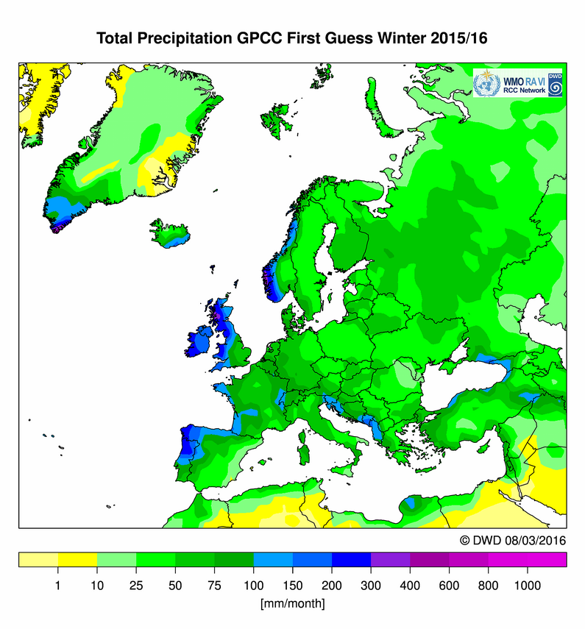 | 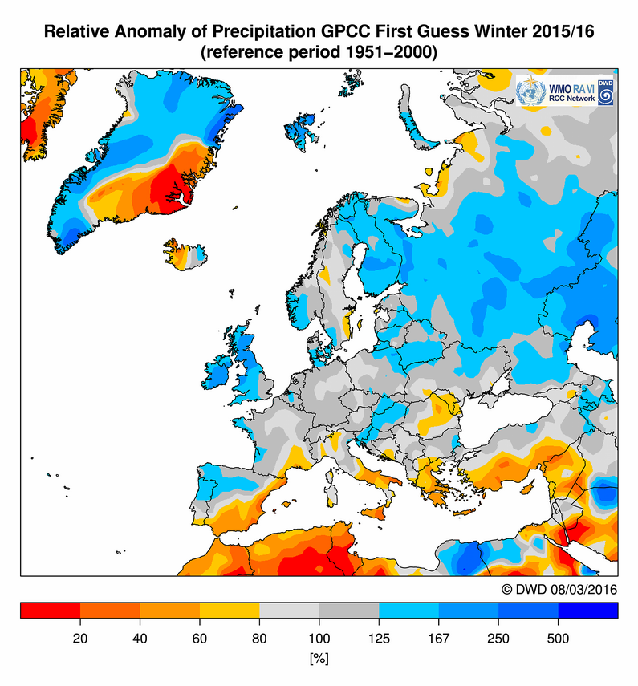
Figure 3. The observed 2015/2016 winter season precipitation in mm per month (left panel) and 2015/2016 winter precipitation relative anomalies in mm per month (right panel). Source: http://www.dwd.de/rcc-cm

December 2015 was wetter than normal in Ukraine, northern and northeastern parts of Carpathian region, eastern part of Romania as well as along the eastern coasts of Black Sea and its hinterland. On the other hand, monthly precipitation totals of less than 80% were observed in the Pannonian Plain, most of Croatia, western Balkans, eastern part of Greece, most part of Turkey, parts of the mountainous region of South Caucasus, western Mediterranean, as well as Israel and Jordan. Extremely dry conditions were observed in Bulgaria, most of Croatia and eastern part of Greece, where some locations did not record any precipitation. The situation was the same in Armenia, where there was no rainfall during the first two decades of December. In the remainder of the SEECOF region, December precipitation totals were near normal.

In January 2016, above normal precipitation totals were registered in almost entire SEECOF region. For example, Mavrovo (the Former Yugoslav Republic of Macedonia) received record-breaking monthly precipitation sum of 265.9 mm for the month of January. Drier than normal conditions were recorded in central and western Mediterranean (Crete and Cyprus), while in some areas on the west of Balkans and Carpathian region, in the eastern and southern part of Greece, southern parts of Turkey, as well as in Israel and Jordan January precipitation totals were near normal.

February 2015 was wetter than normal in the Pannonian Plain, in Western and Central Balkans, along the coasts of Adriatic Sea, on the northwestern slopes of Carpathian region, western part of Ukraine, in most of Bulgaria, some areas in mountainous region of South Caucasus, as well as in some parts on the east and northwest of Turkey. Some stations along the coast of the Adriatic Sea observed record-breaking monthly precipitation for February (Rijeka (North Adriatic) – 407.7 mm; Ogulin (mountainous part) – 277.7 mm and Poreč (Istra, North Adriatic) – 189.6 mm). Monthly precipitation totals of less than 80% were observed in some parts of eastern Ukraine, along the northwestern, southeastern and eastern coasts of the Black Sea with its hinterland, along the coasts of the Caspian Sea, in eastern and southern Greece, in the western Mediterranean, as well as on the south of the Turkey, while February totals were near normal in the remainder of the SEECOF region.

In December 2015 transportation was affected by frost, snowfall and storms at some places in Turkey - Zonguldak, Inebolum, Sinop and Konya. Four people were injured due to the transportation difficulties.
On January 17th and 18th, heavy and very heavy snow accompanied by blizzard, hit northern, central, southern (snow and rain) and eastern parts of Ukraine as well as some parts of Moldova. Following the above mentioned event, Chernigiv, Symu, Kharkiv, Cherkasu, Kirovgrad, Poltava, Dnipropetrovs’k, Odessa, Mykolayiv, Kherson regions (all places in Ukraine) received between 7 mm and 39 mm of precipitation in 6-12 hours, while snow depth of 10 cm to 34 cm led to problems in power outage, telecommunications, utilities and transport. During the 3rd decade of January, heavy snowfall was registered at some places in Armenia causing traffic interruptions and damages.

In January, heavy rainfall caused flooding in Aidin (Turkey), while heavy rainfall accompanied by storm caused traffic disruptions on the south of Turkey (Saamsun, Ordu, Anatalya).

In February 2016, heavy storms affected marine transport in Cannakkale and Istanbul in Turkey, and five people were injured by these storm.

Gale force of bora (NE wind) was recorded along the Adriatic coast on 17th and 18th January, causing widespread damage and traffic interruptions. Mean wind speed at the North Adriatic was 25 m/s (Island Pag) and wind gusts reached 48.9 m/s. A few episodes with gale force wind (NE and SE) were recorded during February too (the strongest gusts of bora wind (NE) were recorded on the island Krk, North Adriatic on 10th February – 54.5 m/s). In February, mainly strong wind with the speed of 35-27 m/s was recorded in Lory region (Armenia).

VERIFICATION OF CLIMATE OUTLOOK FOR 2015/2016 WINTER SEASON
The Consensus statement for the winter of 2015/2016 indicated that positive temperature anomalies were favored with northeast-southwest gradient in the entire SEECOF region, which was correctly predicted.
The climate winter 2015/2016 outlook indicated higher uncertainties for precipitation than for temperature. An increased probability for above-normal precipitation was forecasted over the northern part of the Balkan Peninsula, Carpathian region and Ukraine, which was mostly correctly predicted. Below-normal winter precipitation conditions were correctly predicted for the south of Greece, Cyprus and the southeastern area of Mediterranean. On the other hand, on the east coasts of the Black Sea with its hinterland, western and southern part of the Ukraine, as well as northern and northwestern slopes of the Carpathian Mountains climate outlook was incorrect, since the conditions were near-normal, instead of above normal. In most of the SEECOF region, the probabilities for below-, near-, or above- normal conditions were approximately equal, hence it was impossible to take into account the verification of the climate outlook for the 2015/2016 winter precipitation.
APPENDIX A: Contributions to Step 1 of SEECOF-15

- World Meteorological Organization
- Met Office, United Kingdom
- International Research Institute for Climate and Society, United States of America
- European Center for Medium Range Weather Forecast
- Meteo France, Republic of France
- Federal Service for Hydrometeorology and Environmental Monitoring, Russian Federation
- Deutscher Wetterdienst, Federal Republic of Germany
- National Centers for Environmental Prediction, United States of America
- South East European Virtual Climate Change Center hosted by Republic Hydrometeorological Service of Serbia, Republic of Serbia
- Armenian State Hydrometeorological and Monitoring Service, Republic of Armenia
- National Institute of Meteorology and Hydrology, Republic of Bulgaria
- Meteorological and Hydrological Service, Republic of Croatia
- Hellenic National Meteorological Service, Greece
- Meteorological Service, the Republic of Cyprus
- The National Environmental Agency of Georgia, Georgia
- Israel Meteorological Service, State of Israel
- Republic Hydrometeorological Institute, Former Yugoslav Republic of Macedonia
- State Hydrometeorological Service, Republic of Moldova
- Federal Hydrometeorological Service of the Federation of Bosnia and Herzegovina, Federation of Bosnia and Herzegovina, Bosnia and Herzegovina
- Republic Hydrometeorological Service of the Republic of Srpska, Republic of Srpska, Bosnia and Herzegovina
- Republic Hydrometeorological Service of Serbia, Republic of Serbia
- Environmental Agency of the Republic of Slovenia, Republic of Slovenia
- Turkish State Meteorological Service, Republic of Turkey
- Ukrainian Hydrometeorological Center, Ukraine

APPENDIX B: Analysis and verification of the SEECOF-14 climate outlook for the 2015-2016 winter season:
Verification summary based on the national reports and contributions of the participants of the SEECOF-15 online meeting

Country | Seasonal temperature  (DJF) |  | Seasonal precipitation  (DJF) |  | High Impact Events
Country | Observed | SEECOF-14 climate outlook for  temperature | Observed | SEECOF-14 climate outlook for precipitation | High Impact Events
Armenia  (1) | Above normal | Above normal | Near  or  above normal  in the entire country | No predictive signal | December 2015 was dry during the I and II decades. Snow was observed in the III decade with heavy in some places. (Martini, Kapan 20-23 mm/h).  Extreme weather conditions in January 2016 were connected to stormy wind and heavy snowfall. Wind speed reached 25-28 m/s, with gusts 31 m/s at January 6th and 14th. Heavy snowfall was observed at 1st, 2nd and 24th in Shirak, Gekharquinq and Sjeniq regions.  In February mainly strong wind has been recorded in Lory region with speed 35-37 m/s Also dense fog observed during winter.  All this events caused damages and traffic interruptions.
Bosnia and Herzegovina, Federation of Bosnia and  Herzegovina  (5) | Above normal | Above normal | Near normal | No predictive signal | Winter 2015-2016 mainly was 3rd or 4th warmest during the period 1981-2016, while it was the warmest winter on Bjelasnica (mountain station).
Bosnia and Herzegovina, Republica Srpska  (5) | Above normal | Above normal | Aboνе ог near normal  on the North;  Below normal  In the southern part of the country | Above  or  near normal  in the northern part of the country  No predictive signal  In the most part of the country | The month of December 2016 was extremely dry with no precipitation in many places  The month of February 2016 was extremely warm  On Feb 10th storm windy (Banja L. 31,8 m/s)  There was a cold period in January with very low temperatures from ranged from -10⁰C to -16.3⁰C ( mountains regins to -22.3⁰C) and snow cover in the bigger part of the entity.
Bulgaria  (1,5) |  | Above normal | Near or above normal | Near normal or no signal | The month of December 2015 was extremely dry with almost no precipitation. The month of February 2016 was extremely warm. There was a cold period in January 2016 with very low temperatures and snow cover in the bigger part of the country.
Croatia  (1) | Above normal | Above normal | Above normal  in the Northern Adriatic and its hinterland and part of Central Croatia  Below normal  in the Southern Adriatic  Normal  in the remaining part of Croatia | No predictive signal  in the most of the country  Above normal in the northwestern part of the country | December 2015 was extremely dry. In the most parts of Croatia there was not precipitation at all (especially along the Adriatic coast).  Extreme weather conditions in January 2016 were connected mostly to wind. Gale force of bora (NE wind) was recorded along the Adriatic coast on 17th and 18th January, and caused a lot of damages and traffic interruptions. Mean wind speed at the North Adriatic was 25 m/s (Island Pag) and wind gusts were 48.9 m/s.  February 2016 was very wet and extremely wet, especially in the part of Northern and Central Croatia as well as part of the Northern Adriatic and its hinterland. In some stations monthly precipitation amounts exceeded maximum monthly amounts for February (Rijeka (North Adriatic) – 407.7 mm; Ogulin (mountainous part) – 277.7 mm and Poreč (Istra, North Adriatic) – 189.6 mm).  A few episodes with gale force wind (NE and SE) were recorded too. (the strongest gusts of bora wind (NE) was recorded at the island Krk, North Adriatic on 10th February – 54.5 m/s).
Cyprus  (5) | Above normal | Above normal | Below normal | Near or Below  normal | DEC: Warmer than the normal with the western and northern coastal zone warmer than the rest of the island. Extremes (deviating by 4°C or more from normal) were recorded. i.e., the recorded maximum of Polis of the 23rd of December 23.9°C (with a normal of 18°C). Extreme maximum temperature lower by 4°C (or more) from normal were recorded during the 31st of December. i.e., Athalassa maximum of 10.6°C (17.3°C normal) and that of Prodromos station maximum of 2.7°C with 8.3°C normal.  Larnaka area (Southeast) recorded a total accumulated precipitation of 116mm (37 mm above its normal) while the Troodos mountainous range and the western and northern coasts recorded accumulated precipitation well below normal. A Yellow EMMA warning concerning high accumulated precipitation was issued on the 17th.  JAN: Extreme low temperatures were recorded i.e., the absolute minimum of -9.7°C over Prodromos (normal 0.7°C), or the minimum of the eastern coasts  -2.4°C (the normal being 6.6°C). A Yellow EMMA warning concerning extreme low temperatures for Troodos mountainous range was issued on the 25th. The Yellow EMMA was upgraded to Orange on the same day.  Generally January recorded a good accumulated precipitation budget covering almost 158% (mean area average) of normal or 131mm (normal 83mm).  FEB: The warmest February of the recent 30 years.  i.e., The absolute maximum of February of 28.2°C was recorded at the station of Polis Chrysochous while the normal is only 16.3°C,  The recorded maximum of 27.8°C was Athalassa’s station absolute maximum for February while the normal is only 16.0°C,  The recorded maximum 18.9°C, of Troodos station (1720m height) was the absolute maximum of February while the normal is only 4.1°C.  Regarding the accumulated precipitation it is suggested that February was a notably dry month covering only 31% of normal i.e., Area average only 21.6mm (normal 69.2mm).
Georgia  (1) | Near  or  above normal | Above normal | Near normal in Kolkheti lowlands  and in mountainous  region of Georgia  below normal  in the rest part of the country | Above normal  in most of the country  No predictive signal  in eastern part of the country | No comments for high impact events
Greece  (2,5) | Above normal | Above normal | Below normal  in the most of the country  Above normal  in northeastern part of country | No predictive signal  in most of the territory  Below normal in the southern part of the Greece | Two warm spell periods during February (15-18, and 23rd February) set some new daily maximum temperature records.  Some selected examples, where the difference from the previous Tmax record is greater than 1°C: Mytulini on February 23rd with record Tmax temperature was 26.2°C (ref. period 1955-2015); Kalamata on February 17th 26.0°C (1956-2015) and Tymbaki on February 23rd it was 27.0°C (1959-2015).  The December precipitation total was much below climatology, while some locations even recorded zero precipitation. Specifically, the December monthly rainfall (averaged values of selected Weather stations) was approximately 10-times below 1971-2000 normal value (12.51%).
The Former Yugoslav Republic  of Macedonia  (5) |  | Above normal | Below normal | No predictive signal | December 2015 No precipitations.  January 2016 - Maximal monthly sum of precipitation historically measured in Mavrovo 265.9 mm.  February 2016 - Unusually high air temperatures.  The maximal temperatures measured in Skopje 24.3°C on 24th, in Kriva Palanka 22.0°C on 17th and Berovo 21.7°C on 23th exceeded the historical values for this month.
Israel  (5) | Above normal | Above normal | Below  normal  in the most of the country  Near normal  on the south | Near or Below  normal | - No comments for high impact events.
Republic of Moldova  (5) | Above normal | Above normal | Near  or  below normal | Above normal | On 17th January was recorded a meteorological phenomenon in the form of heavy snow: at MS Stefan-Voda and HP Olanesty during 12 hours have fallen 23 mm of precipitations. Heavy snow in the southern half of the country have been accompanied by strong wind of up 20 m/s (MS Stefan-Voda, Comrat, Ceadir-Lunga) and by blizzard which created unfavorable conditions for traffic.
Serbia  (5) | Above normal | Above normal | Below normal to normal in most part of Serbia  Above normal  in northernmost and some eastern parts | No predictive signal in the most of the country  Above normal  in northern part of the county | Winter 2015/2016 was extremely warm, the third warmest in Serbia.  Record-breaking maximum daily air temperatures for February and winter were observed at twelve main meteorological stations in Serbia. The highest daily air temperature of 25.5ºC during winter was measured on February 15th in Krusevac and Cuprija.  Crni Vrh observed record few number of days with snow cover since the measurements began.
Slovenia  (5) | Above normal | Above normal | Above normal | No predictive signal | No major high impact events occurred during the winter season.  December was extremely dry and warm (especially in the mountains). January brought an intensive rain/wind period from 8th till 12th.  February was very warm and wet.  The winter was 5th warmest in more than 100 years.
Turkey  (2) | Above normal | Above normal | Above normal  mostly in the northern areas  Below normal  in the south of the country | No predictive signal | In December 2015 transportation was affected by frost, snowfall and storms in Zonguldak, Inebolum, Sinop and Konya. Four people were injured due to the transportation difficulties.  In January 2016, agricultural damage occurred in Mersin due to frost. In Hakkari, avalanche occurred and affected on transportation. In Aydin flood occurred due to heavy rainfall while storm affected transportation in Samsun, Ordu and Anatalya.  In February 2016, flood occurred in Bartin, Sinop, and Mersin. Heavy storms affected seas transportation in Cannakkale and Istanbul, five people were injured during storm.
Ukraine  (5) | Above normal | Above normal | Above normal  to  Normal  Below normal  in some places in western southern part of the country | Above normal | December was abnormally dry in most of Ukraine. Precipitation were 20-77$ of the month nom, in some places Odessa, Mykolaiev, Kherson, Kirovhrad and Chernivtsi regions 1-19%, in Behtery (Kherson region). Odessa , Sarata and Izmail (Odessa region) not fallen at all (it was driest month for the entire observation period)  In January, meteorological extraordinary phenomena in the form of heavy and very heavy snow were observed: on 17-19th of January in northern, central, southern (snow and rain) and eastern parts (Chernigiv, Symu, Kharkiv, Cherkasu, Kirovgrad, Poltava, Dnipropetrovs’k, Odessa, Mykolayiv, Kherson regions) from 7 mm to 39 mm of precipitation fell in 6-12 hours (snow cover 10-34 cm). Snowfall was accompanied by strong blizzards (wind speed 15-24 m/s during 12-29 hours in Ust-Danaysk (Odessa region) wind speed was 25-27 m/s), strong ice covering with diameter of sediments 21 mm was in Kherson. Unfavorable weather conditions caused low power, telecommunications, utilities and transport.  February was one of the warmest, in some areas of western and southern parts of country it was the warmest for the entire period of observation. There were many days when were repeated and excess absolute daily temperatures at most of stations in Ukraine.

Note: 1 - Basic climatological period (1961-1990)
2 - Basic climatological period (1971-2000)
3 - Basic climatological period (1951-2000)
4 - Basic climatological period (1981-2000)
5 - Basic climatological period (1981-2010)
6 - Basic climatological period (1961-2013)
7 – No information about basic climatological period

