EL NIÑO/SOUTHERN OSCILLATION (ENSO) DIAGNOSTIC DISCUSSION

issued by

CLIMATE PREDICTION CENTER/NCEP/NWS
and the International Research Institute for Climate and Society
12 May 2016

ENSO Alert System Status: El Niño Advisory/ La Niña Watch

Synopsis: La Niña is favored to develop during the Northern Hemisphere summer 2016, with about a 75% chance of La Nina during the fall and winter 2016-17.
During the past month, sea surface temperature (SST) anomalies decreased across the equatorial Pacific Ocean, with near-to-below average SSTs recently emerging in the eastern Pacific (Fig. 1). The latest Niño region indices also reflect this decline, with the steepest decreases occurring in the Niño-3 and Niño-1+2 regions (Fig. 2). The surface cooling was largely driven by the expansion of below-average subsurface temperatures, which extended to the surface in the eastern Pacific (Figs. 3 and 4). While oceanic anomalies are clearly trending toward ENSO-neutral, many atmospheric anomalies were still consistent with El Niño, such as the negative equatorial and traditional Southern Oscillation indices. Upper-level easterly winds persisted over the central and eastern Pacific, while low-level winds were near average. Enhanced convection continued over the central tropical Pacific and was suppressed north of Indonesia (Fig. 5). Collectively, these anomalies reflect a weakening El Niño and a trend toward ENSO-neutral conditons.
Most models predict the end of El Niño and a brief period of ENSO-neutral by early Northern Hemisphere summer (Fig. 6). The model consensus then calls for increasingly negative SST anomalies in the Niño 3.4 region as the summer and fall progress. However, there is clear uncertainty over the timing and intensity of a potential La Niña (3-month Niño-3.4 SST less than or equal to -0.5°C). The forecaster consensus favors La Niña onset during the summer, mainly weighting the dynamical models (such as NCEP CFSv2) and observed trends toward cooler-than-average conditions. Overall, La Niña is favored to develop during the Northern Hemisphere summer 2016, with about a 75% chance of La Nina during the fall and winter 2016-17 (click CPC/IRI consensus forecast for the chance of each outcome for each 3-month period).
This discussion is a consolidated effort of the National Oceanic and Atmospheric Administration (NOAA), NOAA’s National Weather Service, and their funded institutions. Oceanic and atmospheric conditions are updated weekly on the Climate Prediction Center web site (El Niño/La Niña Current Conditions and Expert Discussions). Forecasts are also updated monthly in the Forecast Forum of CPC's Climate Diagnostics Bulletin. Additional perspectives and analysis are also available in an ENSO blog. The next ENSO Diagnostics Discussion is scheduled for 9 June 2016. To receive an e-mail notification when the monthly ENSO Diagnostic Discussions are released, please send an e-mail message to: ncep.list.enso-update@noaa.gov.

Climate Prediction Center
National Centers for Environmental Prediction
NOAA/National Weather Service
College Park, MD 20740

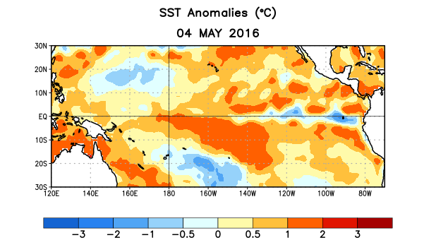
Figure 1. Average sea surface temperature (SST) anomalies (°C) for the week centered on 4 May 2016. Anomalies are computed with respect to the 1981-2010 base period weekly means.

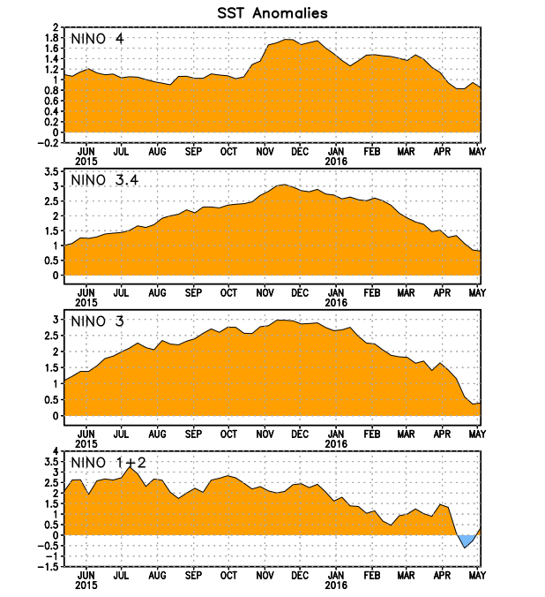
Figure 2. Time series of area-averaged sea surface temperature (SST) anomalies (°C) in the Niño regions [Niño-1+2 (0°-10°S, 90°W-80°W), Niño 3 (5°N-5°S, 150°W-90°W), Niño-3.4 (5°N-5°S, 170°W-120°W), Niño-4 (5ºN-5ºS , 150ºW-160ºE]. SST anomalies are departures from the 1981-2010 base period weekly means.
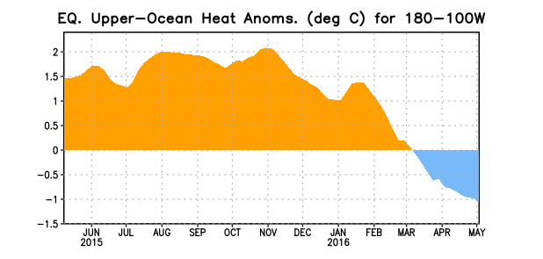
Figure 3. Area-averaged upper-ocean heat content anomaly (°C) in the equatorial Pacific (5°N-5°S, 180º-100ºW). The heat content anomaly is computed as the departure from the 1981-2010 base period pentad means.

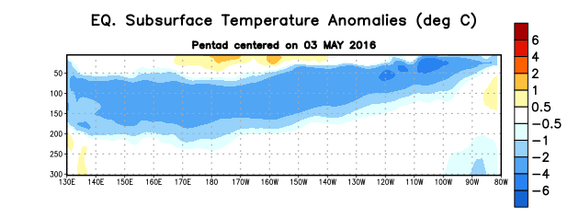
Figure 4. Depth-longitude section of equatorial Pacific upper-ocean (0-300m) temperature anomalies (°C)
centered on the pentad of 3 May 2016. The anomalies are averaged between 5°N-5°S. Anomalies are departures from the 1981-2010 base period pentad means.

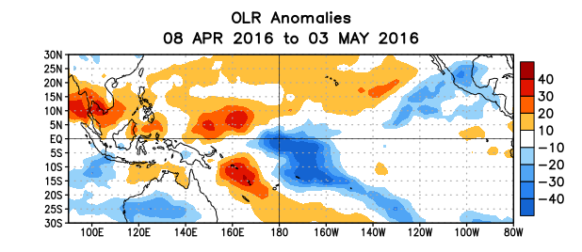
Figure 5. Average outgoing longwave radiation (OLR) anomalies (W/m²) for the period 8 April – 3 May 2016. OLR anomalies are computed as departures from the 1981-2010 base period pentad means.

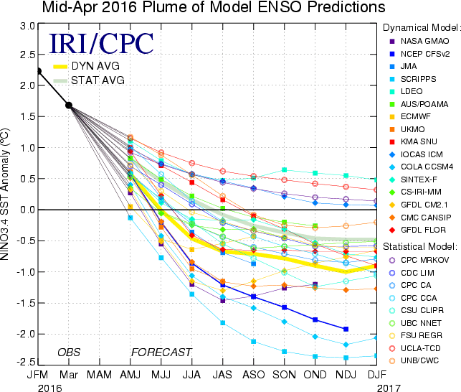
Figure 6. Forecasts of sea surface temperature (SST) anomalies for the Niño 3.4 region (5°N-5°S, 120°W-170°W). Figure updated 19 April 2016.

