## Joint meeting of MedCOF-5, SEECOF-14 and PRESANORD-9

## 23 to 26 November 2015

## Marrakech, Morocco

Information for Participants

1. **Venue and Dates**

The three events will be held in Marrakech, Morocco, at the below given address of the **“Kenzi Farah Hotel”** from 23 to 26 November 2015:

*Address : Avenue du Président Kennedy, quartier de l’Hivernage, Marrakech*

*Telephone : +212 (0) 524 44 74 00*

*Fax : +212 (0) 524 4382 16*

*E-mail :* [*indivfarah@kenzi-hotels.com/*](mailto:indivfarah@kenzi-hotels.com/) *Website* : [www.kenzi-hotels.com](http://www.kenzi-hotels.com)

1. **Accommodation & Logistics**

Participants are encouraged to stay at the “Kenzi Farah Hotel” where the Forum will be held. A block reservation has been made at special rates 680MAD for a single room per night with breakfast. In order to confirm their booking, participants should provide information about their arrival and departure date to the local coordinator: [m.d.elhachimi](mailto:hm.d.elhachimi) [@gmail.com](mailto:rabia.merrouchi@gmail.com), as early as possible but preferably before 17 November 2015.

1. **Transportation Between Airport and the Hotel**

The participants will be responsible of their local transportation & expenses between airport and the hotel. All international participants are expected to arrive at **Marrakech Menara Airport**. To get from the **Marrakech Menara Airport** to the hotel, take a taxi. The taxi ride will cost about 20 €. Please agree on the fare with your driver before you begin the journey.

Participants who need assistant should **provide their itinerary status to Mr Elhachimi, before 17 November 2015**, in order to arrange their transport from Airport to the hotel through an agency. The price is about 10Eur/p.

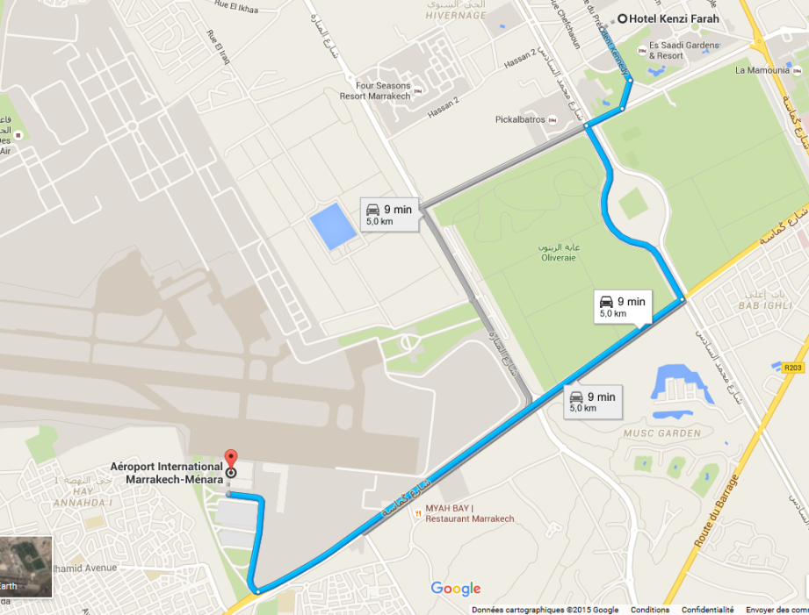

1. **Entry Visa for Morocco**

It is recommended that international participants start the process for getting an entry visa for Morocco, if it is required. The contact details for all participants will be forwarded to Mr. **Moulay Driss Elhachimi**, the local organizer, who can be contacted at [m.d.elhachimi](mailto:hm.d.elhachimi) [@gmail.com](mailto:rabia.merrouchi@gmail.com) in case of any questions regarding visas. For more information please visit: <http://www.consulat.ma/an/prestation.cfm?gr_id=72>

Below table shows the countries whose nationals are exempted from visa:

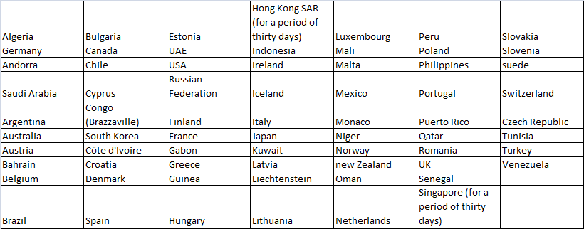

1. **Currency Exchange**

The official currency of Morocco is the Moroccan Dirham, denoted as MAD or Dhs. The Moroccan Dirham is composed of 100 centimes; notes are available in denominations of (Dhs) 200, 100, 50, 25, and 20, all in new and old varieties and coins are available in denominations of (Dhs) 10, 5, 2 and 1, or 50, 20, 10 and 5 centimes. There are several types of 10 and 5 Dirham coins in circulation. Below are the approximate exchange rates for Euro and US Dollars.

|  |
| --- |
| 1 USD = 9.80 Dhs |
| 1 EUR = 10.80 Dhs |

1. **Climate**

The mean conditions in Marrakech in November are as follows:

|  |  |
| --- | --- |
| Max Daytime Temperature °C | : 22°C |
| Min Night-time Temperature °C | : 10°C |
| [Hours of Sunshine (Daily)](http://www.weather2travel.com/holidayweather/sunshinehours.php" \o "What is Hours of Sunshine (Daily)?) | : 7.3 Hours per day |
| [Days with some Rainfall](http://www.weather2travel.com/holidayweather/dayswithrain.php) | : 6 Days |
| [Monthly Rainfall (mm)](http://www.weather2travel.com/holidayweather/rainfall.php) | : 41 mm |

1. **Time Zone**

In November, there is no time difference between local time in Casablanca and the Greenwich Mean Time (GMT).

1. **Voltage**

The voltage in morocco is 220-240V and the plug shape is French type, illustrated below. If your appliances plug has a different shape, you may need a plug adapter.

|  |  |  |
| --- | --- | --- |
| [E_3d_plug_m](http://www.iec.ch/worldplugs/img/plugs_sockets/E_3d_plug_l.png) | [E_3d_sock_s](http://www.iec.ch/worldplugs/img/plugs_sockets/E_3d_sock_l.png) | [E_dia_sock_s](http://www.iec.ch/worldplugs/img/plugs_sockets/E_dia_sock_l.png) |
| [E_dia_plug_s](http://www.iec.ch/worldplugs/img/plugs_sockets/E_dia_plug_l.png) |

1. **Coordination**

**The local coordinator:**

Name: Mr Moulay Driss Elhachimi

Department: Development, International Cooperation and Quality Department

Direction de la Météorologie Nationale, Casablanca, Morocco

Phone: +212 (0) 5 22 65 48 60

GSM: +212 (0) 6 66 19 78 78

Fax: +212 (0) 5 22 91 36 87

E-mail: [m.d.elhachimi](mailto:hm.d.elhachimi) [@gmail.com](mailto:rabia.merrouchi@gmail.com)

**WMO Coordinator:**

Name: Ms Anahit Hovsepyan  
 Scientific Officer

World Climate Applications and Services Division

Climate Prediction and Adaptation Branch

Climate and Water Department

Address: 7 bis, Avenue de la Paix

Case Postale No. 2300

CH-1211 Geneve 2, Switzerland

Telephone: +41 22 730 8212

Email: [ahovsepyan@wmo.int](mailto:ahovsepyan@wmo.int)

Telephone: +41 22 730 8212

Email: [ahovsepyan@wmo.int](mailto:ahovsepyan@wmo.int)

1. **Emergency Contact Person**

Name : Mr Moulay Driss Elhachimi

Phone : +212 (0) 522 65 48 60

GSM : +212 (0) 6 66 19 78 78

Fax : +212 (0)5 22 91 36 87

E-mail : [m.d.elhachimi](mailto:hm.d.elhachimi) [@gmail.com](mailto:rabia.merrouchi@gmail.com)

Or

Name : Mme Fatima Driouech

Phone : +212 (0) 5 22 65 48 72

GSM : +212 (0) 6 61 47 23 52

Fax : +212 (0) 5 22 91 34 35

E-mail : [driouechfatima@yahoo.fr](mailto:driouechfatima@yahoo.fr)