
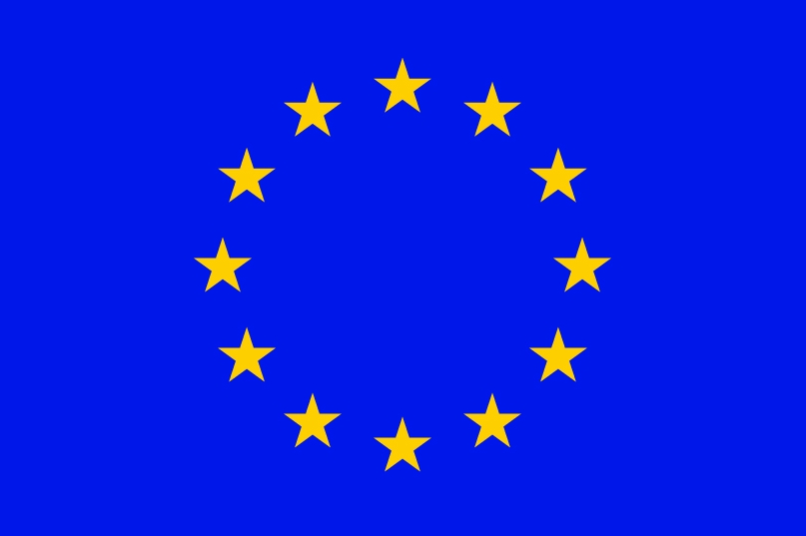


Fourteen Session of the
SOUTH-EAST EUROPEAN CLIMATE OUTLOOK FORUM (SEECOF-14)
(25-26) November, 2015

SEASONAL OUTLOOK FOR THE WINTER SEASON 2015/2016 FOR THE SOUTH EASTERN EUROPE AND CAUCASUS REGION (SEE&C)
Climate experts from WMO RA VI RCC Network Node on long-range forecasting (Meteo France, France and Roshydromet, Russia) and WMO RA VI RCC Network Node on climate monitoring (Deutscher Wetterdienst, Germany), UK Met-Office, Global Producing Centre ECMWF, International Research Institute for Climate and Society (IRI, USA), National Centers for Environmental Prediction (NCEP, USA), South East European Virtual Climate Change Centre (SEEVCCC, Serbia), and National Hydrometeorological Services of the SEECOF region provided their valuable contribution to the successful implementation of SEECOF-14 by developing relevant documents and providing their scientific guidance and recommendations.
SEECOF-14 was composed of the following Steps:
- Step 1: qualitative verification of the SEECOF-13 climate outlook for 2015 summer season;
- Step 2: assessment of the current state of the climate, including large-scale climate patterns worldwide, and assessments of likely climate evolution in the course of the following months;
- Step 3: building the consensus forecast for 2015/2016 winter season.
All relevant documentation is posted and updated on the SEEVCCC web site: http://www.seevccc.rs

SEECOF-14 CLIMATE OUTLOOK
FOR 2015/16 WINTER SEASON

This prediction is based on output from dynamical models, statistical models and known teleconnections of large-scale climate features. The analysis of the current state of the driving factors prepared by MedCOF-5 also applies to the South East European region.

A strong and mature El Niño event is now established in the tropical Pacific Ocean and is expected to peak around the end of the year and this could potentially influence the winter conditions. The colder-than-average North Atlantic sea surface temperatures (SSTs) to the south of Greenland are predicted to persist over the next few months providing some predictability for winter in the SEE region, too. The Quasi-Biennial Oscillation is currently, and will remain over the next few months, in its westerly phase. Local drivers such as Mediterranean and Black Sea SSTs are expected to also play a role.

The maps show the probabilistic consensus forecast for tercile categories of anomalies for seasonal mean temperature and precipitation, relative to the period 1981-2010. Due to the climate warming trend anomalies are affected by the selected reference period.

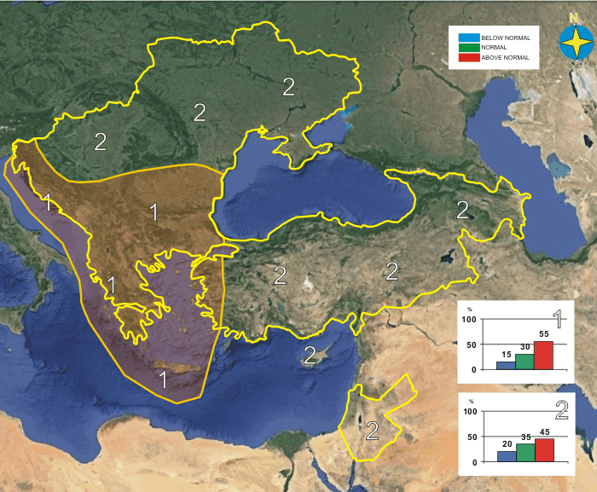
Figure 1. Graphical presentation of 2015/16 winter temperature outlook
The conjunction of the effects of these drivers seems to significantly influence the circulation over our region of interest It could explain that the majority of climate models predict an anticylonic anomaly pole over northwestern Africa and a cyclonic anomaly pole over northwestern Europe. As a result, positive temperature anomalies are favored over our domain of interest (see Figure 1 for winter mean temperatures). The signal in temperature is strongest over the southern half of the Balkan Peninsula and the western coast of Turkey.
For precipitation anomalies, the models favour a south-north gradient. Over the northern half of the Balkan Peninsula and northwestern part of the Caucasus region there is an enhanced probability for above-normal precipitation. Below-normal precipitation is favoured over southern Greece, Cyprus and the southeastern Mediterranean area. Higher level of uncertainty for precipitation dominates the rest of the SEE region (see Figure 2 for winter precipitation totals).
Sub-seasonal variations, not predictable a long time in advance, may dominate at times, so regular updates to the forecast are strongly recommended. In addition, regional factors (for example sea surface temperatures in the smaller basins of the region) may shape local variability to a higher degree than usual.

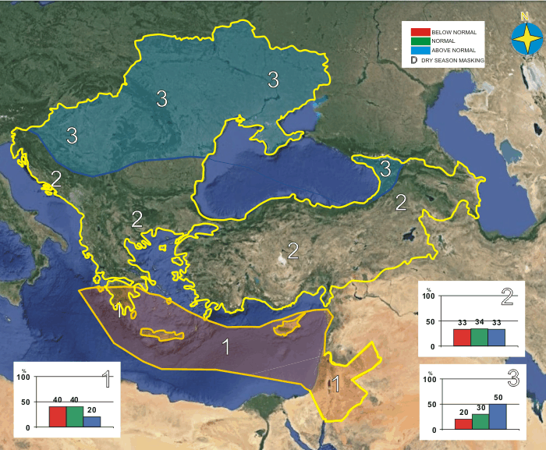

Figure 2. Graphical presentation of 2015/16 winter precipitation outlook

Seasonal averages cannot provide details about short spells of weather during the season. It is possible than even in an average season spells of severe wintry weather (for example: winter storms, very cold episodes, very wet spells) occur and lead to significant local socio-economic impacts.

Note that it is necessary to express seasonal forecasts in terms of probability due to inherent uncertainty. Any further advice on the forecast signals, shorter-range updates and warnings will be available throughout the winter from the National Meteorological Services, along with details on the methodology and skill of long-range predictions.

* The graphical representation of climate outlook in this statement is only for guidance purposes, and does not imply any opinion whatsoever concerning the legal status of any country, territory, city or area or of its authorities, or concerning the delimitation of its frontiers or boundaries.
APPENDIX A: Contributors to SEECOF-14

- World Meteorological Organization
- Met Office, United Kingdom
- International Research Institute for Climate and Society, United States of America
- European Center for Medium Range Weather Forecasts
- Meteo France, Republic of France
- Roshydromet, Russian Federation
- Deutscher Wetterdienst, Federal Republic of Germany
- National Center for Environmental Prediction, United States of America
- South East European Virtual Climate Change Center hosted by Republic Hydrometeorological Service of Serbia, Republic of Serbia
- National Institute of Meteorology and Hydrology, Republic of Bulgaria
- Meteorological and Hydrological Service, Republic of Croatia
- Meteorological Service, Republic of Cyprus
- Hellenic National Meteorological Service, Greece
- National Environmental Agency of Georgia, Georgia
- Republic Meteorological Service of Hungary, Republic ofHungary
- Republic Hydrometeorological Institute, Former Yugoslav Republic of Macedonia
- Hydrometeorological Institute of Montenegro, Montenegro
- National Meteorological Administration, Romania
- Republic Hydrometeorological Service of the Republic of Srpska, Republic of Srpska, Bosnia and Herzegovina
- Republic Hydrometeorological Service of Serbia, Republic of Serbia
- Ukrainian Hydrometeorological Center, Ukraine

