CLIMATE OUTLOOK FOR 2015 SUMMER SEASON
FOR THE SEE&CAUCASUS REGION

May 20th, 2015

The NHMS of Serbia regularly prepares climate outlooks for our country on the basis of the ECMWF seasonal forecast model outputs, as well as on the basis of the SEEVCCC regional climate model outputs. In this paper we will present the climate outlook for summer season 2015 for the SEE&Caucasus region, based on all available forecasting material including: outputs from 12 GPCs, WMO Leading Centre for LRF, IRI and SEEVCCC.

Near normal values of the summer mean temperatures in Bulgaria, in the south of Romania and the east of Serbia are likely to occur (zone 3 in Figure 1). In most of the SEECOF region there is more likelihood for the above-average temperature. There is higher probability for exceeding the average temperature in the Pannonian Plain, across the Adriatic and the Ionian Sea with their hinterland, in the Dinaric Alps, in the south of Greece, in the Central and Eastern Mediterranean with belonging hinterlands, Israel and Jordan, along the south coasts of the Black Sea and in the South Caucasus (zone 1 in Figure 1), comparing to the rest of the SEECOF region (zone 2 of Figure 1).

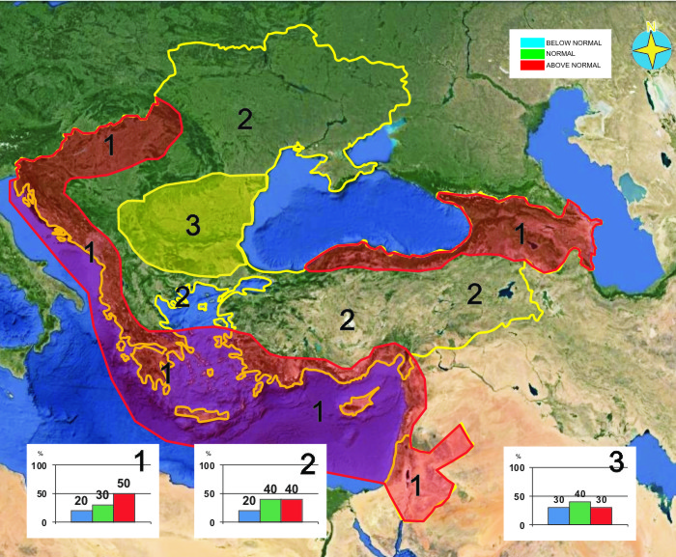
Figure 1. Graphical presentation of the 2015 summer temperature outlook

Uncertainties in regional predictions are higher for precipitation than for temperature. In the South Caucasus region, southeastern parts of Ukraine, the Pannonian Plain, across the Adriatic Sea with its hinterland and most of the Dinaric Alps summer season precipitation totals are likely to be near- or below- average (zone 1 in Figure 2), while there is higher probability for above-average conditions in the mountainous region of Turkey (zone 2 in Figure 2). In the rest of the SEECOF region (zone 3 in Figure 2) the uncertainty is high: probabilities for below-, near- or above- average conditions are approximately equal. It must be emphasized that it might be possible that some parts, especially mountainous ones, might locally have near- or above- normal summer season totals, due to episodes of the enhanced convection with high intensity rainfall. Along the southern coasts of the eastern Mediterranean, in the southern part of the Aegean Sea, in Israel and Jordan, due to dry season masking, it is not possible to forecast summer season precipitation.

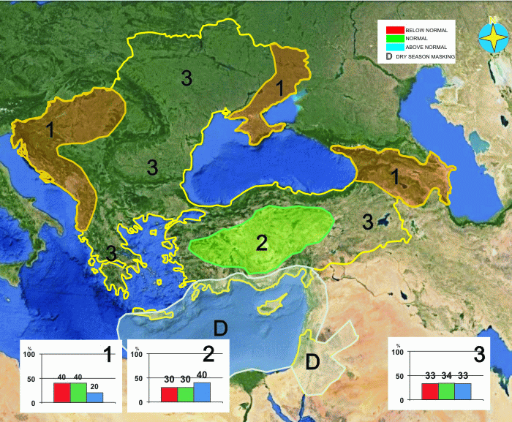
Figure 2. Graphical presentation of the 2015 summer precipitation outlook

Reference:
The maps show the probabilistic consensus forecast for tercile categories of anomalies of seasonal-mean temperature and precipitation, relative to the period 1981-2010.

