
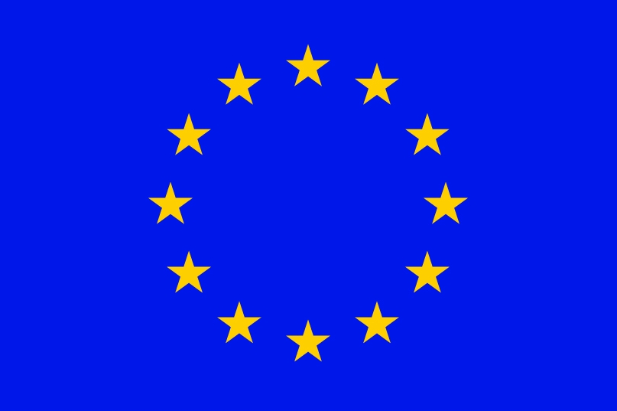


Eleventh Session of
SOUTHEASTERN EUROPE CLIMATE OUTLOOK FORUM (SEECOF-13)
April-May, 2015

SEASONAL OUTLOOK FOR SUMMER SEASON 2015 FOR THE SOUTH EASTERN EUROPE AND CAUCASUS REGION (SEE&C)
Climate experts from WMO RA VI RCC Network Nodes on long-range forecasting (Meteo France, France and Roshydromet, Russia) and WMO RA VI RCC Network Node on climate monitoring (Deutscher Wetterdienst, Germany), UK Met-Office, Global Producing Centre ECMWF, International Research Institute for Climate and Society (IRI, USA), National Centers for Environmental Prediction (NCEP,USA), WMO RA VI RCC South East Europe Virtual Climate Change Centre (SEEVCCC, Serbia) and National Hydrometeorological Services of SEECOF region provided their valuable contribution to the successful implementation of SEECOF-13 by developing the relevant documents and providing scientific guidance and recommendations.
The SEECOF-13 comprised of the following Steps:
- Step 1: qualitative verification of the SEECOF-12 climate outlook for 2014-2015 Winter;
- Step 2: assessment of the current state of the climate including large-scale climate patterns worldwide and assessments of its likely evolution in the course of the next months;
- Step 3: building the consensus forecast for 2015 summer season.
All relevant documentation is posted and updated in SEEVCCC web site: http://www.seevccc.rs

SEECOF-13 CLIMATE OUTLOOK
FOR THE 2015 SUMMER SEASON

As well as, the MedCOF-4 seasonal climate outlook, SEECOF-13 prediction is based on the output from dynamical models, including, inter alia, the operational products of the SEEVCCC centre, statistical models and known teleconnections of large-scale climate features.

The April value of the SST monthly mean anomaly in the El Niño 3.4 box was around +0.8°C. All available models suggests very high probability for the persistence or increase of the of El Niño conditions for summer season (JJA).

There is a very high consistency of the SST anomaly patterns for summer among Meteo-France, ECMWF and NCEP, except in the equatorial Atlantic. In the northern part of the Atlantic Ocean, a kind of dipole pattern is visible with a cold anomaly from Labrador to the British Isles and a warm anomaly in the South-western tropics (extending along the US coast). In the Mediterranean Sea most of the models show a positive SST anomaly.

The lack of consistency in the equatorial Atlantic among different models and a relative weakness of large scale drivers – as e.g. the absence of any sign of tropical influence manifested as teleconnection patterns – over the Mediterranean region suggest that predictability for the whole season is low at present.

The maps show the probabilistic consensus forecast for the tercile categories of anomalies for seasonal mean temperature and precipitation, relative to the period 1981-2010. Due to the climate warming trend anomalies are affected by the selected reference period.

In the whole SEECOF region there is more likelihood for above-average temperature. The probability for the above-average temperature conditions is decreasing from the north-northwest to the southeast of the SEECOF region. So, there is higher probability for exceeding the average temperature in the eastern and central Mediterranean with belonging coasts, in the South Caucasus region, Israel and Jordan (zone 1 in Figure 1), while there is lower probability for the above-average conditions in other parts of the SEECOF region (zone 2 in Figure 1).

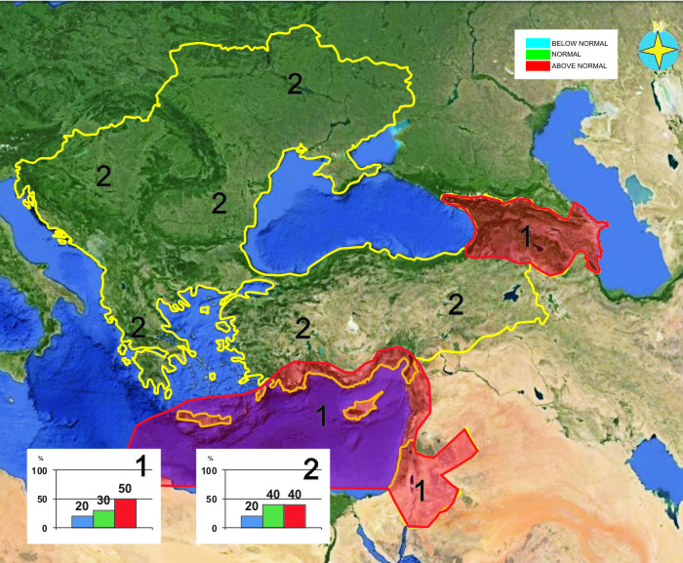
Figure 1. Graphical presentation of the 2015 summer temperature outlook

Uncertainties in regional predictions are higher for precipitation than for temperature. In the South Caucasus region and eastern parts of Ukraine summer season precipitation totals are likely to be near- or below- average (zone 1 in Figure 2), while there is slightly enhanced probability for the above-average conditions in the mountainous region of Turkey, southern part of the Aegean Sea with belonging coast, as well as in the south of Greece (zone 2 in Figure 2). In the rest of the SEECOF region (zone 3 in Figure 2) the uncertainty is high: probabilities for below-, near-, or above- average conditions are approximately equal. It must be emphasized that it might be possible that some parts, especially mountainous ones, might locally have near- or above- normal summer season totals, due to episodes of the enhanced convection with high intensity rainfall. Along the northern and eastern coasts of the eastern Mediterranean, in Israel and Jordan, due to dry season masking, it is not possible to forecast summer season precipitation.

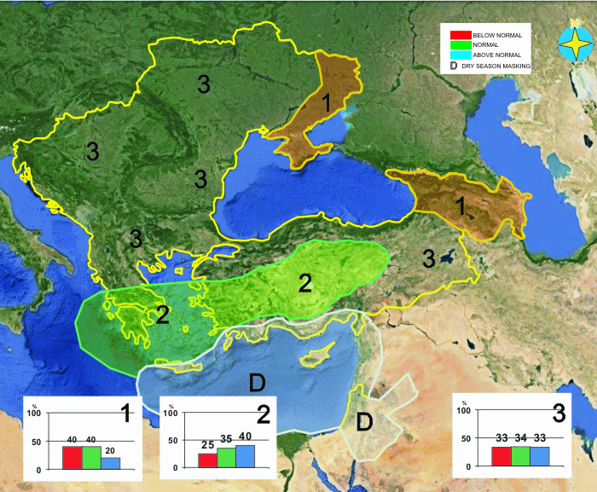
Figure 2. Graphical presentation of the 2015 summer precipitation outlook

Reference:
The maps show the probabilistic consensus forecast for tercile categories of anomalies of seasonal-mean temperature and precipitation, relative to the period 1981-2010.

Any further advice on the forecast signals, shorter-range updates and warnings will be available throughout the summer from the National Meteorological Services, along with the details on the methodology and skill of long-range predictions.

* The graphical representation of climate outlook in this statement is for guidance purposes only, and does not imply any opinion whatsoever concerning the legal status of any country, territory, city or area or of its authorities, or concerning the delimitation of its frontiers or boundaries.

APPENDIX A: Contributors to SEECOF-13

- World Meteorological Organization
- Met Office, United Kingdom
- International Research Institute for Climate and Society, United States of America
- European Center for Medium Range Weather Forecast
- Meteo France, Republic of France
- Deutscher Wetterdienst, Federal Republic of Germany
- National Center for Environmental Prediction, United States of America
- South East European Virtual Climate Change Center hosted by Republic Hydrometeorological Service of Serbia, Republic of Serbia
- Institute of Geosciences, Energy, Water and Environment, Albania
- Armenian State Hydrometeorological and Monitoring Service, Armenia
- National Institute of Meteorology and Hydrology, Republic of Bulgaria
- Meteorological and Hydrological Service, Republic of Croatia
- Meteorological Service, Republic of Cyprus
- Hellenic National Meteorological Service, Greece
- The National Environmental Agency of Georgia, Georgia
- Hungarian Meteorological Service, Hungary
- Israel Meteorological Service, State of Israel
- Republic Hydrometeorological Institute, Former Yugoslav Republic of Macedonia
- State Hydrometeorological Service, Republic of Moldova
- Hydrometeorological Institute of Montenegro, Montenegro
- National Meteorological Administration, Romania
- Federal Hydrometeorological Service of the Federation of Bosnia and Herzegovina, Federation of Bosnia and Herzegovina, Bosnia and Herzegovina
- Republic Hydrometeorological Service of the Republic of Srpska, Republic of Srpska, Bosnia and Herzegovina
- Republic Hydrometeorological Service of Serbia, Republic of Serbia
- Turkish State Meteorological Service, Republic of Turkey
- Ukrainian Hydrometeorological Center, Ukraine

