ANNEX III

REGIONAL TRAINING ON LONG-RANGE FORECASTS, CLIMATE WATCH RELATED ASPECTS AND CLIMATE SCENARIOS (LRF Training)
13 – 16 November 2013, Belgrade

THE FIRST SESSION OF THE MEDITERRANEAN CLIMATE OUTLOOK FORUM (MedCOF-1)
18 – 19 November 2013, Belgrade

THE TENTH SESSION OF THE SOUTH-EAST EUROPEAN CLIMATE OUTLOOK FORUM (SEECOF-10)
20 – 21 November 2013, Belgrade

INFORMATION NOTE

BACKGROUND

The IPA/2012/290552 Multibeneficiary Project: “Building resilience to disasters in Western Balkans and Turkey” has been approved by the European Commission Directorate General for Enlargement for joint implementation by the UNISDR and the WMO, for a period of 24 months (May 2012 – May 2014).
The project is part of the EC DG Enlargement Instrument for Preaccession Assistance (IPA) Programme for the Western Balkans and Turkey. The overall objective of the project is to reduce vulnerability of IPA beneficiary countries to disasters caused by natural hazards in line with the Hyogo Framework for Action and increase their resilience to climate change.
The direct beneficiaries are the national authorities in charge for the disaster risk reduction and disaster risk management and the National Meteorological and Hydrological Services (NMHSs) of Albania, Bosnia and Herzegovina, Croatia, Montenegro, Serbia, Kosovo*, the former Yugoslav Republic of Macedonia and Turkey.
The project activities are grouped in eight tasks, of which four are implemented under WMO management. Two face-to face sessions of the South-East Europe Climate Outlook Forum (SEECOF) will be conducted and supported by the project during the implementation period. SEECOF was established in 2008 and has been conducted nine times in cooperation with the South East European Virtual Climate Change Centre (SEEVCCC), hosted by the Republic Hydrometeorological Service of Serbia. The SEECOF session will this year be jointly organized with the first session of the Mediterranean Climate Outlook Forum (MedCOF).
Regional training in the use and interpretation of long-range forecasts, climate watch related aspects, and climate scenarios in application to various user sectors will be organized before the SEECOF/MedCOF sessions.

2. DATES AND VENUE

A regional training on long-range forecasts, climate watch related aspects and climate scenarios will be organized on 13 – 16 November 2013 and the SEECOF and MedCOF sessions on 18 – 21 November 2013 in Belgrade, Serbia, on the kind invitation of the Republic Hydrometeorological Service of Serbia (RHMSS).

The workshop will be held at the premises of the Best Western Hotel Sumadija, Sumadijski trg 8, 11000 Belgrade, Serbia. More details are available on the following web site: www.hidmet.gov.rs

PARTICIPANTS

The project will support one expert from each IPA Project beneficiary to participate in the training on long-range forecasts, climate watch related aspects, and climate scenarios. For the SEECOF session the project will support the participation of two experts, the expert who participated in the training before and another expert, preferable a representative from the user sector.

All participants are kindly requested to bring their own laptops.

LANGUAGE

The working language of the events is English.

ACCOMMODATION

A number of rooms have been provisionally reserved for the participants at the Best Western Hotel Sumadija, situated in an attractive, quiet residential neighborhood in Belgrade, nearby RHMSS and one of Belgrade’s most beautiful parks – the Kosutnjak Park. It is also within walking distance of the Belgrade Hippodrome and the Ada Ciganlija Lake and recreational center.

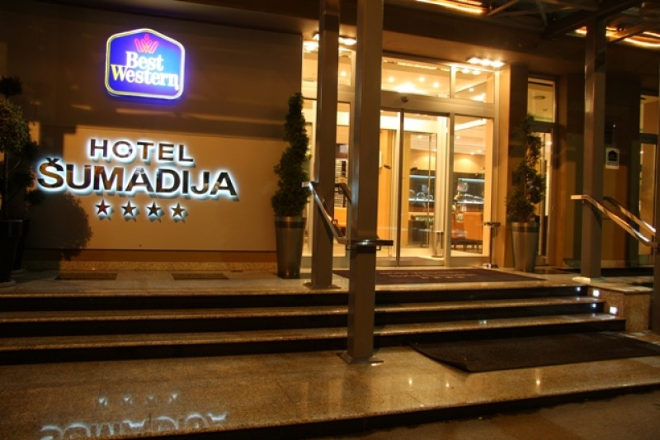
Best Western Hotel Sumadija

Address: Sumadijski trg 8
11000 Belgrade
Phone : +381 11 3054100
Fax: +381 11 3554368
E-mail: office@hotelsumadija.com
Web: www.hotelsumadija.com



Room choice | Night + breakfast | Half Board (HB) | Full Board (FB)
Single room (per person) | 65 € | 76 € | 87 €
Double room (per room) | 75 € | 97 € | 119 €

All taxes are included in the price.

The participants are requested to fill in the Hotel Reservation Form, attached as Annex I, and email it to RHMSS to the following e-mail addresses: rhms.intdep@hidmet.gov.rs.

Please note that the special hotel rate will only be available until 1st November.

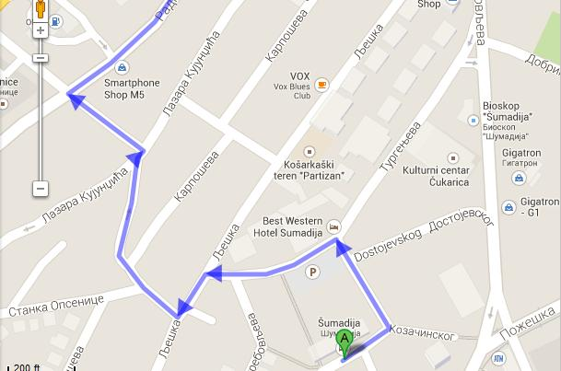
SUMADIJA HOTEL
AIRPORT

Belgrade’s Nikola Tesla International Airport is 15 km away from the hotel.

In case you wish to stay in another hotel, here are a few links to the web pages of the hotels located in the vicinity of the BW Hotel Sumadija:

- Hotel TRIM, Kneza Viseslava 72, www.trimhotel.rs
- HOTEL PRESTIGE, Bulevar vojvode Misica 24, www.hotelprestige.rs
- BALKAN GARNI Hotel, Pozeska 67A, www.balkangarni.rs

TRANSPORTATION

Transfer from the airport to the hotel and back to the airport by taxi will be organized upon your request at the special rate of 20 EUR. If you wish to have the taxi organized, please make sure to fill in your flight number and the time of your arrival in the hotel Registration Form, so that you could be met at the airport.
Another option is to use the public transportation.
From the airport you should take the bus 72 (leaving every 40 minutes) to its last stop "Zeleni venac". From there take the bus number 52 or 53 to the “Osnovna skola Josif Pancic” bus stop, which is 100 m away from the BW Hotel Sumadija.
The best option is to purchase bus tickets in the newsstands/kiosks, because it is cheaper that way. You should buy a non-personalized paper BUS PLUS card which costs 40 RSD (around 0.3 €), which can be charged multiple times (the price of a single ride ticket is 72 RSD, approx. 0.6 EUR, and the price of a time-limited ticket (75 minutes) is 100 RSD, approx. 0.8 EUR). The card must be validated upon every entry into the vehicle. The card reader will register and charge it for the amount of a single ride unless selected differently. You can also buy regular paper tickets directly from bus drivers, but the price of those tickets is higher – 150 RSD (1.3 EUR).
Of course, you can get all information, including a map of Belgrade, at the Information desk at the airport.

VISA REQUIREMENTS

For the participants requiring visa for Serbia, RHMSS will provide, upon demand, an official invitation letter for the visa application. Invitation letters for processing your visa will be issued upon receipt of your nomination for participation in the meeting.
You can find all the necessary information concerning the Serbian visa, as well as the visa application form, on the following website: www.mfa.rs.

INTERNET AND TELEPHONE CONNECTION:

The BW Hotel Sumadija offers free Wi-Fi connection to hotel guests.

The Belgrade area code for domestic calls is 011 and for international calls +381 11.

TIME, ELECTRICITY AND WATER

Belgrade is in the Central European Time (CET) zone (GMT+1 hour). Summer time (GMT+2 hours) lasts from the end of March until the end of October.

As in most cities of Continental Europe, the electricity voltage in Belgrade is 220V. Electrical outlets are standard European.

Tap water in Belgrade is safe to drink.

CURRENCY AND BANKS

The currency in Serbia is Dinar - RSD. All major currencies may be exchanged for the local currency at local banks. Please find the latest exchange rates at:
http://www.nbs.rs/internet/english/scripts/ondate.html

WEATHER IN BELGRADE IN NOVEMBER

Daily mean temperature: 6.8⁰C
Mean max temperature: 6-10⁰C
Mean min. temperature: 0-3⁰C
Average precipitation amount: 56.4mm

LIFE AND HEALTH INSURANCE

Life/major health insurance for each of the selected participants is necessary and is the responsibility of the candidate or his/her institution or Government. The organizers will not assume any responsibility for life and major health insurance, nor for expenses related to medical treatment or accidents.

LOCAL ORGANIZERS AND CONTACT DETAILS:

For any other information, please contact:

Ms Diana Mijuskovic
Head of Division for International Relations
RHMSS
Phone: +381 11 30 50 864
Mobile: +381 64 83 85 182
+381 64 83 85 004
Fax: +381 11 30 50 847
e-mail: rhms.intdep@hidmet.gov.rs

