CLIMATE OUTLOOK FOR 2011 SUMMER SEASON
FOR SERBIA AND THE SEE REGION

NHMS of Serbia regularly prepares climate outlook for our country on the basis of the ECMWF seasonal forecast model outputs, but also from the SEEVCCC regional climate model outputs. On this paper we will extend scope of our climate outlook and give climate outlook for summer season for Serbia, but also for the SEE region.

CLIMATE OUTLOOK FOR 2011 SUMMER SEASON BASED ON SEEVCCC MODEL OUTPUTS FOR SERBIA AND THE SEE REGION

In the north of Serbia summer season temperature will be above normal, while in other parts of the country it will be within normal range. In most parts of Serbia summer season precipitation will be within normal range.

In the inland of the Balkan Peninsula summer season temperature will be within or above normal; in the eastern Mediterranean, Black Sea coasts of the Caucasus and northeast Turkey as well as in the mainland of northeast Turkey it will be below normal, while in other parts of SEE region, within normal range.

In the greater part of the SEE region summer season precipitations will be within normal range. Summer season precipitations will be above normal only in the Carpathian region, in inland of Turkey, in Israel and mountainous region of south Caucasus. Along the coasts of Aegean, Ionian and Adriatic Sea, coastal part of Bulgaria and Romania, western Balkans and in the Pannonian plain summer season precipitation will be below normal.

CLIMATE OUTLOOK FOR 2011 SUMMER SEASON BASED ON ECMWF SEASONAL FORECAST MODEL OUTPUTS FOR SERBIA AND THE SEE REGION

In most parts of Serbia summer season temperature will be normal while in the mountain region of the southwestern and central parts of Serbia summer season temperature will be somewhat above normal. In the whole Serbia summer season precipitations will be normal or below normal. In other words, greater part of Serbia will have normally warm, but drier summer, while mountain region of southwestern and central parts of Serbia will have warm and drier summer.

In the western parts of Balkan Peninsula, Pannonian plain, Adriatic and Ionian Sea and belonging coasts, eastern Mediterranean, Israel, coastal parts of Turkey and Bulgaria summer season temperature will be above normal, while in the rest of the SEE region they will be normal or above normal. In the greater part of the SEE region summer season precipitation will be normal, while in the western, central and southern Balkan summer season precipitation will be below normal.

In the other words, in the greater parts of the Balkan Peninsula summer will be warmer or normally warm and normally humid, in the western part of the Balkans, on the Adriatic, Ionian Sea and belonging coasts it will be warmer and drier, while in the Pannonian plain, in the eastern Mediterranean, coastal parts of Bulgaria and Turkey and Israel summer will be warmer and normally humid.

SUGGESTED NHMS SERBIA - CLIMATE OUTLOOK FOR 2011 SUMMER SEASON FOR SERBIA AND SEE REGION

Summer season temperature in Serbia will be above normal. In most parts of Serbia summer season precipitation will be within normal range, while in the north of Serbia it will be below normal.

In the west, north, central and east part of Balkan Peninsula summer season temperature will be within or somewhat above normal; in central and of northeast part of Turkey and west part of the south Caucasus it will be normal, while in the rest of SEE region it will be above normal.

In the greater part of the SEE region summer season precipitations will be within normal range. Summer season precipitations will be above normal only in the Carpathian region, in some parts of inland southern Turkey. Along the coasts of Aegean Sea, western Black Sea and Adriatic Sea, Cyprus, western Balkans and in the Pannonian plain summer season precipitation will be below normal.
CLIMATE OUTLOOK FOR 2011 SUMMER SEASON BASED ON IRI
MULTI-MODEL FORECASTS FOR SERBIA AND SEE REGION

On the basis of the IRI multi-model forecast for summer temperature and precipitation climate outlook for 2011, summer season outlook is not like the climate outlook obtained on the basis of ECMWF.
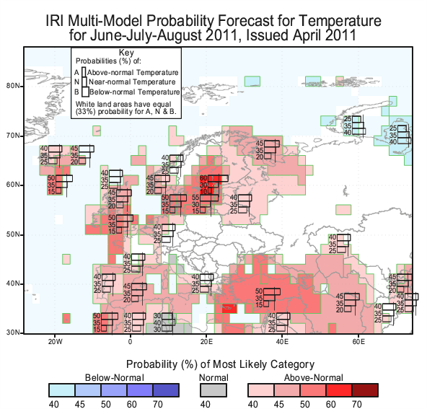

Most of the forecasting models indicate that summer season temperature in the most of SEE region will be above normal, while in the western, central and greater part of eastern Balkan and along the Adriatic sea they are not reliable. In central and eastern Mediterranean, Israel and belonging coasts summer season will be dry, while for the most parts of the SEE region at this time there are no reliable forecasts for summer season precipitation.

