SPRING 2011

The spring of 2011 in the Equatorial Pacific resembles the previous spring with the inverse sign. It is a spring of the La-Nina decay. Both climatological and numerical/statistical model forecasts for summer (see the figure from IRI web-site) predict near neutral ENSO conditions. Since numerical models are mainly governed by equatorial Pacific SST it could result in increasingly erroneous forcing for the models governed by persistent SST which integration starts in late April – early May. It is also worth noting that since today even state-of-the-art models are not perfect the impact of the forcing errors on the forecast of atmospheric variables over Europe is unpredictable. It may appear deterioration as well as improvement.

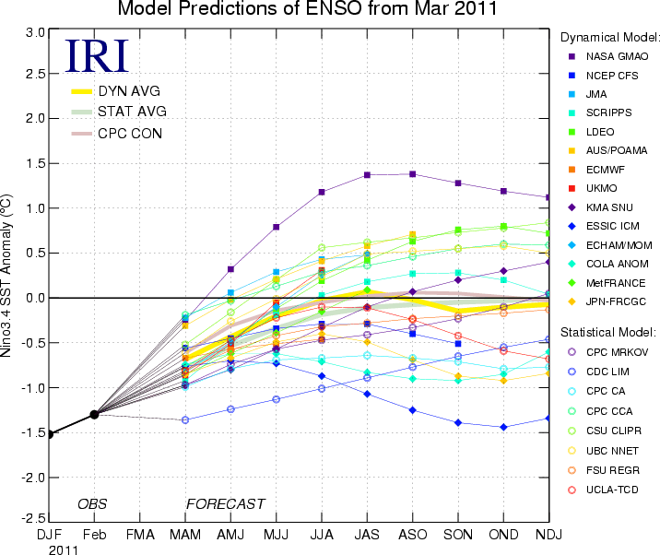

From
http://iri.columbia.edu/climate/ENSO/currentinfo/archive/201103/SST_table.html

An Atlantic SST anomaly pattern resembles the tripole associated with the negative NAO. It's likely that the pattern is a result from the negative NAO winter, even two successive winters. It's also likely that this pattern can't be destroyed under late winter - spring near neutral conditions and it may persist into the forthcoming summer. SEE processes may also be affected by the persistent strong positive SST anomaly in the western Mediterranian.

Along with SST, persistence is provided by the snow and ice. The snow extent was above normal in the Eurasia this spring.

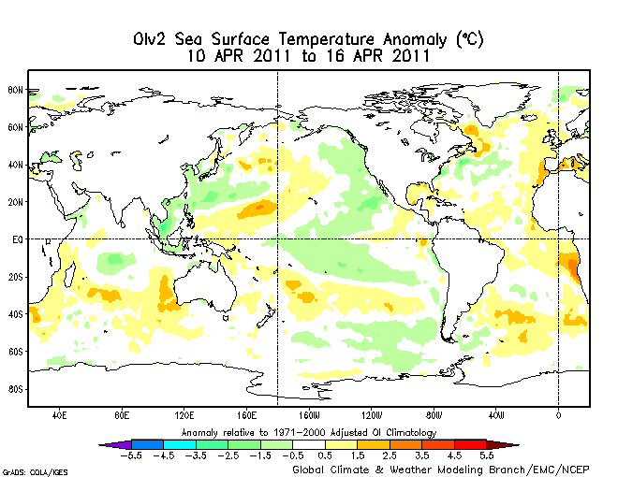

From http://www.emc.ncep.noaa.gov/research/cmb/sst_analysis/images/wkanomv2.png

The most prominent feature of the SLP field is a semiannular positive SLP anomaly in the middle latitudes, which extends at least up to the middle troposphere. In the March SPL map, the Azores high looks like a ridge from the Siberian high, with the SLP anomaly at its centre climatological location being near zero. In the early April, that persistent pattern resulted in strong positive temperature and negative precipitation anomalies over West Europe and inverse sign anomalies over East Europe.

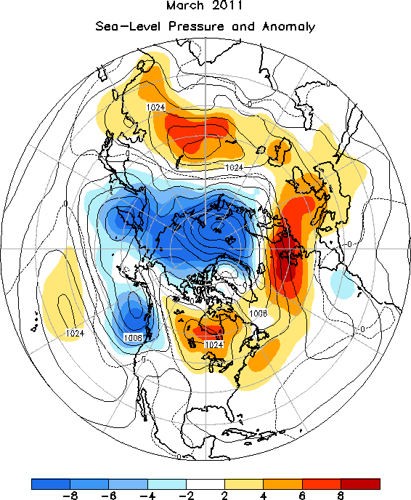

FIGURE E8. Northern Hemisphere mean and anomalous sea level pressure (CDAS/Reanalysis). Mean values are denoted by solid contours drawn at an interval of 4 hPa. Anomaly contour interval is indicated by shading. Anomalies are calculated as departures from the 1981-2010 base period monthly means. (from CPC CDB)

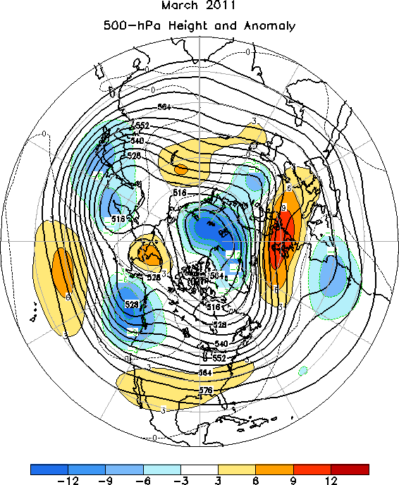
FIGURE E9. Northern Hemisphere mean and anomalous 500-hPa geopotential height (CDAS/Reanalysis). Mean heights are denoted by solid contours drawn at an interval of 8 dam. Anomaly contour interval is indicated by shading. Anomalies are calculated as departures from the 1981-2010 base period monthly means. (from CPC CDB)

Table of Teleconnection Indices in CPC version, with the latest being dated back to March 2011, is shown below. They match the fields shown above. It should be noted that persistency of the circulation patterns is quite low and they can’t be extrapolated into summer. Furthermore, the whole set of the modes explains about a half of the variance, with circulation in summer playing not so crucial role as in winter.

Table of Teleconnection Indices
MARCH 2011
MONTH | NAO | EA | WP | EP-NP | PNA | TNH | EATL/WRUS | SCAND | POLEUR
MAR 11 | 0.2 | -0.8 | -0.1 | 0.0 | 0.4 | --- | 0.1 | -1.0 | 0.9
FEB 11 | 0.4 | 0.4 | -0.1 | -0.1 | -2.4 | 0.8 | 0.6 | 0.3 | 0.1
JAN 11 | -1.5 | -1.3 | -1.4 | -0.4 | 1.0 | 1.1 | -0.4 | -0.2 | -0.4
DEC 10 | -1.8 | -0.5 | -1.3 | --- | -2.1 | -2.9 | -2.0 | 0.6 | 0.5
NOV 10 | -1.8 | 0.2 | -0.3 | 0.3 | -0.8 | --- | -1.0 | -0.1 | 1.2
OCT 10 | -0.5 | -0.8 | 0.7 | -0.6 | 2.2 | --- | 0.0 | 0.3 | -1.1
SEP 10 | -0.6 | 0.6 | 0.1 | -0.3 | 1.1 | --- | -1.1 | 0.5 | 0.1
AUG 10 | -1.7 | 1.2 | 0.4 | -1.5 | 1.1 | --- | -0.8 | -0.3 | 1.1
JUL 10 | -0.4 | 1.8 | -2.4 | -0.2 | 0.9 | --- | -1.4 | 0.8 | 1.5
JUN 10 | -0.5 | 0.3 | -0.1 | 1.5 | -0.1 | --- | -1.9 | -0.6 | 2.1
MAY 10 | -1.3 | -1.4 | -2.5 | -0.2 | -0.7 | --- | -2.1 | 0.5 | -1.8
APR 10 | -0.9 | 0.1 | 0.9 | -1.2 | 1.3 | --- | -0.7 | -0.3 | -0.4
MAR 10 | -1.3 | 1.2 | 1.8 | -1.6 | 1.7 | --- | 1.1 | -0.4 | -1.2
TABLE E1. Standardized amplitudes of selected Northern Hemisphere teleconnection patterns for the most recent thirteen months (computational procedures are described in Fig. E7). Pattern names and abbreviations are North Atlantic Oscillation (NAO); East Atlantic pattern (EA); West Pacific pattern (WP); East-Pacific - North Pacific pattern (EP-NP); Pacific/North American pattern (PNA); Tropical/Northern Hemisphere pattern (TNH); East Atlantic/Western Russia pattern (EATL/WRUS-called Eurasia-2 pattern by Barnston and Livezey, 1987, Mon. Wea. Rev., 115, 1083-1126); Scandanavia pattern (SCAND-called Eurasia-1 pattern by Barnston and Livezey 1987); and Polar Eurasia pattern (POLEUR). No value is plotted for calendar months in which the pattern does not appear as a leading mode. (from CPC CDB).

