IRI Multi-model probability for temperature and precipitation for JJA 2011, Issued on April 2011

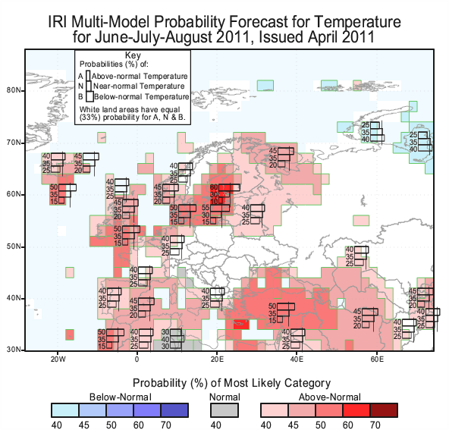
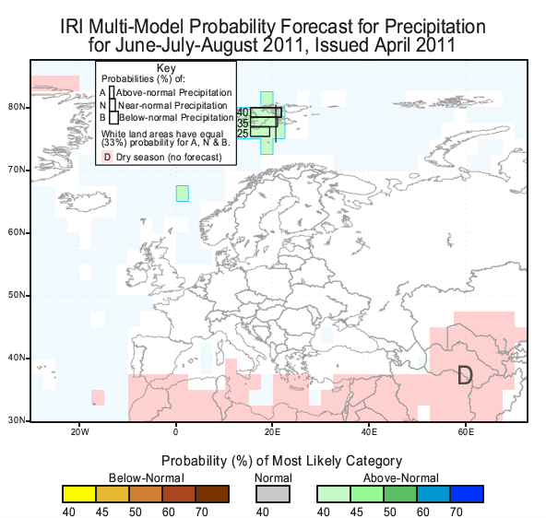
IRI Multi-model probability for temperature and precipitation for JJA 2011, Issued on May 2011

