EL NIÑO/SOUTHERN OSCILLATION (ENSO) DIAGNOSTIC DISCUSSION

issued by

CLIMATE PREDICTION CENTER/NCEP/NWS
7 April 2011

ENSO Alert System Status: La Niña Advisory

Synopsis: A transition to ENSO-neutral conditions is expected by June 2011.
La Niña weakened for the third consecutive month, as reflected by increasing surface and subsurface ocean temperatures across the equatorial Pacific Ocean. All four Niño indices ranged between –0.3°C and –0.8°C at the end of March 2011 (Fig. 1). Subsurface oceanic heat content anomalies (average temperatures in the upper 300m of the ocean, Fig. 2) became weakly positive in response to the continued eastward progression of a strong oceanic Kelvin wave, which has begun to shoal in the eastern Pacific (Fig. 3). However, the basin wide extent of negative SST anomalies remained considerable throughout the month (Fig. 4). Also, La Niña impacts on the atmospheric circulation remained strong over the tropical and subtropical Pacific. Convection remained enhanced over much of Indonesia and suppressed over the western and central equatorial Pacific (Fig. 5). Also, anomalous low-level easterly and upper-level westerly winds have persisted in this region. Collectively, these oceanic and atmospheric anomalies reflect a weakening La Niña, but with ongoing global impacts.
Nearly all of the ENSO models predict La Niña to continue weakening in the coming months, and the majority of models indicate a return to ENSO-neutral by May-June-July 2011 (three month average in the Nino-3.4 index between –0.5°C and +0.5°C; Fig. 6). While there is confidence in ENSO-neutral conditions by June 2011, the forecasts for the late summer and beyond remain highly uncertain. At this time, all of the multi-model forecasts (shown by the thick lines) suggest ENSO-neutral conditions will persist from June through the rest of the year. However, the spread of individual model forecasts and overall model skill at these lead times leaves the door open for either El Niño or La Niña conditions by the end of 2011.
La Niña will continue to have global impacts even as the episode weakens through the Northern Hemisphere spring. Expected La Niña impacts during April-June 2011 include suppressed convection over the west-central tropical Pacific Ocean, and enhanced convection over Indonesia. Potential impacts in the United States include an enhanced chance for below-average precipitation across much of the South, while above-average precipitation is favored for the northern Plains. An increased chance of below-average temperatures is predicted across the northern tier of the country (excluding New England). A higher possibility of above-average temperatures is favored for much of the southern half of the contiguous U.S. (see 3-month seasonal outlook released on March 17th, 2011).
This discussion is a consolidated effort of the National Oceanic and Atmospheric Administration (NOAA), NOAA’s National Weather Service, and their funded institutions. Oceanic and atmospheric conditions are updated weekly on the Climate Prediction Center web site (El Niño/La Niña Current Conditions and Expert Discussions). Forecasts for the evolution of El Niño/La Niña are updated monthly in the Forecast Forum section of CPC's Climate Diagnostics Bulletin. The next ENSO Diagnostics Discussion is scheduled for 5 May 2011. To receive an e-mail notification when the monthly ENSO Diagnostic Discussions are released, please send an e-mail message to: ncep.list.enso-update@noaa.gov.
Climate Prediction Center
National Centers for Environmental Prediction
NOAA/National Weather Service
Camp Springs, MD 20746-4304

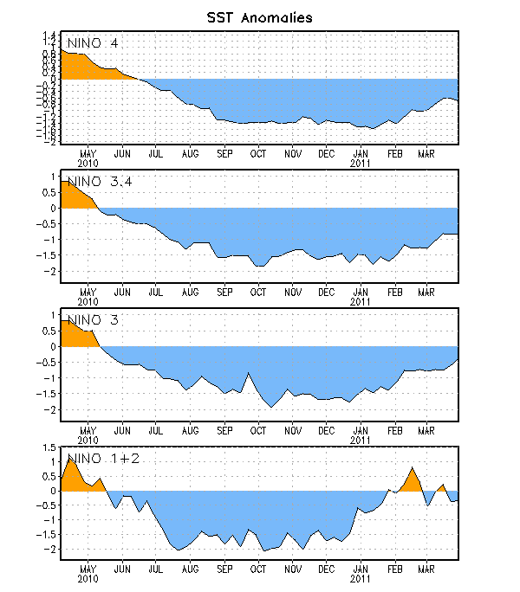
Figure 1. Time series of area-averaged sea surface temperature (SST) anomalies (°C) in the Niño regions [Niño-1+2 (0°-10°S, 90°W-80°W), Niño 3 (5°N-5°S, 150°W-90°W), Niño-3.4 (5°N-5°S, 170°W-120°W), Niño-4 (150ºW-160ºE and 5ºN-5ºS)]. SST anomalies are departures from the 1971-2000 base period weekly means (Xue et al. 2003, J. Climate, 16, 1601-1612).

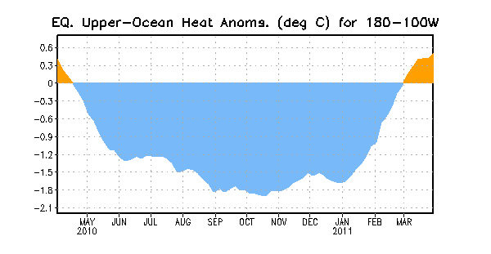
Figure 2. Area-averaged upper-ocean heat content anomalies (°C) in the equatorial Pacific (5°N-5°S, 180º-100ºW). Heat content anomalies are computed as departures from the 1982-2004 base period pentad means.

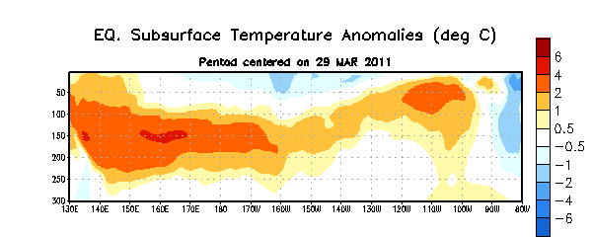
Figure 3. Depth-longitude section of equatorial Pacific upper-ocean (0-300m) temperature anomalies (°C) centered on the week of 29 March 2011. The anomalies are averaged between 5°N-5°S. Anomalies are departures from the 1982-2004 base period pentad means.

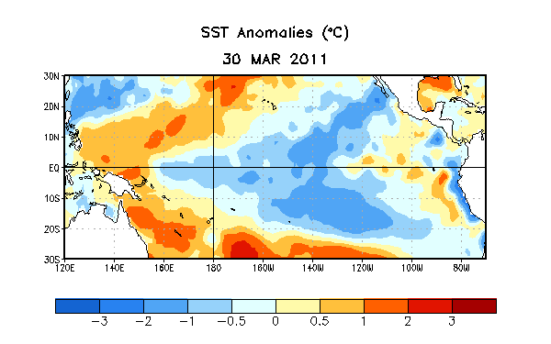
Figure 4. Average sea surface temperature (SST) anomalies (°C) for the week centered on 30 March 2011. Anomalies are computed with respect to the 1971-2000 base period weekly means (Xue et al. 2003, J. Climate, 16, 1601-1612).

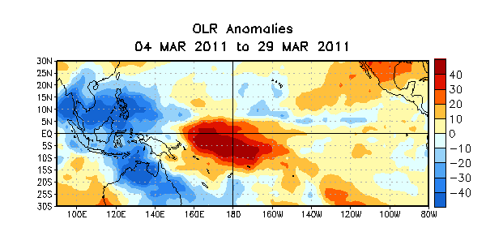

Figure 5. Average outgoing longwave radiation (OLR) anomalies (W/m²) for the four-week period 4 – 29 March 2011. OLR anomalies are computed as departures from the 1979-1995 base period pentad means.

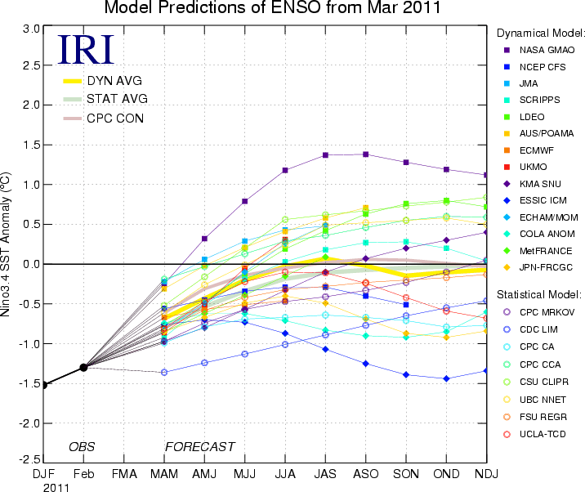
Figure 6. Forecasts of sea surface temperature (SST) anomalies for the Niño 3.4 region (5°N-5°S, 120°W-170°W). Figure courtesy of the International Research Institute (IRI) for Climate and Society. Figure updated 16 March 2011.

