WEATHER CLIMATE WATER

GLOBAL SEASONAL
CLIMATE UPDATE
Pre-Operational Phase
TARGET SEASON: JUNE-JULY-AUGUST 2019

Issued: 21 May 2019
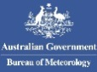

Summary

Observed sea surface temperatures in the east-central tropical Pacific exhibited weak El Niño conditions during February-April 2019. The sea surface temperatures in the Niño 3.4 and Niño 3 regions, both of which are often used to characterize El Niño/Southern Oscillation (ENSO) conditions, are predicted to be approximately 0.7 to 0.9 °C above average during the June-August 2019 season, and hence, remain at weak El Niño levels. This tendency towards weak El Niño conditions is predicted by a majority of dynamical models.
Influences from the expected tendency towards positive sea surface temperature anomalies across sizeable portions of the globe, both in the tropics (e.g., a weak strength El Niño in the Pacific) and extra-tropics, are seen in the temperature forecast for June-August 2019, which leans quite strongly, on average, towards above-normal land temperature, particularly in tropical latitudes. Below-average sea surface temperature is predicted in relatively smaller areas, such as in the middle and high latitude north Atlantic and to the southwest of Australia. These smaller areas may still noticeably affect the overlying atmospheric circulation and climate, as they enhance the SST gradients with nearby areas of positive SST anomalies. A global warming trend also contributes to the sea surface temperature and air temperature forecast, leading to a general prevalence towards a positive tilt in anomalies defined using the climatological base period (1993–2009) centred more than 10 years in the past.
With weak El Niño conditions expected during the June-August 2019 season, some of the predicted large-scale seasonal precipitation anomalies over land are in keeping with typical El Niño responses, such as the enhanced probability for below-normal for much of the Indonesian archipelago, Central America and the Caribbean, and above-normal for part of southeast South America. However, some anomalies do not follow El Niño-related expectations, for example, the lack of a tilt of the odds towards below-normal rainfall in northeast South America. Some such tilts of the odds are likely associated with sea surface temperature anomalies not directly related to El Niño.

Surface Air Temperature, JJA 2019  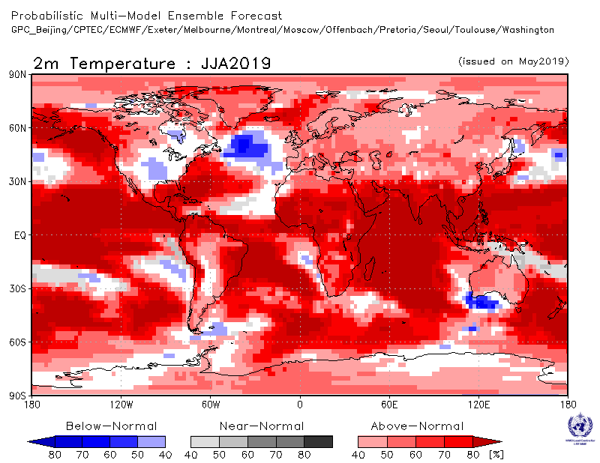 | Precipitation, JJA 2019  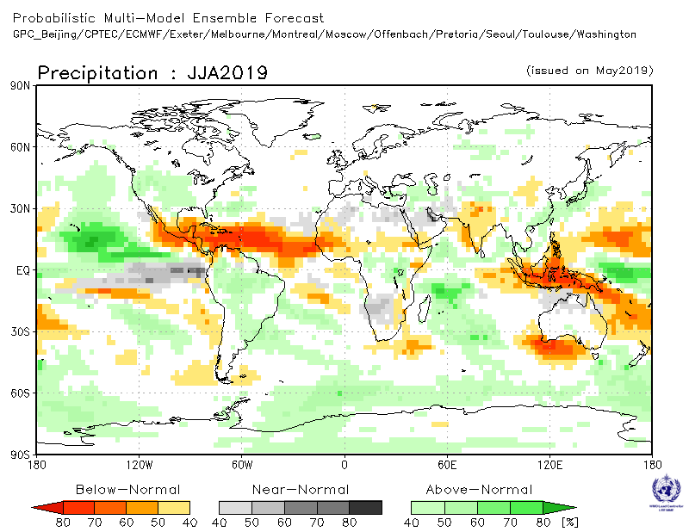

Figure 1. Probabilistic forecasts of surface air temperature and precipitation for the season June-July-August 2019. The tercile category with the highest forecast probability is indicated by shaded areas. The most likely category for below-normal, above-normal and near-normal is depicted in blue, red and grey shadings respectively for temperature, and orange, green and grey shadings respectively for precipitation. White areas indicate equal chances for all categories in both cases. The baseline period is 1993–2009.

1. Observations: February-March-April 2019
In the following sections, observed temperature and precipitation patterns for the period February-April 2019 are briefly described. For more detailed information about regional and local climate anomalies, the reader is referred to the concerned WMO Regional Climate Centres (RCCs) or RCC Networks, listed in Section 5.

1.1 Large-scale sea surface temperature (SST) indices
Sea surface temperatures (SST) were above normal across all ENSO regions of the Pacific, more so in the central Pacific than in the eastern Pacific; all Niño regions showed positive anomalies characteristic of a weak El Niño. The Indian Ocean Dipole (IOD) over the period was neutral. The North Tropical Atlantic (NTA) index was near-average to weakly positive, while the South Tropical Atlantic (STA) index was also positive.

Month | Niño 1+2 | Niño 3 | Niño 4 | Niño 3.4 | IOD | NTA | STA
Feb 2019 | 0.31 | 0.55 | 0.96 | 0.68 | -0.09 | 0.21 | 0.25
Mar 2019 | 0.16 | 0.76 | 0.91 | 1.01 | 0.05 | 0.00 | 0.65
Apr 2019 | 0.08 | 0.67 | 0.73 | 0.82 | 0.04 | 0.18 | 0.51
Feb 2019-Apr 2019 | 0.18 | 0.66 | 0.87 | 0.84 | 0.0 | 0.13 | 0.47

Table 1. Large-scale oceanic indices (°C). Anomalies are with respect to the 1981–2010 average. (Source: U.S. Climate Prediction Center)

1.2 Observed temperature
Temperature anomalies across the globe continued the trend of warmer than normal conditions for the months February-April 2019 (Figure 2, top). Above normal temperatures dominated the globe, with a few areas of cool anomalies interspersed. The warmest land anomalies occurred over Western Australia, Central and Southern Africa, Eastern Europe, Central and Northern Asia and northwest North America. A tendency towards positive temperature anomalies was also present over Western Europe. Embedded within the general warmth over land, regions of below-normal land temperature were located over central North America and northern Africa.
Most oceanic regions, except for small areas of cooler-than-normal temperatures east of Australia, the Southern Hemisphere oceans west and south of South America, and the eastern Atlantic, had positive temperature anomalies. SSTs in the equatorial Pacific indicated weak El Niño conditions. SST anomalies throughout the extratropical North Pacific Ocean were generally positive.
Consistent with the seasonal mean anomalies, warm extremes dominated (Figure 2, bottom panel). Warm extremes (exceeding temperatures observed during 1981–2010) occurred over Western Australia, southern parts of Africa and the northernmost part of Europe. Much cooler than normal temperatures (in lowest decile) were found over the continental US, part of northern Africa and over the oceanic region in the southern hemisphere.

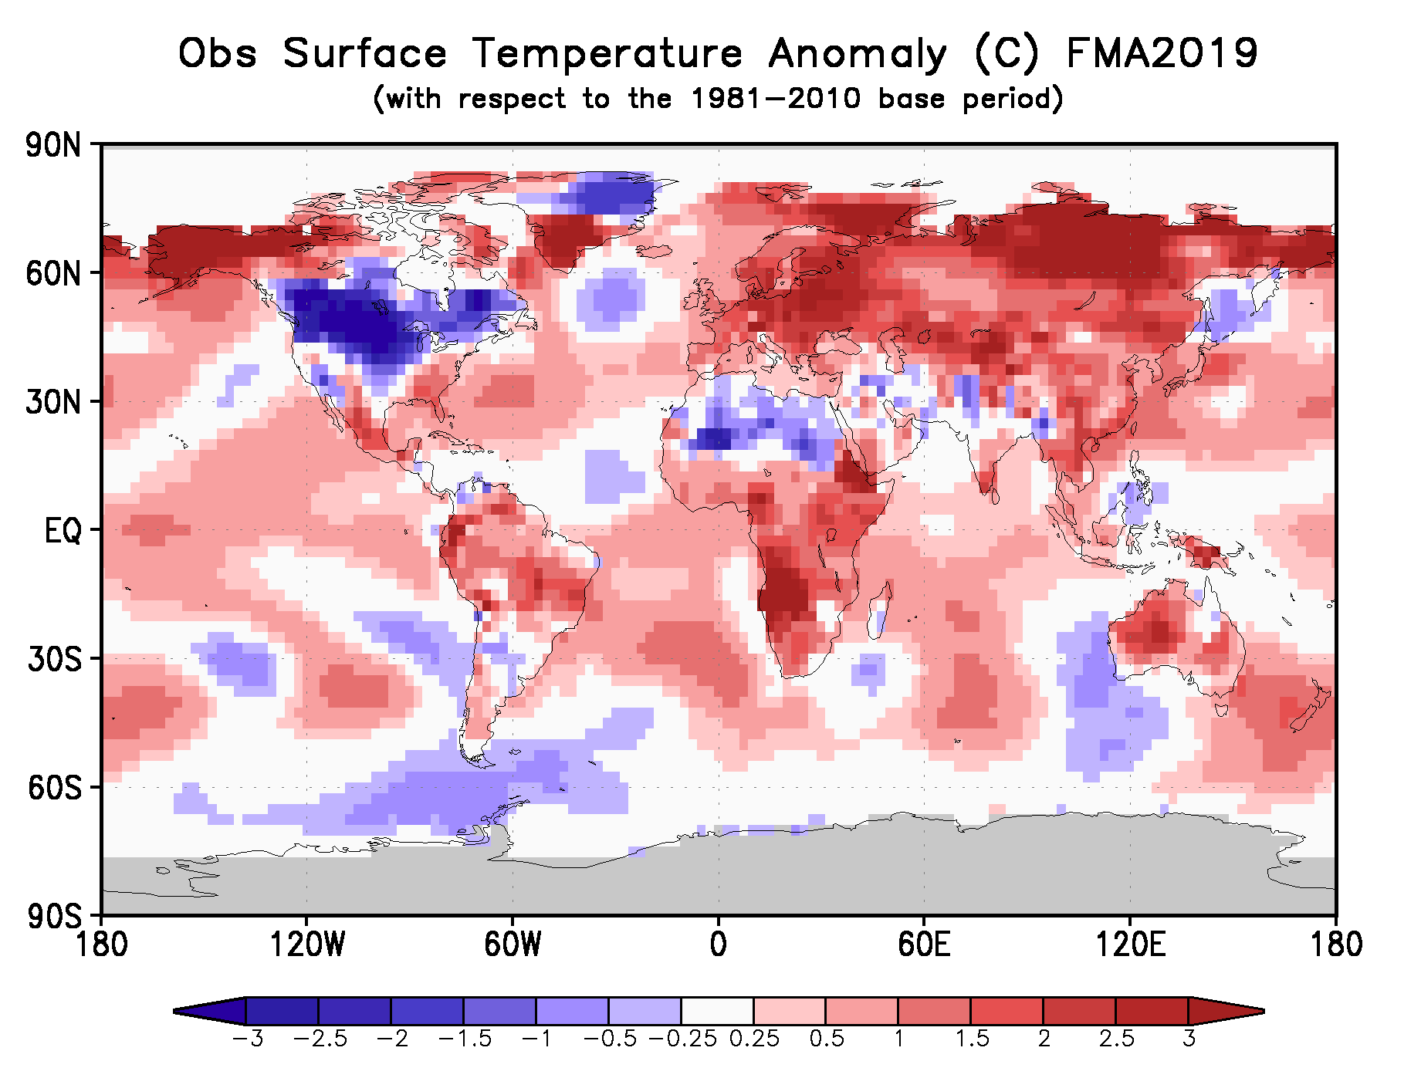

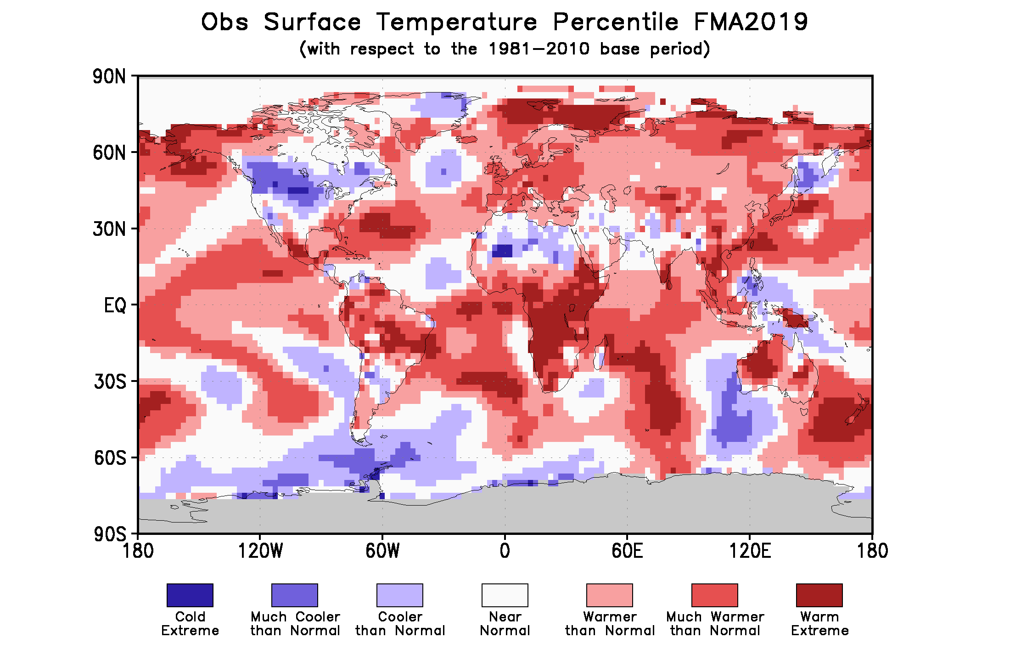

Figure 2. Observed February-April 2019 near-surface temperature anomalies relative to 1981–2010 (top). The Cooler than Normal, Near Normal, and Warmer than Normal shadings on the percentile map (bottom) indicate that seasonal mean anomalies were in the bottom, middle, and upper tercile of the 1981–2010 distribution, respectively. Regions with anomalies in the lowest and highest decile (or 10%) of the distribution are marked as Much Cooler than Normal and Much Warmer than Normal, respectively. The Cold Extreme and Warm Extreme shadings indicate that the anomalies exceeded the coldest and warmest temperature values of the 1981–2010 period for the season. Grey shading indicates areas where observational analysis was not available. (Source: U.S. Climate Prediction Center).

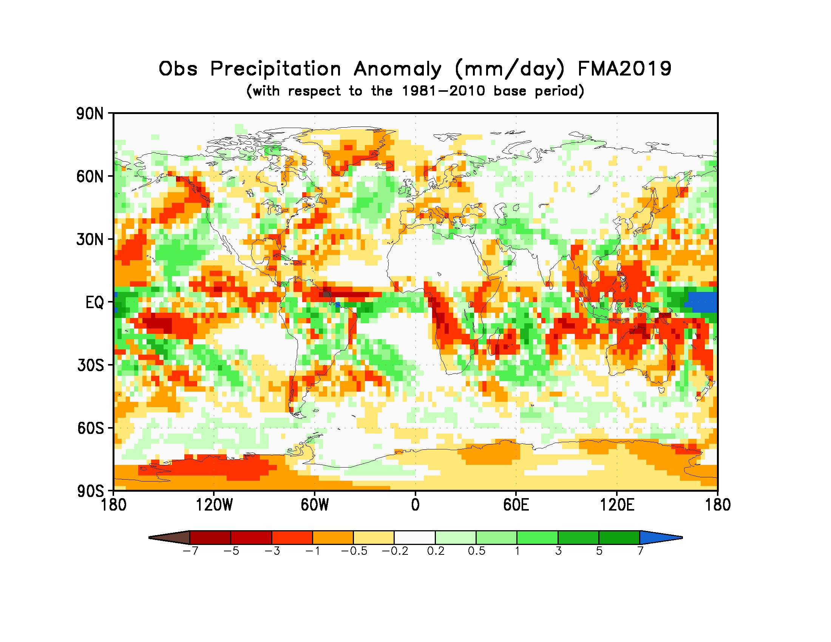
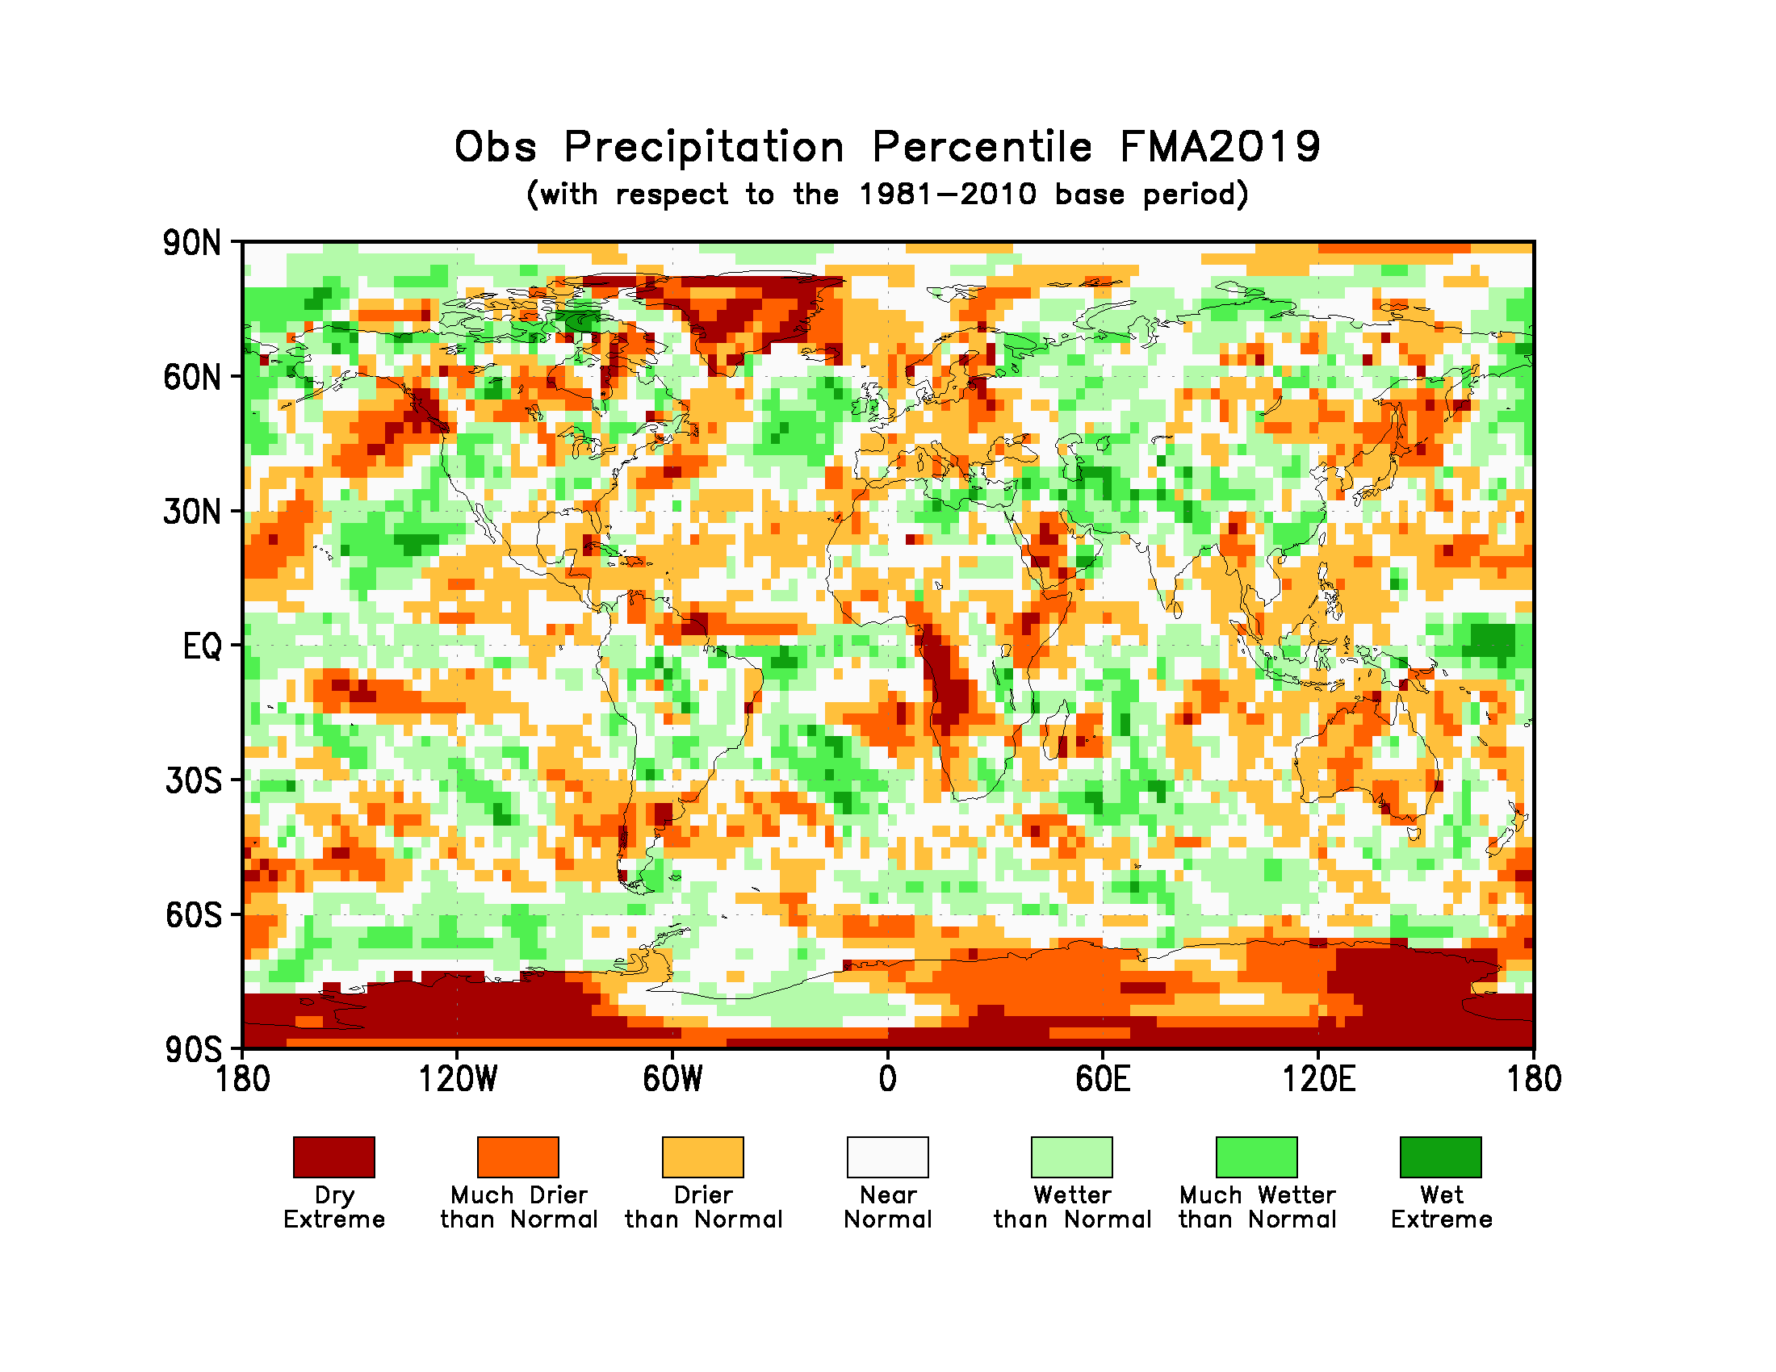
Figure 3. Observed precipitation anomalies for February-April 2019, relative to 1981–2010 base period (top). The Drier than Normal, Near Normal and Wetter than Normal shadings on the percentile map (bottom) indicate that seasonal mean anomalies were in the bottom, middle, and upper tercile of the 1981–2010 distribution, respectively. Regions with anomalies in the lowest and highest decile (or 10%) of the distribution are marked as Much Drier than Normal and Much Wetter than Normal, respectively. The Dry Extreme and Wet Extreme shadings indicate that the anomalies exceeded the driest and wettest values of the 1981–2010 period for the season.
(Source: U.S. Climate Prediction Center).

1.3 Observed precipitation
For February-April 2019 above-normal precipitation anomalies were located over warm SSTs associated with weak El Niño conditions in the equatorial Pacific near the dateline. Farther west, over the Indonesian Archipelago and Northwest Australia, these positive anomalies were flanked by negative precipitation anomalies. Negative precipitation anomalies also occurred over the western parts of southern Africa (a region that also experienced warm temperatures). Over South America, except for the northernmost and southernmost regions where precipitation anomalies were negative, precipitation anomalies were generally positive. A band of negative precipitation anomalies extended from north central tropical Pacific towards the northwest to Greenland. Dry extremes (precipitation below that observed during 1981-2010) over land occurred only over the western regions of southern Africa and near the South Pole. In general, global precipitation anomaly pattern did not exhibit large-scale spatial coherence because the El Niño conditions were weak.

2. Potential evolution of the state of the climate over the next three months (June–July-August 2019)

2.1 Large-scale SST-based indices, June-July-August 2019
Month | Nino 1+2 | Nino 3 | Nino 4 | Nino3.4 | IOD | NTA | STA
June 2019 | -0.39 ± 0.2 | 0.76 ± 0.39 | 0.85 ± 0.19 | 0.97 ± 0.36 | 0.63 ± 0.24 | -0.03 ± 0.16 | 0.31 ± 0.35
July 2019 | -0.35 ± 0.29 | 0.75 ± 0.52 | 0.87 ± 0.22 | 0.93 ± 0.44 | 0.46 ± 0.3 | 0.04 ± 0.17 | 0.31 ± 0.39
August 2019 | -0.33 ± 0.55 | 0.68 ± 0.65 | 0.88 ± 0.29 | 0.9 ± 0.61 | 0.51 ± 0.33 | 0.11 ± 0.18 | 0.31 ± 0.41
June -  August 2019 | -0.36 ± 0.3 | 0.73 ± 0.49 | 0.87 ± 0.22 | 0.94 ± 0.45 | 0.53 ± 0.26 | 0.04 ± 0.16 | 0.31 ± 0.38

Table 2: Multi-model forecasts for oceanic indices (℃), with standard deviation. Values are the equal-member-weighting average of those derived, using each GPC models own hindcast climate mean, from the 13 GPCs supplying SST forecasts (GPC Beijing, CPTEC, ECMWF, Exeter, Melbourne, Montreal, Moscow, Offenbach, Pretoria, Seoul, Tokyo, Toulouse, Washington). The standard deviation is calculated on all ensemble members, except for GPC Toulouse (GPC Toulouse provides only ensemble mean anomaly). The latitude/longitude bounds of the regions are given in the supplementary information section.

Observed sea surface temperatures in the east-central topical Pacific were at weak El Niño levels during February-April 2019. The sea surface temperatures in the Niño 3.4 and Niño 3 regions, both of which are often used to characterize ENSO conditions, are predicted to be approximately 0.7 to 0.9 °C above-average during the June-August 2019 season, and hence, remain at weak El Niño levels. The IOD prediction is for above-average conditions during June-August 2019. The northern equatorial Atlantic SST (NTA) is predicted to be near-average during the season, and the southern equatorial Atlantic SST (STA) is predicted to be somewhat above-average.

2.2 Predicted temperature, June-July-August 2019
For information on the construction of the multi-model forecast maps refer to the supplementary information section. (Note: Maps indicating forecast consistency among GPC models are available in the supplementary information).

Figure 4. Probabilistic forecasts of surface air temperature for June-July-August 2019. The tercile category with the highest forecast probability is indicated by shaded areas. The most likely category for below-normal, above-normal and near-normal is depicted in blue, red and grey shadings respectively. White areas indicate equal chances for all categories in both cases. The baseline period is 1993–2009.
Influences from the expected tendency towards positive sea surface temperature anomalies across sizeable portions of the globe, both in the tropics (e.g., a weak strength El Niño in the Pacific) and extra-tropics, are seen in the temperature forecast for June-August 2019, which leans quite strongly, on average, towards above-normal land temperature, particularly in tropical latitudes. Below-average sea surface temperature is predicted in relatively smaller areas, such as in the middle and high latitude north Atlantic and to the southwest of Australia. These smaller areas may still noticeably affect the overlying atmospheric circulation and climate, as they enhance the SST gradients with nearby areas of positive SST anomalies. A global warming trend also contributes to the sea surface temperature and air temperature forecast, leading to a general prevalence towards a positive tilt in anomalies defined using the climatological base period (1993–2009) centred more than 10 years in the past.
RA I (Africa): An enhanced probability for above-normal temperature is predicted over virtually all of Africa, with strong model-to-model consistency. The strongest tilt of the odds towards warmer temperature is predicted over the tropical and eastern portions of Africa; relatively weaker tilts of the odds are predicted over northern and especially northwest Africa. It is noted that above-normal temperatures would lead to a continuation of generally above-normal temperatures observed in equatorial and southern Africa during February-April 2019.
RA II (Asia): Weakly to moderately enhanced probabilities for above-normal temperature are predicted over most of Asia and the Middle East. The weakest tendency towards above-normal is forecast for central and northern Asia, where model consistency is also weak. The strongest probabilities for above-normal are in southern Asia. Much of the region predicted likely to be above-normal was observed to be above-normal during February-April 2019, with the exception of a large portion of southern Asia where near-normal temperatures were observed.
RA III (South America): Enhanced probabilities for above-normal temperature are predicted in most of South America with a stronger tilt in the probabilities towards warmth in the northern and eastern portions as well as much of the immediate west coastal area. A tilt of the odds towards warm is lacking in the south-central interior of the continent. The spatial structure of model consistency is similar to the tilt in probabilities. Observed temperatures during February-April 2019 were also above-normal in mainly the same regions with an above-normal tendency in the prediction, with a lack of above-normal observed in the southern interior portion.
RA IV (North America, Central America and the Caribbean): Enhanced probabilities for above-normal temperature are strongly predicted in northwest North America, in the Caribbean and all of Central America. Enhanced probabilities for below-normal temperature are predicted for the southern interior and northeast interior regions of the continent, with an area of no forecast signal enveloping the region of below-normal temperature. Model consistency is strongest in northwest North America, the Caribbean and Central America. Much of the region with an above-normal prediction in northwest North America was also above-average during February-April 2019, along with parts of Central America and the Caribbean. In much of the interior the continent, below-normal temperature was observed in February-April, so that the forecast indicates a likelihood of continuation of these anomalies.
RA V (Southwest Pacific): An enhanced probability for above-normal temperature is predicted in much of the Southwest Pacific region, including the Indonesian archipelago, Australia and New Zealand, but not in many of the southwest Pacific islands where there is no forecast signal. Model consistency for above-normal is strong in most of these areas. For much of the region, the February-April 2019 observations matched the above-normal forecast, with the exception of the eastern portion of the Indonesian archipelago and small portions of Australia. The prediction for warmth is consistent with the prediction for weak El Niño conditions.
RA VI (Europe): A weakly to moderately enhanced probability for above-normal temperature is predicted in virtually all of Europe and Greenland. Consistency among individual models for the above-normal prediction is moderate-to-strong, but less strong in central Greenland. This prediction for above-normal follows up on generally above-normal temperatures observed over most of mainland Europe but is opposite to the observed below-normal temperature over northeast Greenland during February-April 2019.

2.3 Predicted precipitation, June-July-August 2019

Figure 5. Probabilistic forecasts of precipitation for the season June-July-August 2019. The tercile category with the highest forecast probability is indicated by shaded areas. The most likely category for below-normal, above-normal and near-normal is depicted in orange, green and grey shadings respectively. White areas indicate equal chances for all categories in both cases.
The baseline period is 1993–2009.

With weak El Niño conditions expected during the June-August 2019 season, some of the predicted large-scale seasonal precipitation anomalies over land are in keeping with typical El Niño responses, such as the enhanced probability for below-normal for much of the Indonesian archipelago, Central America and the Caribbean, and above-normal for part of southeast South America. However, some anomalies do not follow El Niño-related expectations, as for example the lack of a tilt of the odds towards below-normal rainfall in northeast South America. Some such tilts of the odds are likely associated with sea surface temperature anomalies not directly related to El Niño.
RA I (Africa): Weakly enhanced probabilities for below-normal precipitation are predicted in the Sahel region of Africa, stretching from western Africa, where the signal is stronger and model consistency is strongest, eastward to just north of the Greater Horn. A weak tilt of the odds towards below-normal is also predicted in the immediate coastal portion of eastern equatorial Africa, and in the southeast part of the continent. Weakly enhanced probabilities for above-normal precipitation are predicted in part of central Africa, with moderate model consistency. A weakly enhanced probability for near-normal precipitation is forecast for parts of northern Africa and southern Africa. The tilt of the odds towards below-normal rainfall in part of the Greater Horn of Africa coincides with below-normal observed rainfall during February-April 2019.
RA II (Asia): Weakly enhanced probabilities for above-normal precipitation are predicted in parts of central Asia and the east coastal region and some islands offshore of the eastern coast, with moderate model consistency. The southern portion of this coastal region also experienced above-normal conditions in February-April 2019. Over part of south-central Asia a tilt of the odds towards below-normal conditions is forecast, and in the large islands offshore of southeast Asia there is likewise a tilt towards below-normal conditions, both with strong model consistency.
RA III (South America): An enhanced probability for above-normal precipitation is predicted over a large part of the northern interior and southeast portions the South America, both with moderate model consistency. A tilt of the odds towards below-normal is forecast for the extreme northern coast along the Caribbean Sea, with strong model consistency. The forecast for the below-normal conditions over the extreme northern coast, and parts of the above-normal in the interior and southeast portion, are both mainly a continuation of similar conditions in February-April 2019.
RA IV (North America, Central America and the Caribbean): An enhanced probability for below-normal precipitation is predicted in Central America and most of the Caribbean. A weakly enhanced probability of above-normal is forecast in the central interior and central west coast of North America. Both of the above-mentioned forecast regions have moderately strong model consistency. The forecast for below-normal in Central America and the Caribbean generally matches the February-April 2019 observations, and the forecast for above-normal in the central west coast, extending inland to the east, also roughly matches the recent observations.
RA V (Southwest Pacific): Enhanced probabilities for below-normal precipitation are predicted for the Indonesia archipelago, part of eastern and extreme southwest Australia, and all except for the northernmost southwest Pacific islands. These regions all show mainly strong model consistency. A tilt of the odds towards above-normal is forecast for southern New Zealand and a small portion of south-central Australia, both with moderate model consistency. The forecast for below-normal in part of eastern Australia matches the February-April 2019 observations in a portion of this area, but the forecast for southern New Zealand would be a reversal from below-normal observations in February-April.
RA VI (Europe): Over most of the Europe and Greenland there is no distinct signal that is forecast by the models. A weak tendency towards above-normal precipitation is forecast for the southeast portion to the south of the Black Sea and the Caspian Sea, with moderate model consistency. This southeast region was also marked by above-normal precipitation during February-April 2019.

3. Latest updates for monitoring and prediction information
Each month, the latest updates for the real-time monitoring and seasonal mean predictions included in GSCU can be found at:
Monitoring:
https://ftp.cpc.ncep.noaa.gov/mingyue/GSCUWMO/
Predictions:
https://www.wmolc.org/modules/data/plot/autograds4/download_PMME.php?filename=wmo/WMOLC_T2M.gif
https://www.wmolc.org/modules/data/plot/autograds4/download_PMME.php?filename=wmo/WMOLC_PREC.gif

4. How to use the Global Seasonal Climate Update
The GSCU is intended as guidance for RCCs, Regional Climate Outlook Forums (RCOFs) and National Meteorological and Hydrological Services (NMHSs). It does not constitute an official forecast for any region or nation. Seasonal outlooks for any region or nation should be obtained from the relevant RCCs (see below for contact details) or NMHS.
Seasonal forecasts are probabilistic in nature. Although the text and figures used in the GSCU highlight the tercile categories that is predicted with the highest probability, it is important to recognize that the other tercile categories may also have substantial (though lower) probability.
The geographical areas occupied by the forecast signals should not be considered precise. Similarly, signals with small spatial extent may be unreliable.
The skill of seasonal forecasts is substantially lower than that of weather timescales and skill may vary considerably with region and season. It is important to view the forecast maps together with the skill maps provided in the supplementary appendices.
For reference, the six WMO Regional Associations domains are depicted in the figure 6 below.
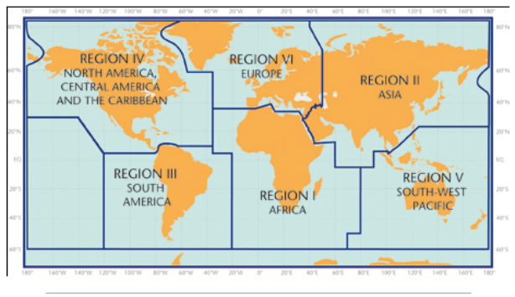
Figure 6. WMO Regional Associations domains

5. Designated and developing WMO Regional Climate Centres and Regional Climate Centre Networks
- RA I: http://www.wmo.int/pages/prog/wcp/wcasp/RCC-Africa.html
- RA II: http://www.wmo.int/pages/prog/wcp/wcasp/RCC-Asia.html
- RA III: http://www.wmo.int/pages/prog/wcp/wcasp/RCC-SouthAmerica.html
- RA IV: http://www.wmo.int/pages/prog/wcp/wcasp/RCC-NorthAmerica.html
- RA V: http://www.wmo.int/pages/prog/wcp/wcasp/RCC-SouthwestPacific.html
- RA VI: http://www.wmo.int/pages/prog/wcp/wcasp/RCC-Europe.html

6. Resources
Sources for the graphics used in the GSCU:
- The WMO Lead Centre for Long-Range Forecast Multi-Model Ensemble (LC-LRFMME): http://www.wmolc.org
- WMO portal to the Global Producing Centres for Long-range Forecasts (GPCs-LRF): http://www.wmo.int/pages/prog/wcp/wcasp/clips/producers_forecasts.html
- WMO GSCU portal
http://www.wmo.int/pages/prog/wcp/wcasp/LC-LRFMME/index.php
- WMO portal for Regional Climate Outlook Forums (RCOFs):
https://public.wmo.int/en/our-mandate/climate/regional-climate-outlook-products
- International Research Institute for Climate and Society (IRI):
http://portal.iri.columbia.edu/portal/server.pt
- NOAA Climate Prediction Centre (CPC):
http://www.cpc.noaa.gov

7. Acknowledgements
This Global Seasonal Climate Update was jointly developed by the WMO Commission for Climatology and Commission for Basic Systems with contributions from:
- WMO Lead Centre for Long-Range Forecast Multi-Model Ensemble (LC-LRFMME), Korea Meteorological Administration, NOAA National Centers for Environmental Prediction
- WMO Global Producing Centres for Long-Range Forecast (GPCs-LRF): GPC-Beijing (China Meteorological Administration), GPC-CPTEC (Center for Weather and Climate Studies, Brazil), GPC-ECMWF (European Center for Medium-Range Forecast), GPC-Exeter (UK Met Office),GPC- Melbourne (Bureau of Meteorology), GPC-Montreal (Meteorological Services of Canada), GPC-Moscow (Hydro meteorological Center of Russia), GPC-Offenbach (Deutscher Wetterdienst), GPC-Pretoria (South African Weather Services), GPC-Seoul (Korea Meteorological Administration), GPC-Tokyo (Japan Meteorological Administration), GPC-Toulouse (Météo-France), GPC-Washington (National Centers for Environmental Prediction)
- International Research Institute for Climate and Society (IRI)

Document with supplementary information can be downloaded from https://ftp.cpc.ncep.noaa.gov/mingyue/GSCUWMO/Supplementary/GSCU_JJA2019_supplementary_info_LC-LRFMME.docx

