**~~Prediction of desert dust melting in aircraft engines~~**

**Aerosol in aircraft turbines: predicting danger from dust melting**

Melted volcanic ash in jet engines remained as a concern for aviation safety over last decades. Because the current generation of aero turbines increased operating temperatures to 1300C or more, desert dust, although more resistant thermal conditions to melting than volcano ash, has been also assumed that can degrade aircraft performances. In order to examine the engine behavior to harmful influence of particles, the Arizona Test Dust (ADT) samples are usually used. Although this approach aims to mimic effects of volcanic ash and mineral dust to turbines, it cannot completely represent real-time flight conditions. We here focus on dust impacts and develop a numerical model methodology to predict mineral melting in engines when aircrafts pass through dust clouds. The model components include simulation of atmospheric dust transport as well prediction of minerals fractions carried by dust. The melting temperature of the mineral mixture in our approach depends: on predicted dust concentration, on melting temperatures of considered minerals and on their fractions in dust and on exposure time of dust to turbine temperatures. The model predicts a significant mineral melting during a recent Mid-East extreme dust storm when the aviation traffic was badly disturbed. The proposed prognostic system, if applied in operational mode, could help in reducing aviation risks due to dust.

===============================================================

Atmospheric particulates are of large concern for aviation because of their potential adverse effects to aircraft turbines. Volcanic ash has been until recently considered by air traffic industry almost exclusively as the major threatening aerosol. According to USGS evidence, 129 accidents induced by volcanic particles has been recorded in the period 1953-2009, from what 53 has been due to turbines abrasion and ash melting under high turbine temperatures (Guffanti, 2010). Ash melting and depositing in engines often leads to engine degradation and/or failure. The continuous increase of turbine working temperatures also raise the danger of mineral dust melting despite it has a few hundred degrees higher melting points than volcanic ash.

Mineral dust particles are mobilized from surface by intense near-ground turbulence over dry erodible desert soils. Once emitted to the atmosphere, dust can sometimes travel hundreds or even thousands kilometers away from sources (Knippertz). In the free atmosphere, dust is not too dangerous for aviation since it has lower concentrations and has higher melting points than volcanic ash. However, during major storms, dust could reach extreme concentrations in the first kilometers above ground when it could adversely affect aircraft turbines, especially during aircraft landing and take-off when turbine temperatures reach maxima. The amount of eventual dust melted and deposited in engines mainly depends (a) on dust concentration, (b) on time of turbine exposure to dust, and (c) on physical and mineralogical features of dust.

Previous studies have investigated behavior of jet turbines in tests made with controlled engines exposure to synthesized mixture of dusts and/or sampled volcanic ash (VIPR3 VAE) (Clarkson). Other studies based on the evidence on past accidents and laboratory tests, explore turbine engine susceptibility to the aerosol estimating the level of engine damage. For that purpose, the *Duration of Exposure versus Ash Concentration* (DEvAC) chart has been introduced to quantify levels of engine vulnerability as a function of aerosol concentration and time an aircraft spends in the ash cloud (Clarkson et al., 2016 [3]). The chart has been applied to both, volcanic ash and dust.

Although controlled engine tests and their susceptibility estimates provide useful general information to aviation operators, they yet cannot assess expected aerosol effects in real time along trajectories of specific flights. As a response to such needs, we have developed a prognostic modeling system designed to predict melting of mineral dust in turbines along aircraft routes. In this system, a high-resolution numerical weather prediction model, NMME (see methods), has been used to drive an on-line dust transport model, DREAM© (DREAM in the following text). For the purpose of this study, we have added to DREAM prognostic concentration fractions for eight typical dust minerals: illite, kaolinite, ... (see Methods/Models for modelling details). We have assumed that dust particles are internally mixed; namely, each particle is a mixture of all eight minerals (Atkinson). Furthermore, as a first-order approximation we calculate the melting point of dust mixture  as a mean of melting points of minerals  weighted with respect to mass of mineral fractions:



Approximate values of mineral melting points  shown in Fig xx are specified following available information in the mineralogy literature (xx).

weighted mean of the melting potential of minerals (inversely proportional to melting points) :





To quantify aircraft vulnerability due to dust melting, we calculate a prognostic parameter dependent on the melting point of mineral mixture in dust, on real-time dust concentration prediction and on time an aircraft is spending in dust cloud.

To test the model, we have selected the massive dust storm event happened over Doha between 1 and 2 April 2015. The dust storm was generated in a desert area of Iraq a day before, which passed swiftly along the eastern Saudi Arabian Peninsula before arriving to Qatar. According the environmental and meteorological authorities in Qatar, this was the strongest ever recorded dust storm at the place.

during which the Doha airport traffic in Qatar was badly disturbed

**associated with winds larger than 100 km/h; According to particulate matter (PM) measurements in Doha (exceeding1,000,000 μg/m3)**,

-------------------

RR 2017 DEvAC chart

• The need to explicitly define an engine’s susceptibility to VA under EASA regulations,

• The recognition that damage to engines is essentially related to ash dose rather than ash concentration,

RR 2016

To help understand

the implications a new chart is proposed that plots

known engine ash encounters on a graph of exposure

duration versus encounter average ash concentration.

and average particulate matter of approximately 10 μm in diameter. (doha)

When engine power increased, more ash-laden air was ingested by the jet turbines and combus­tion temperatures were raised; thus, conditions favorable for substantial melting of ash particles were met. T

===========

[aviation safety](https://en.wikipedia.org/wiki/Aviation_safety) hazard

degrading engine performance

are entering the third and final phase of the Vehicle Integrated Propulsion Research (VIPR) effort to test and evaluate new engine health management technologies.

=========

Klaus Brun, Particle Transport Analysis of Sand Ingestion in Gas Turbine Engines

specifically, jet engines that see significant inlet sand or ash ingestion of particles impacting significant amount of ingestion of fine particulate matter path. Significant interest exists in the military and commercial aerospace industry

In the combustor, the local flame temperature can be as high as 1650C. At these temperatures, sand will become a liquid silicone oxide

===================

cLARKSON

Although there were no known test bed engine studies with volcanic ash, there had been test bed

studies where sand and dust was introduced into engines. Two such studies that appeared to be relevant were the Calspan dust cloud tests

The dusts used for the engine tests were a synthesised mixture of crystalline sands and dusts, plus some glassy material.

a modern large civil turbofan at cruise or climb powers;



=====================

accretion growth or increase by the gradual accumulation of additional layers or matter.

passing through ash and dust completely diff. dust - in uptake and landing critical

damage mechanisms

lack of good data, was a quantitative understanding of the damage mechanisms

ash vs dust; the other more accurate prediction

local vs regional treansport

===============

VIPR3 VAE Goals:

–

Introduce volcanic ash into the engine inlet to emulate engine ash ingestion due to ash cloud encounters in flight

–

Focus on low concentration levels (near the visually discernable threshold)

–

Characterize engine performance degradation due to ash ingestion

–

Evaluate the capability of advanced engine health management technologies for diagnosing volcanic ash induced engine degradation

•

VIPR3 VAE Approach:

–

Utilized

Mazama

ash in the 5 to 60 micron particle size range

–

Exposed the engine to ash mass ingestion rates equivalent to ash cloud encounters in the 1 to 10 mg/m

3 concentration range

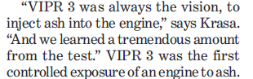

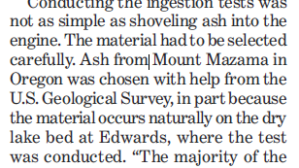

when and how much?

* Walsh: The combination of extreme temperature and residenceime can lead to sand even melting inside the turbine component. With increasing temperatures of gas turbine engines and the development of new cooling designs, it is critical to evaluate the effects of ingested sand particles.
* Zhao: Since the surfaces of components in future engines are likely to be cyclically exposed to temperatures of 1250 °C and above
* Singh: At temperatures above 1000 C, sand particles started melting and promoted blocking of cooling holes. Particle ingestion is excessive while takeoff and landing when engines are in ground proximity and running at full power[1]; According to studies by Edwards and Rouse[7], high sand ingestion can reduce engine stability by eroding blade profiles and lowering the compressor efficiency, as a result of which the line of operation is closer to the surge line.
* *Taltavull,* It is increasingly clear that gas turbines, particularly aeroengines, are susceptible to damage caused by ingested particulate, such as sand, fly ash and volcanic ash, often referred to generically as calcia-magnesia-alumina-silica (CMAS). Such particles may melt, or at least soften, in flight, making it more likely that, if they strike solid surfaces within the turbine, they will adhere to them on impact.

__________

Atmospheric mineral dusts are inorganic particles of rock and soil that have been lifted into the atmosphere, predominantly from arid regions such as the Sahara Although atmospheric dust concentrations and mineralogy vary spatially and temporally9,13 (Supplementary Fig. 1), a large

fraction of observed atmospheric dust mass around the world is made up of just a few minerals.

Paola

-----------------------

**parameterization**

* Singh Figure 5.4 shows the probability of sticking for sandparticles based on viscosity  *visc P* with temperature. Sticking probability rises exponentially as the particle approaches softening temperature.

surface area and have made two limiting calculations, one assuming that dust particles are internally mixed (that is, each particle contains all eight minerals) and the other assuming they are externally mixed (each particle is composed of an individual mineral).

**Melting points**

Guffanti, (USGS, 2010) **Encounters of Aircraft with Volcanic Ash Clouds: A Compilation of Known Incidents, 1953–2009**

weighted mean of the melting potential of minerals (inversely proportional to melting points) : 



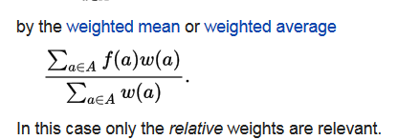

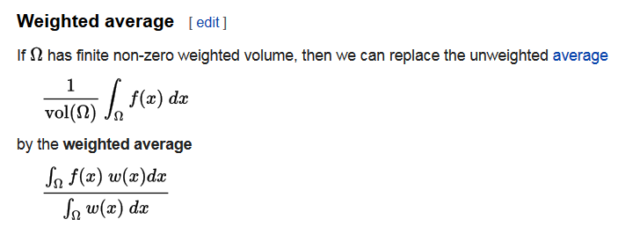

where  is the number concentration of ice nuclei ,  is ice nucleation active surface (Niemand et al., 2012), T is temperature in degrees Kelvin,  is relative humidity with respect to ice, , , and . Xx .