21-22 Sep 2018 Faroe

*...data from the Faroe Isle and there is a massive peak there for PM10 exactly for the dust storm*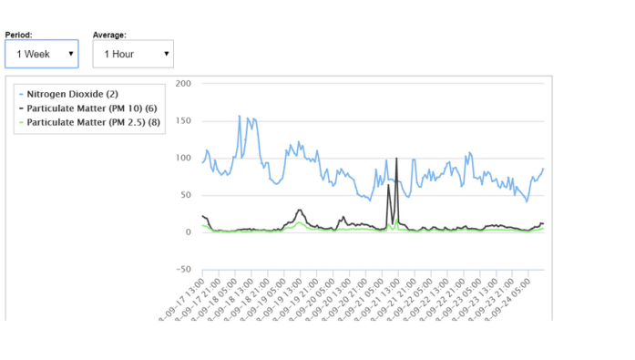

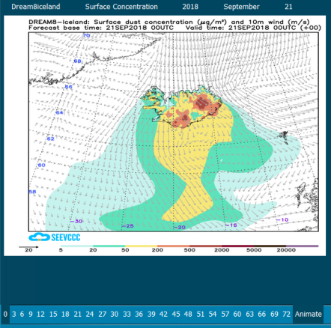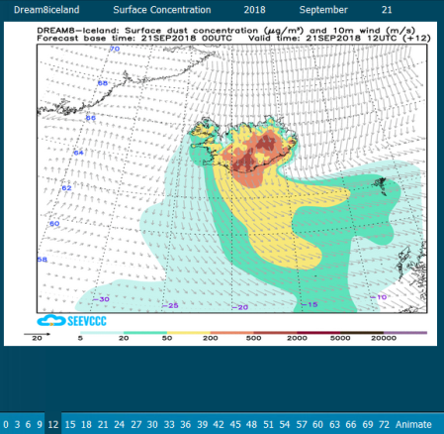

00H 21/09/2018 12H 21/09/2018

the predicted max coincides with PM

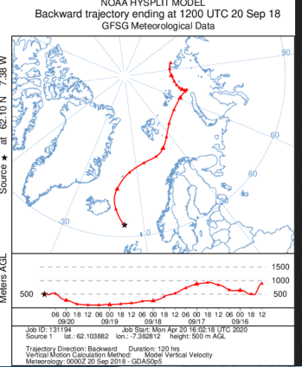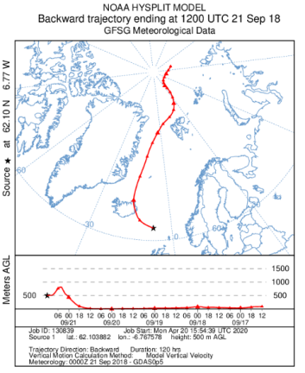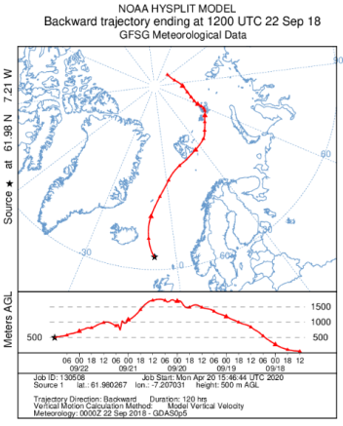

12H 20/09/2018 12H 21/09/2018 12H 22/09/2018

clouds cover Faroe Icl!

**21/9/2018**

**without clouds with clouds**

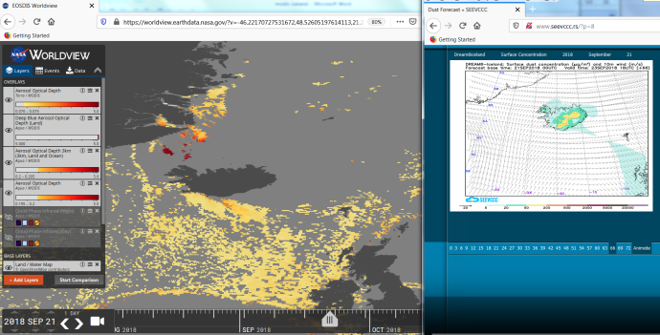 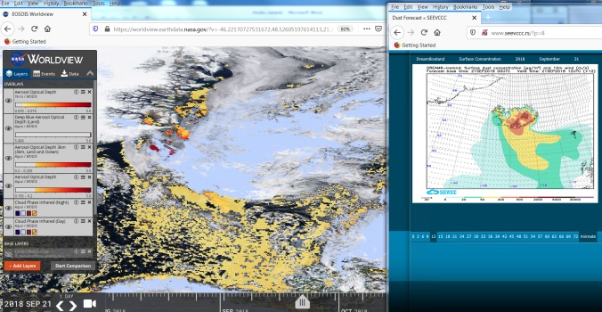

**without clouds**

https://worldview.earthdata.nasa.gov/?v=-46.22170727531672,48.52605197614113,21.278292724683283,79.77995822614113&t=2018-09-21-T18%3A55%3A16Z&l=MODIS_Terra_Aerosol(opacity=0.88,min=0.07),MODIS_Aqua_AOD_Deep_Blue_Land(min=5),MODIS_Aqua_Aerosol_Optical_Depth_3km(min=0.2),MODIS_Aqua_Aerosol(opacity=0.31,min=0.195),MODIS_Aqua_Cloud_Phase_Infrared_Night(hidden,opacity=0.5,disabled=3-2-0),MODIS_Aqua_Cloud_Phase_Infrared_Day(hidden,opacity=0.98,disabled=3-0-2),Land_Water_Map,VIIRS_SNPP_CorrectedReflectance_TrueColor(hidden),MODIS_Aqua_CorrectedReflectance_TrueColor(hidden),MODIS_Terra_CorrectedReflectance_TrueColor

**with clouds**

https://worldview.earthdata.nasa.gov/?v=-46.22170727531672,48.52605197614113,21.278292724683283,79.77995822614113&t=2018-09-21-T18%3A55%3A16Z&l=MODIS_Terra_Aerosol(opacity=0.88,min=0.07),MODIS_Aqua_AOD_Deep_Blue_Land(min=5),MODIS_Aqua_Aerosol_Optical_Depth_3km(min=0.2),MODIS_Aqua_Aerosol(opacity=0.31,min=0.195),MODIS_Aqua_Cloud_Phase_Infrared_Night(opacity=0.5,disabled=3-2-0),MODIS_Aqua_Cloud_Phase_Infrared_Day(opacity=0.98,disabled=3-0-2),Land_Water_Map(hidden),VIIRS_SNPP_CorrectedReflectance_TrueColor(hidden),MODIS_Aqua_CorrectedReflectance_TrueColor(hidden),MODIS_Terra_CorrectedReflectance_TrueColor