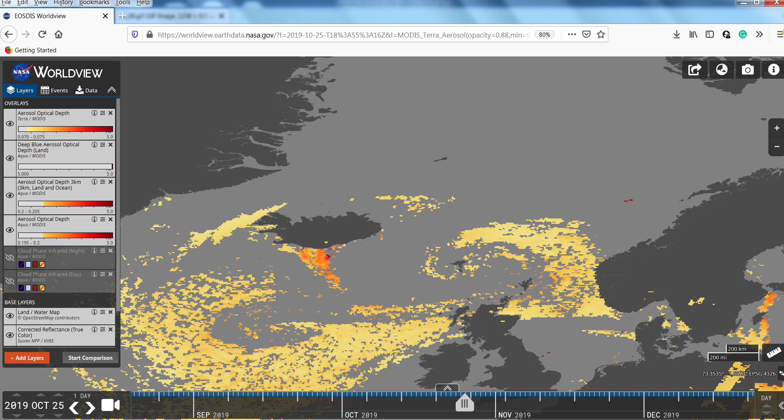

https://worldview.earthdata.nasa.gov/?t=2019-10-25-T18%3A55%3A16Z&l=MODIS_Terra_Aerosol(opacity=0.88,min=0.07),MODIS_Aqua_AOD_Deep_Blue_Land(min=5),MODIS_Aqua_Aerosol_Optical_Depth_3km(min=0.2),MODIS_Aqua_Aerosol(opacity=0.31,min=0.195),MODIS_Aqua_Cloud_Phase_Infrared_Night(hidden,opacity=0.5,disabled=3-2-0),MODIS_Aqua_Cloud_Phase_Infrared_Day(hidden,opacity=0.98,disabled=3-0-2),Land_Water_Map,VIIRS_SNPP_CorrectedReflectance_TrueColor,MODIS_Aqua_CorrectedReflectance_TrueColor(hidden),MODIS_Terra_CorrectedReflectance_TrueColor

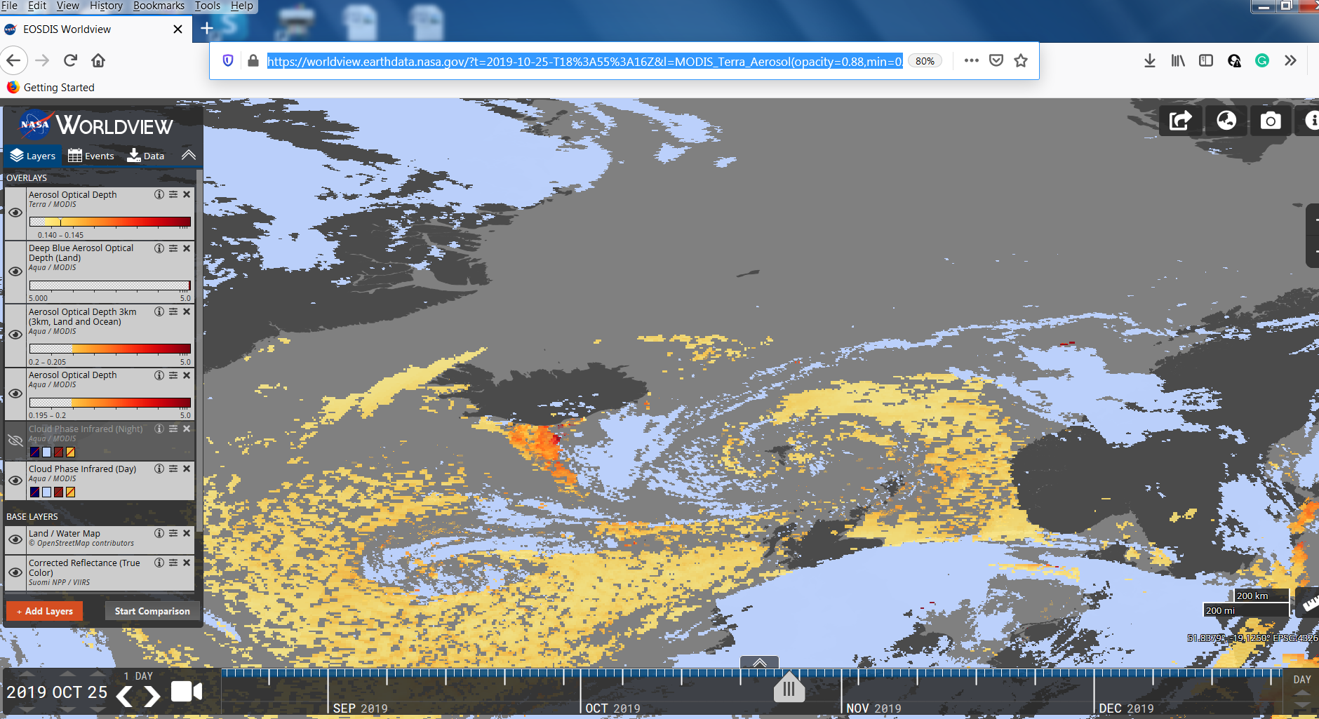

**Only icy clouds, no other!**

https://worldview.earthdata.nasa.gov/?t=2019-10-25-T18%3A55%3A16Z&l=MODIS_Terra_Aerosol(opacity=0.88,min=0.07),MODIS_Aqua_AOD_Deep_Blue_Land(min=5),MODIS_Aqua_Aerosol_Optical_Depth_3km(min=0.2),MODIS_Aqua_Aerosol(opacity=0.31,min=0.195),MODIS_Aqua_Cloud_Phase_Infrared_Night(hidden,opacity=0.5,disabled=3-2-0),MODIS_Aqua_Cloud_Phase_Infrared_Day(opacity=0.98,disabled=3-0-2),Land_Water_Map,VIIRS_SNPP_CorrectedReflectance_TrueColor,MODIS_Aqua_CorrectedReflectance_TrueColor(hidden),MODIS_Terra_CorrectedReflectance_TrueColor